Supplementary Information
Proton Transfer Shuttle Mediated Dormant-Active Balance for Accelerated and Controlled Polymerization of N-Carboxyanhydrides
Jing Huang^{[b]}, Haonan Sheng^{[c]}, Jianjun Cheng^{*[c]}, Xingliang Liu^{*[a]}
[a] Prof. Xingliang Liu
Department of Biomedical Engineering, School of Engineering, China Pharmaceutical University, Nanjing, 211198, Jiangsu, China
[b] Dr. Jing Huang
School of Biomedical Engineering and Informatics, Nanjing Medical University, Nanjing, 211100, Jiangsu, China
[c] Haonan Sheng, Prof. Jianjun Cheng
School of Engineering and Research Center for Industries of the Future, Westlake University, Hangzhou, Zhejiang 310030, China; Institute of Advanced Technology, Westlake Institute for Advanced Study, Hangzhou, Zhejiang 310024, China
*Corresponding Authors: Xingliang Liu. Email: liuxingliang@cpu.edu.cn,
Jianjun Cheng. Email: chengjianjun@westlake.edu.cn
Table of Contents
Materials S3
Instrumentations S3
Polymerization setup and polypeptide characterization S4
Stability of NCA monomer in the presence of TFA S5
Polymerization kinetics S5
Simulation Methods S6
Supporting Figures S7
Supporting Tables S39
Supporting References S51

Materials
All commercial reagents were purchased from Shanghai Aladdin Biochemical Technology Co., Ltd. (Shanghai, China) and used as received unless otherwise specified. Amino acids, trifluoroacetic acid (TFA), tetrabutylammonium acetate (TBAA) and tetrabutylammonium fluoride (TBAF) were purchased from Tokyo Chemical Industry (Shanghai, China). Triphosgene and acetic acid were purchased from Shanghai Macklin Biochemical Technology Co., Ltd. (Shanghai, China). The initiator n-hexylamine (Hex-NH₂), benzylamine and propargylamine were purchased from Millipore Sigma Chemical Co. (St. Louis, MO, USA). Deuterated solvents were purchased from Cambridge Isotope Laboratories, Inc. (Tewksbury, MA, USA). Monomers including γ-benzyl-_{L}-glutamate N-carboxyanhydride (BLG-NCA), γ-ethyl-_{L}-glutamate N-carboxyanhydride (ELG-NCA), γ-(4-propargyloxy)benzyl-_{L}-glutamate NCA (POB-NCA), N^{ε}-carboxybenzyl-_{L}-lysine NCA (ZLL-NCA) were synthesized following literature procedures^{1,2}.

Instrumentations
¹H nuclear magnetic resonance (¹H NMR) spectra were recorded on a 600 MHz-Solution NMR Spectrometer. Chemical shifts (δ) were reported in ppm and referenced to the residual protons in deuterated solvents. Gel permeation chromatography (GPC) experiments were performed on a system equipped with an isocratic pump (1260 Infinity II, Agilent, Santa Clara, CA, USA), a multi-angle static light scattering (MALS) detector (DAWN HELEOS-II, Wyatt Technology, Santa Barbara, CA, USA), and a differential refractometer (dRI) detector (Optilab, Wyatt Technology, Santa Barbara, CA, USA). The detection wavelength of HELEOS was set at 658 nm. Separations were performed using serially connected size exclusion columns (three ShodexTM packed columns KD-803, KD-804 and KD-805, 10 μm, 8 × 300 mm, Yokohama, Japan) using N,N-dimethylformamide (DMF) containing LiBr (0.1 mol/L) as the mobile phase at a flow rate of 1.0 mL/min at 50 °C. The MALS detector was calibrated using pure toluene and can be used for the determination of the absolute molecular weights (MWs). The MWs of polymers were determined based on the dn/dc value of each polymer sample using the internal calibration system processed by the ASTRA 8.1.2 software (version 8.12, Wyatt Technology, Santa Barbara, CA, USA). Fourier transform infrared (FTIR) spectra were recorded on a Perkin Elmer 100 serial FTIR spectrophotometer (PerkinElmer, Santa Clara, CA, USA) calibrated with polystyrene film. Matrix-assisted laser desorption/ionization time-of-flight (MALDI-TOF) mass spectra were collected on a Bruker Rapiflex in the mass spectrometry laboratory, with trans-2-[3-(4-tert-butylphenyl)-2-methyl-2-propenylidene] malononitrile (DCTB) as the matrix. Circular dichroism (CD) data were collected using a chirascan spectrometer V100 (Applied Photophysics, Leatherhead, UK). The pathlength of the CD cuvette was 0.5 mm.

Polymerization setup and polypeptide characterization
The polymerization of NCA accelerated by the TFA/TBAA cooperative system was performed under ambient conditions. In a typical procedure, TFA (0.847 μL, 0.0114 mmol) was first mixed with a DCM solution of γ-benzyl-L-glutamate NCA (BLG-NCA; 30 mg, 0.114 mmol), followed by the addition of a DCM solution of n-hexylamine (Hex-NH₂; 15 μL, 0.076 M, 1.14 μmol). The polymerization was then initiated by adding TBAA (6.18 mg, 0.0171 mmol), with the initial molar ratios set as [M]₀/[I]₀/[TFA]₀/[TBAA]₀ = 100:1:10:15 and [M]₀ = 0.3 M. The conversion of NCA was monitored using fourier-transform infrared (FTIR) spectrometry, and the reaction was stopped after 99% conversion was achieved. The resulting polymers were purified by precipitation in diethyl ether and dried under vacuum.
The obtained polypeptides were dissolved in N,N-dimethyl formamide (DMF) containing 0.1 M LiBr, filtered through a 0.45 μm polytetrafluoroethylene (PTFE) membrane (Thermo Fisher Scientific, Waltham, MA, United States), and analyzed by gel permeation chromatography (GPC). Polymerization involving different solvents, monomers, initiators, and proton shuttle catalysts were conducted following similar procedures.
To examine the MWs at different monomer conversions, the polymerization was quenched at various time intervals by the addition of trifluoroacetic acid (TFA; 2.5 vol%). The polypeptides were collected via precipitation, dried, and dissolved in DMF containing 0.1 M LiBr for GPC analysis. For secondary structure analysis, the polymerization mixture was similarly quenched and then diluted 100-fold with DCM. Circular dichroism (CD) spectra were recorded only at λ > 220 nm due to the strong absorbance of DCM in the low-wavelength region.

Stability of NCA monomer in the presence of TFA
Purified BLG-NCAs and TFA were dissolved in DCM containing Hex-NH₂ or water (10% v/v), and the mixture was vigorously stirred at room temperature. The reaction was monitored by periodically sampling aliquots (~ 2.5 μL), which were dried on a KBr salt plate and analyzed by FTIR. The conversion was evidenced by the disappearance of the NCA anhydride peaks (1857 and 1790 cm⁻¹) and the appearance of polypeptide amide peaks (1650 and 1548 cm⁻¹).

Polymerization kinetics
For the polymerization kinetic studies, NCA monomer consumption was monitored by FTIR. In a typical experiment, the reaction mixture was loaded into a liquid FTIR cell immediately after combining the monomer, initiator, TFA and TBAA. The FTIR spectra were then recorded at specified time intervals until the anhydride adsorption peaks of NCA at 1857 cm⁻¹ and 1790 cm⁻¹ disappeared. The concentration of NCA monomer was then quantified using a pre-established calibration curve based on the absorbance at 1790 cm⁻¹. The rate constant (K_{p}) of the polymerization was recorded in Table S12.

Nuclear magnetic resonance (NMR) titration experiments
NMR titration experiments were conducted to probe the molecular interactions between the reactants, including Hex-NH₂, TFA, and TBAA. To elucidate the Hex-NH₂/TFA interactions, Hex-NH₂ and TFA were dissolved in CD₂Cl₂, into which varying amounts of TBAA were added to adjust the [TFA]₀/[TBAA]₀ ratio from 0.67 to 2. The chemical shifts of α-H at different [TFA]₀/[TBAA]₀ ratios were recorded. The fraction of Hex-NH₂ protonation was quantified by the chemical shift of α-H of Hex-NH₂, calculated according to the following equation:
δ_{m} = δ_{b} + (δ_{s} - δ_{b})· X_{s}
where δ_{b} and δ_{s} are the standard chemical shifts of α-H in the amine (–NH₂) and ammonium (–NH₃⁺) forms of Hex-NH₂, respectively, and δ_{m} is the chemical shift of α-H under certain conditions. The mole fraction of protonated amine, X_{s}, was then calculated from the equation.

Simulation Methods
Density functional theory (DFT) calculations were carried out in Gaussian 16 using the exchange-correlation functional of B3LYP and 6-311G(d,p) basis set in the presence of polarizable continuum model (PCM) describing DCM. Grimme’s D3 dispersion correction was employed to improve the van der Waals interactions. Vibrational frequencies of each structure have been calculated to verify the presence of zero and single imaginary frequency for the intermediates and transition states, respectively. The reaction pathways of all TSs were checked by intrinsic reaction coordinate (IRC) calculations to confirm that these TSs were connected to the desired intermediates. Thermal corrections to Gibbs free energies (G) were obtained in vacuum at 298.15 K and 1.013×10⁵ Pa.
Supplementary Figures
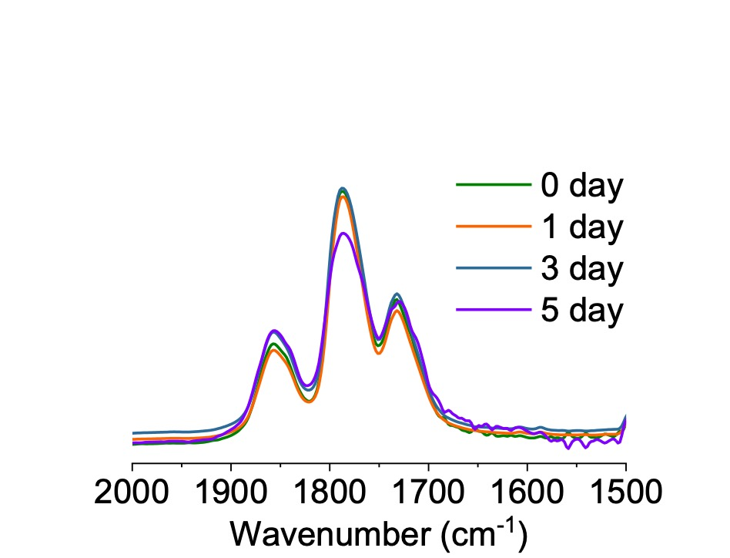
Figure S1. The stability of BLG-NCA in DCM in the presence of TFA. [M]₀ = 0.3 M.

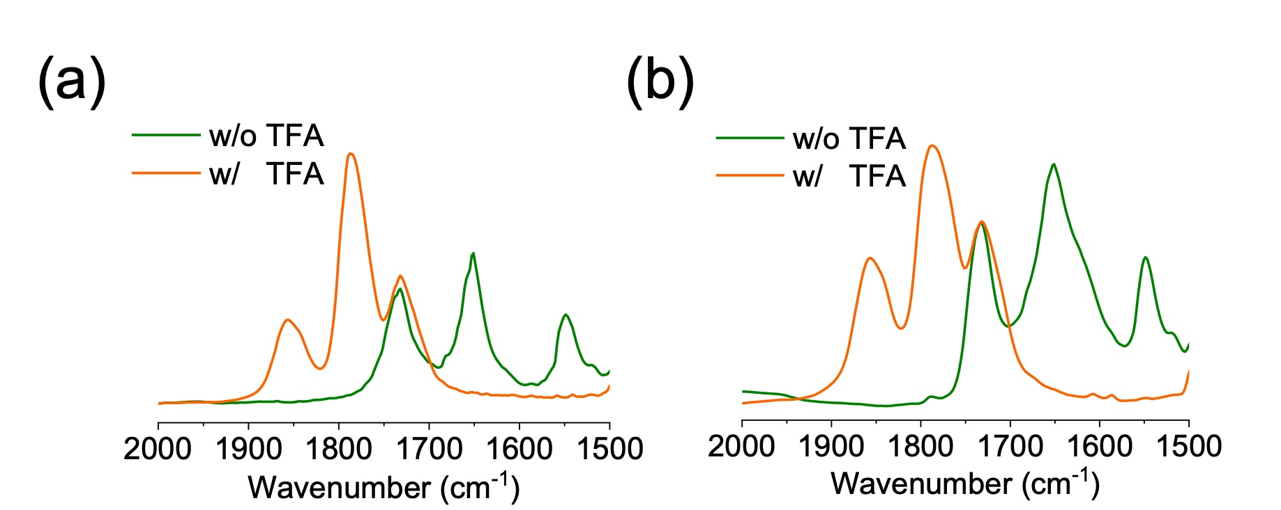
Figure S2. Overlaid FTIR spectra showing the polymerization of BLG-NCA initiated by (a) Hex-NH₂ and (b) 10% water after 24 h in the absence and presence of TFA in DCM. [M]₀/[I]₀/[TFA]₀ = 100:1:10, [M]₀ = 0.3 M.
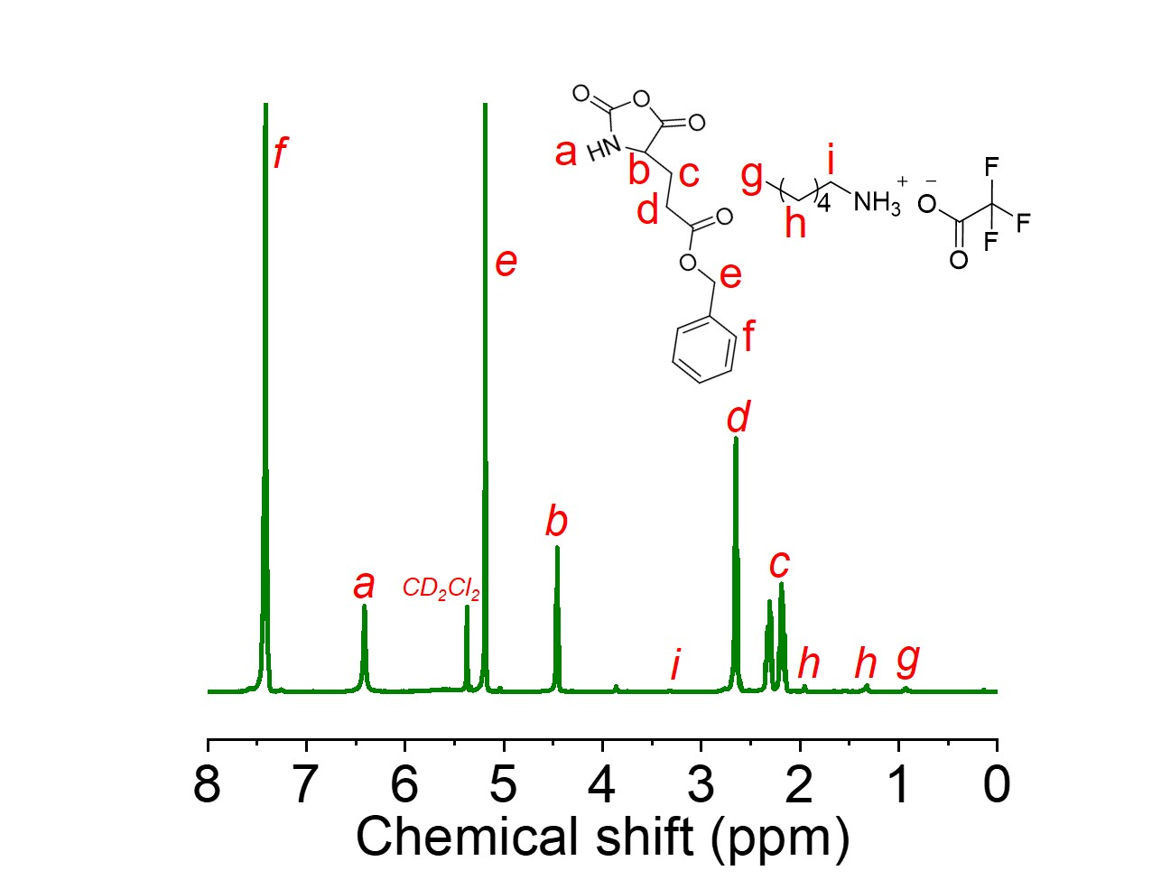
Figure S3. ¹H NMR spectrum showing the stability of BLG-NCA in CD₂Cl₂ after 24 h in the presence of TFA. [M]₀/[I]₀/[TFA]₀ = 100:1:10, [M]₀ = 0.3 M.

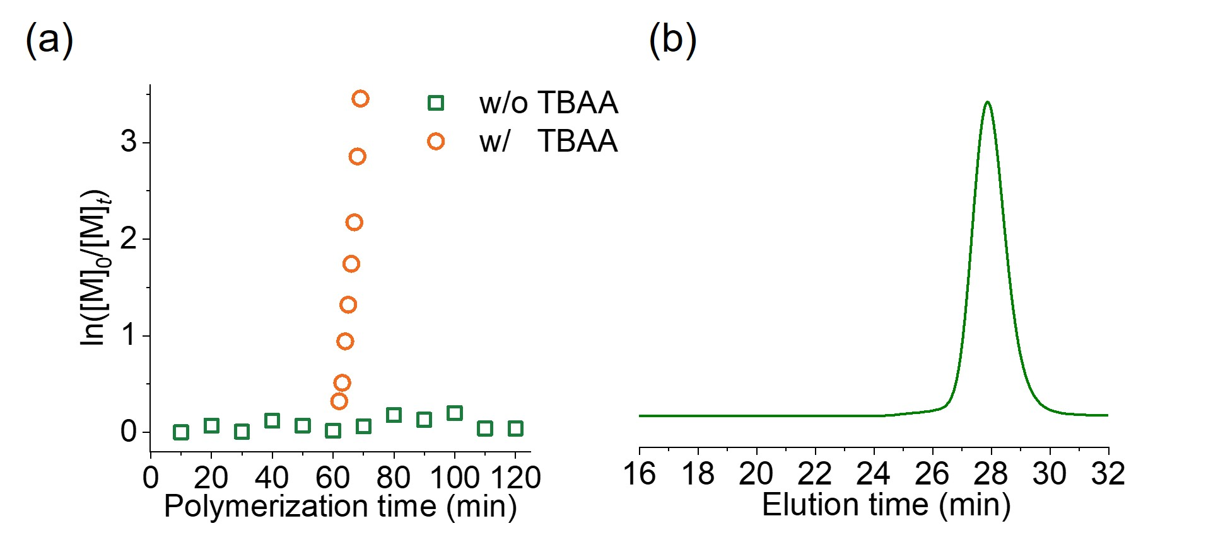
Figure S4. (a) Semilogarithmic kinetics plot for the polymerization of BLG-NCA in DCM initiated by Hex-NH₂. TBAA was added after 1 h of TFA-mediated inhibition, with [M]₀/[I]₀/[TFA]₀/[TBAA]₀ = 100:1:10:15 and [M]₀ = 0.3 M. (b) Normalized GPC-LS traces of obtained PBLG from (a).

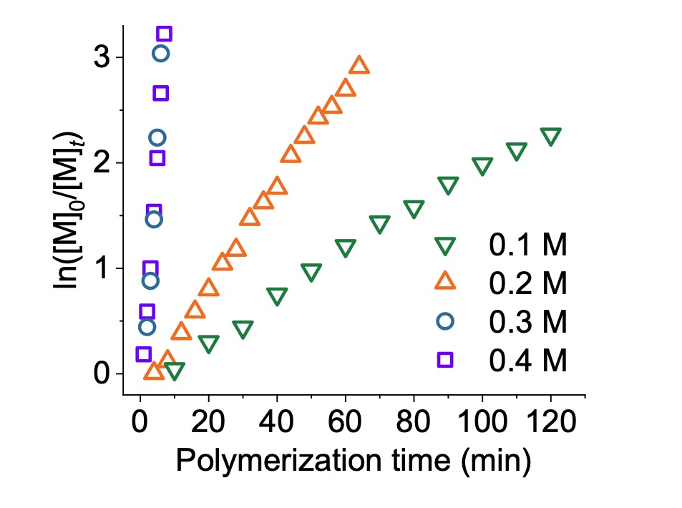
Figure S5. Semilogarithmic kinetic plot of polymerization of BLG-NCA in DCM initiated by Hex-NH₂ at various [M]₀ in the TFA/TBAA cooperative system. [M]₀/[I]₀/[TFA]₀/[TBAA]₀ = 100:1:10:15.

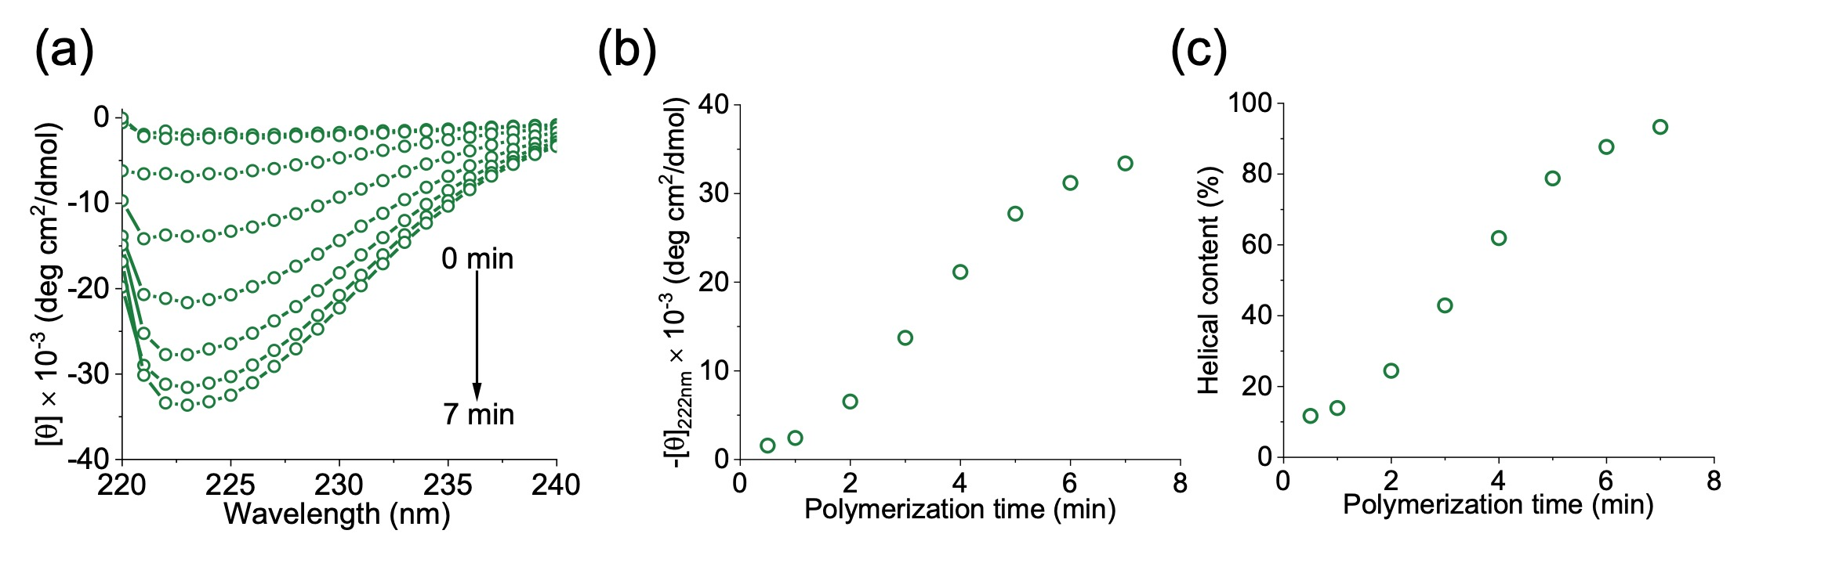
Figure S6. (a) Overlaid CD spectra of the polymerization mixture quenched at different time intervals in DCM. [M]₀/[I]₀/[TFA]₀/[TBAA]₀ = 100:1:10:15, [M]₀ = 0.3 M. (b) The time-dependent changes in CD signals at 222 nm over time during the early stage of polymerization. (c) The helical content of the polymerization mixture quenched at different time intervals in DCM. [M]₀/[I]₀/[TFA]₀/[TBAA]₀ = 100:1:10:15, [M]₀ = 0.3 M.

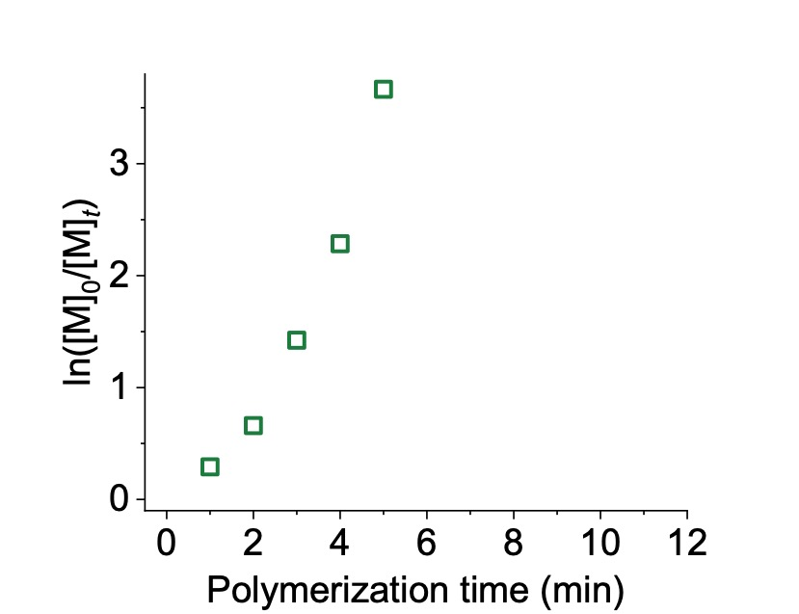
Figure S7. Semilogarithmic kinetic plot of polymerization of BLG-NCA in DCM initiated by TBAA. [M]₀/[TBAA]₀ = 100:15.

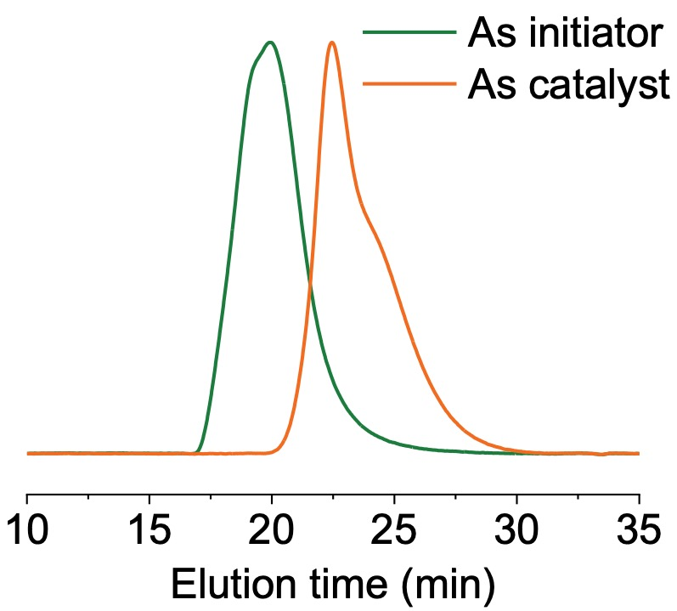
Figure S8. Normalized GPC-LS traces of obtained PBLG using TBAA as initiator ([M]₀/[TBAA]₀=100:15) and catalyst ([M]₀/[I]₀/[TBAA]₀=100:1:15).

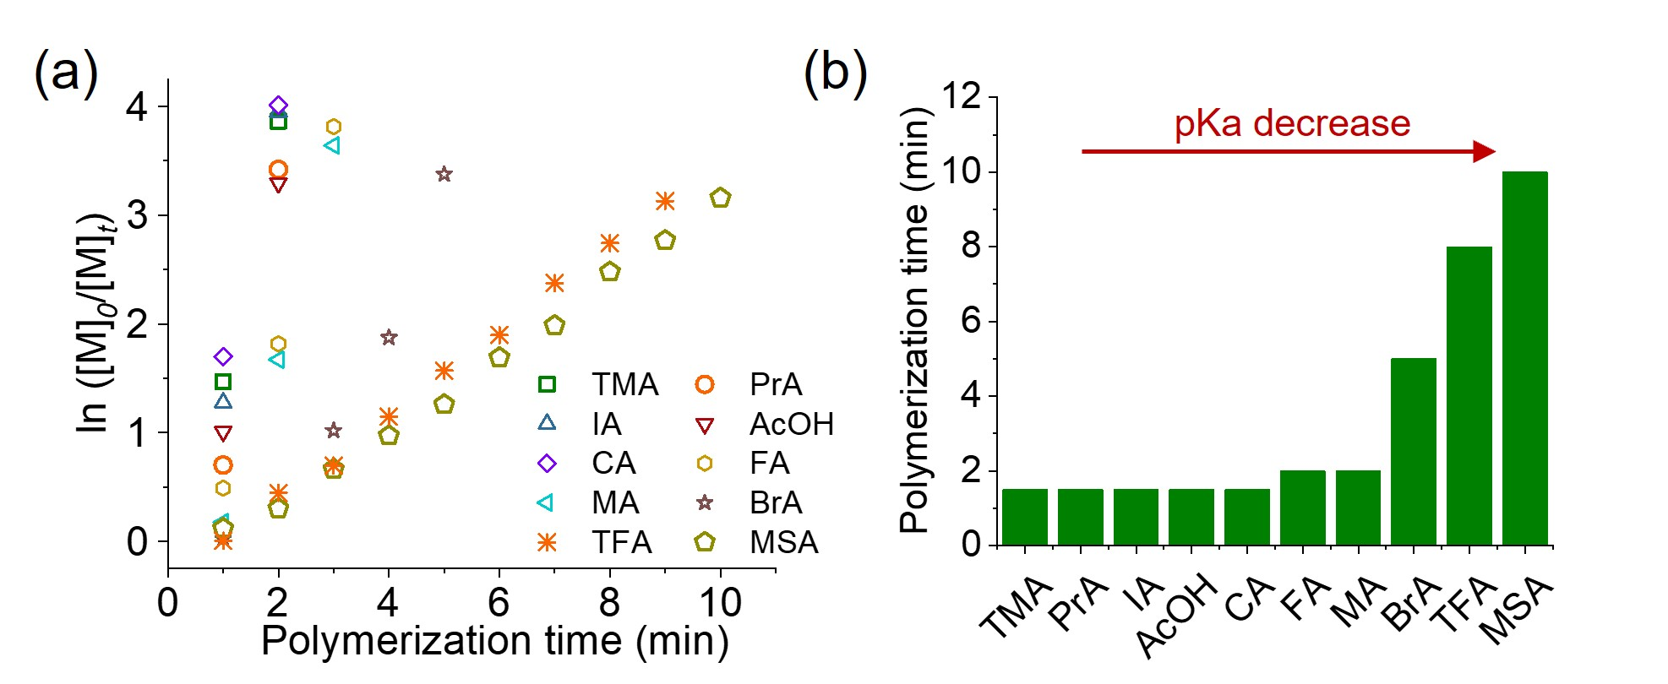
Figure S9. (a) Semilogarithmic kinetics plot for the polymerization of BLG-NCA in the presence of acid with different pKa. [M]₀/[I]₀/[Acid]₀/[TBAA]₀ = 100:1:10:15 and [M]₀ = 0.3 M. (b) The polymerization time for achieving 95% monomer conversion against the pKa value of organic acids added.

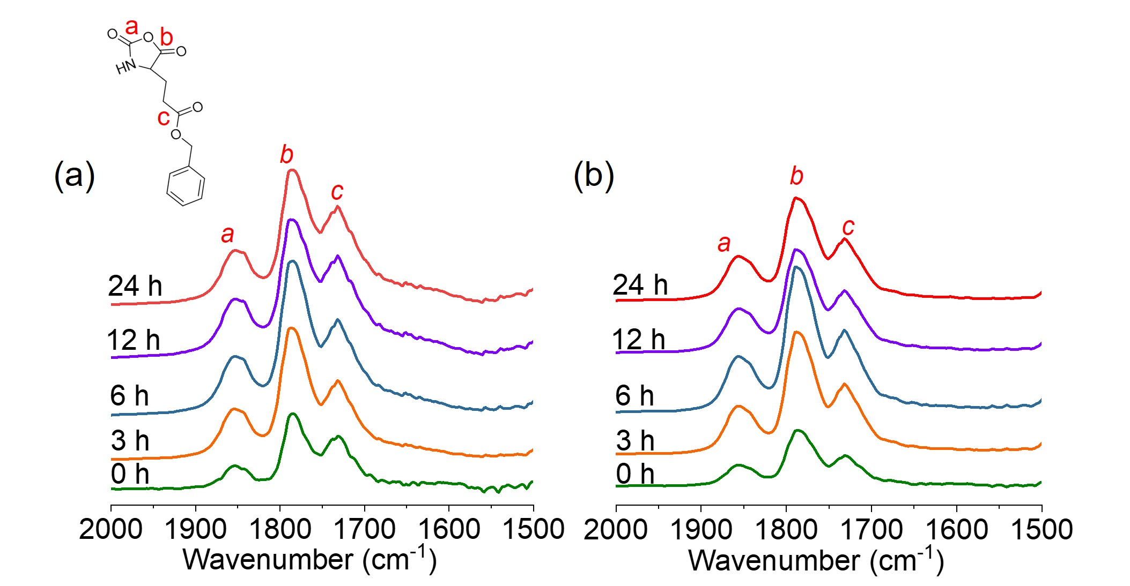
Figure S10. Overlaid FTIR spectra showing the polymerization of BLG-NCA initiated by Hex-NH₂ after 24 h in the presence of (a) MSA and (b) TFA in DCM. [M]₀/[I]₀/[Acid]₀ = 100:1:10, [M]₀ = 0.3 M.

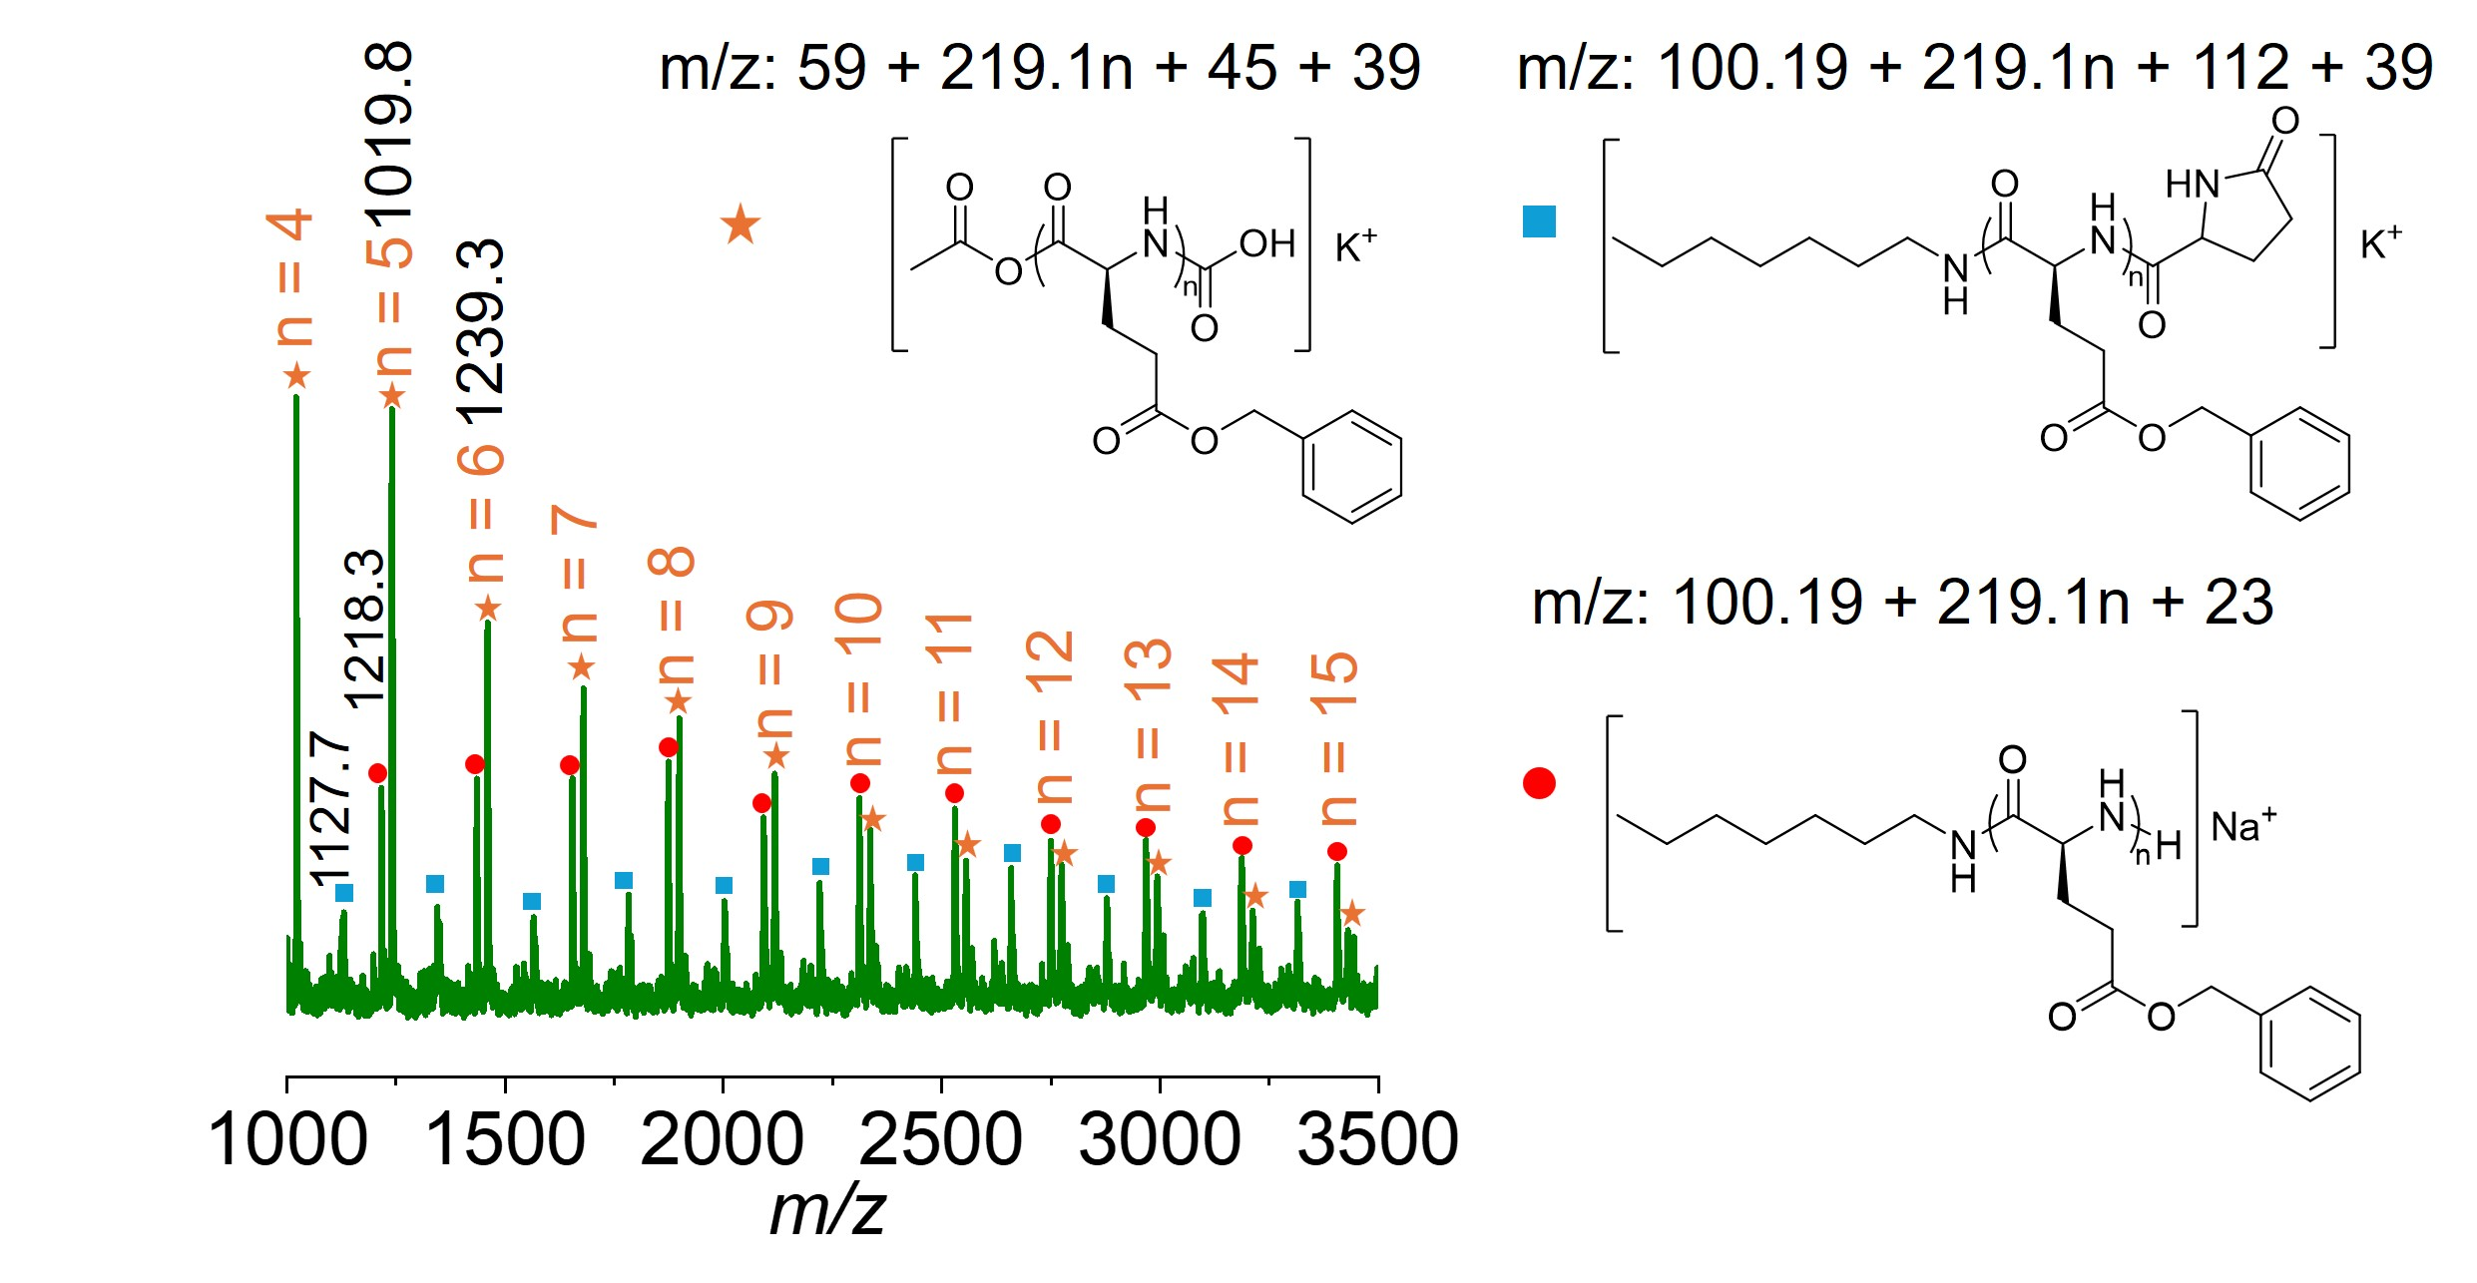
Figure S11. MALDI-TOF characterization of PBLG initiated by Hex-NH₂ in the presence of AcOH and TBAA. [M]₀/[I]₀/[AcOH]₀/[TBAA]₀=100:1:10:15, [M]₀ = 0.3 M.

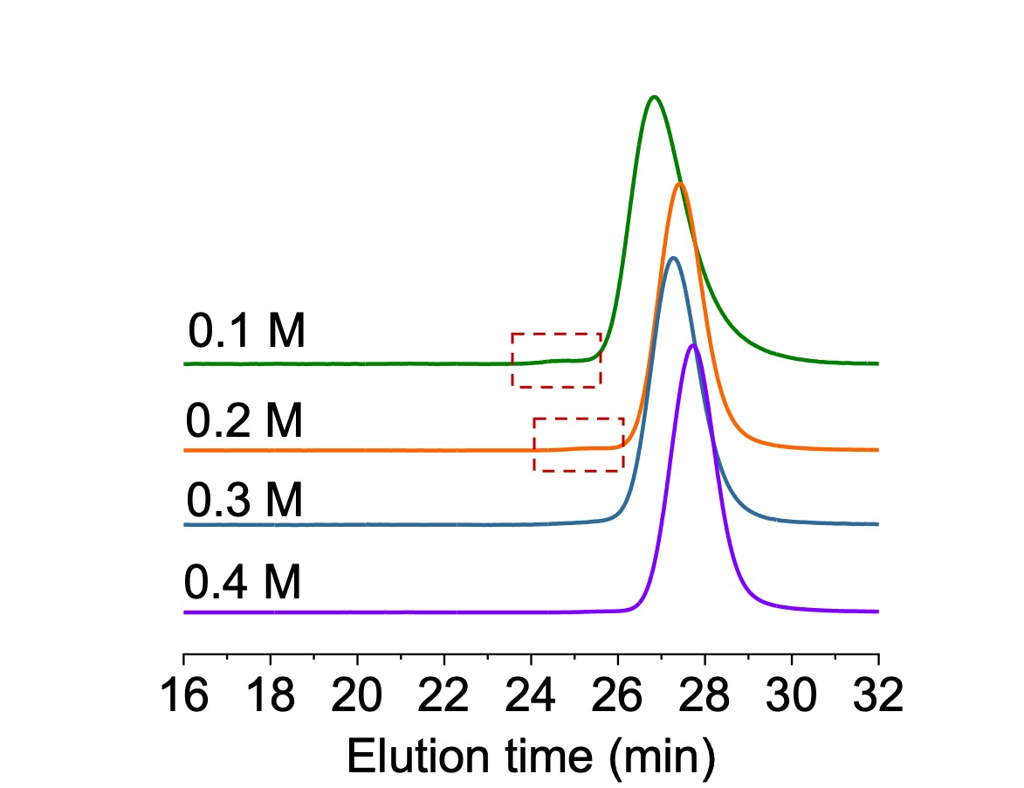
Figure S12. Normalized GPC-LS traces of obtained PBLG at different [M]₀ in the TFA/TBAA cooperative system. [M]₀/[I]₀/[TFA]₀/[TBAA]₀=100:1:10:15.

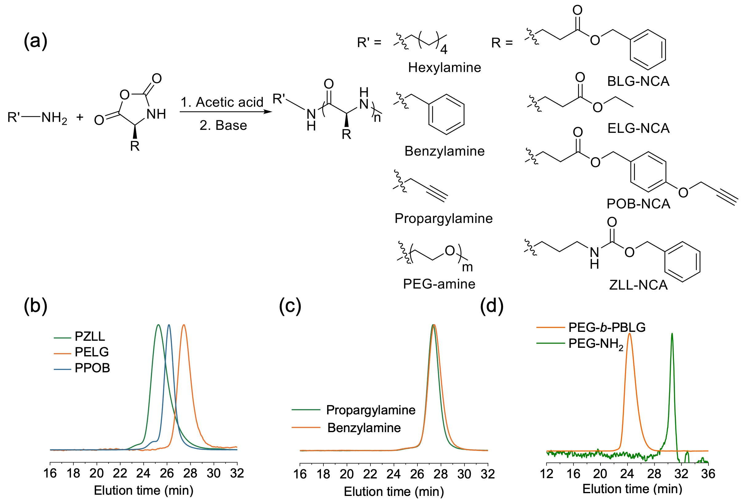
Figure S13. Polymerization of various NCA monomers in the presence of different initiators. (a) Chemical structures of various initiators and NCA monomers. (b) Normalized GPC-LS traces of the resulting polypeptides obtained in the presence of TFA and TBAA with ZLL-NCA, ELG-NCA and POB-NCA as the monomer. (c) Normalized GPC-LS traces of the resulting polypeptides initiated by benzylamine and propargylamine in the presence of TFA and TBAA. [M]₀/[I]₀/[TFA]₀/[TBAA]₀ = 100:1:10:15, [M]₀ = 0.3 M. (d) Normalized GPC-LS traces of the resulting polypeptides initiated by macroinitiator PEG-NH₂ (5 kDa) in the presence of TFA and TBAA. [M]₀/[I]₀/[TFA]₀/[TBAA]₀ = 100:1:10:15, [M]₀ = 0.3 M.

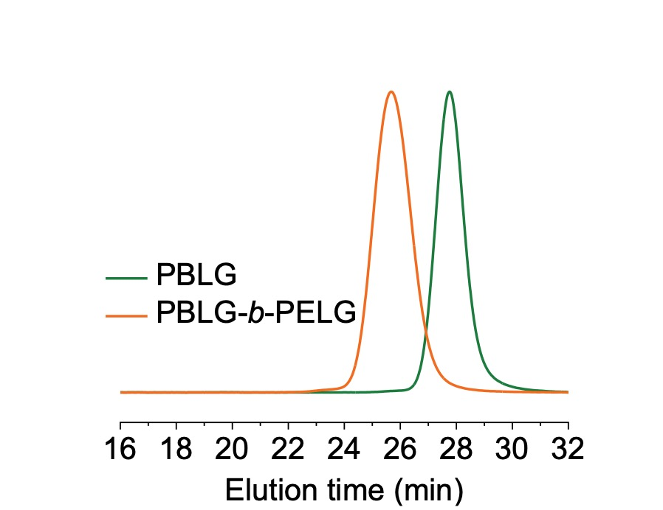
Figure S14. Normalized GPC-LS traces showing the synthesis of di-block polypeptide initiated by Hex-NH₂ in the presence of TFA and TBAA. [BLG-NCA]₀/[ELG-NCA]₀/[I]₀/[TFA]₀/[TBAA]₀ = 100:100:1:10:15. [M]₀ = 0.3 M.

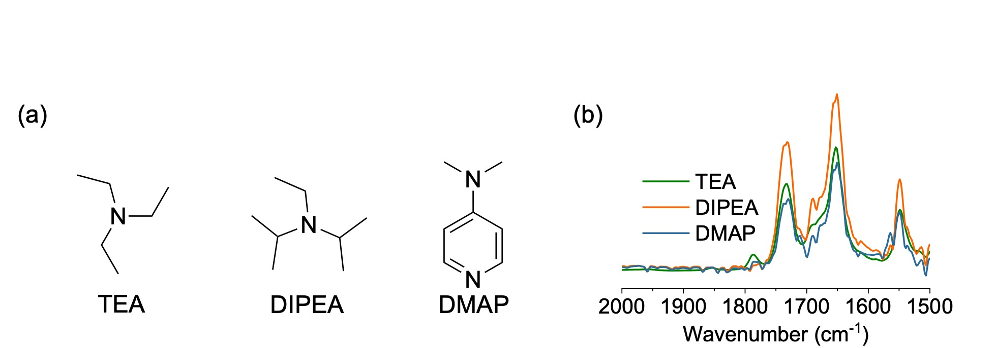
Figure S15. (a) Chemical structures of TEA, DIPEA and DMAP. (b) Overlaid FTIR spectra showing the polymerization of BLG-NCA initiated by Hex-NH₂ using different tertiary amines as proton shuttle catalyst in DCM after 60 min of polymerization. [M]₀/[I]₀/[TFA]₀/[Tertiary amine]₀ = 100:1:10:15, [M]₀ = 0.3 M.

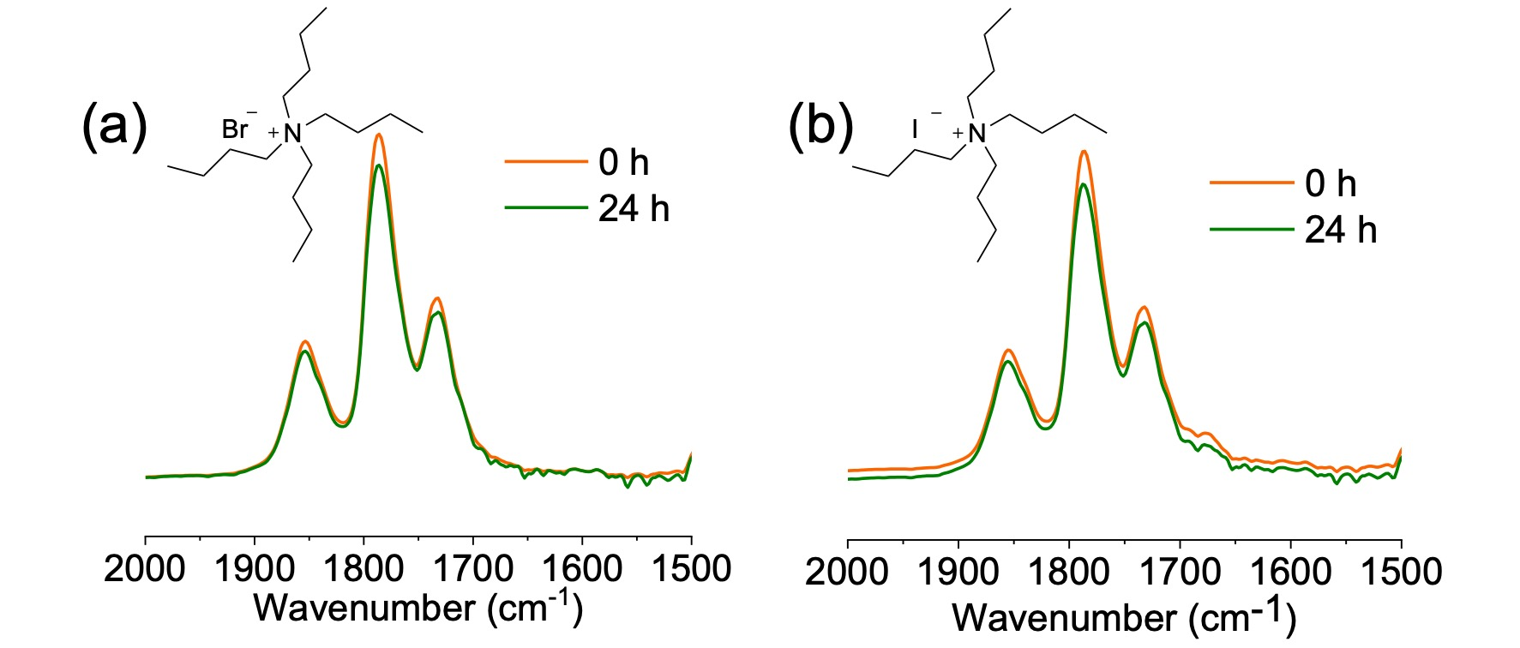
Figure S16. Overlaid FTIR spectra showing the polymerization of BLG-NCA initiated by Hex-NH₂ using (a) TBAB and (b) TBAI as proton shuttle catalyst in DCM. [M]₀/[I]₀/[TFA]₀/[TBAB]₀ = 100:1:10:15, [M]₀/[I]₀/[TFA]₀/[TBAI]₀ = 100:1:10:15, [M]₀ = 0.3 M.

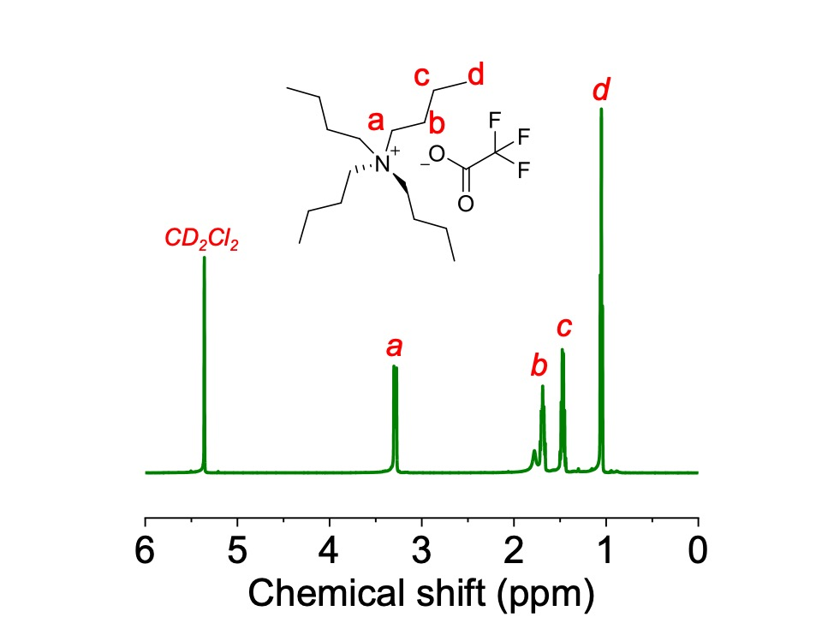
Figure S17. ¹H NMR spectrum of TBAF in CD₂Cl₂.

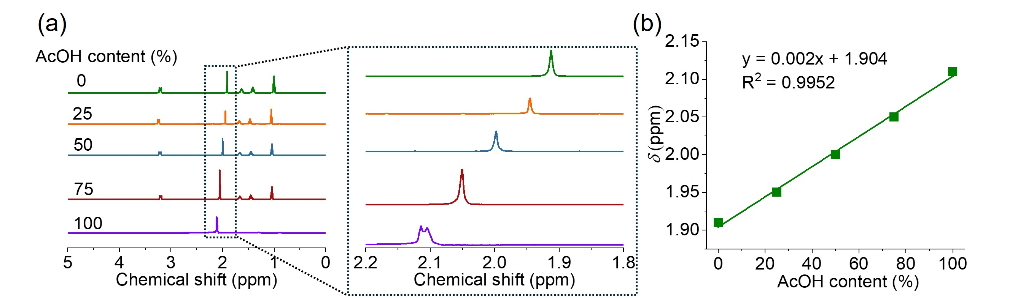
Figure S18. (a) Overlaid ¹H NMR spectra of the mixture of AcOH and TBAA in CD₂Cl₂ at various [AcOH]₀/[TBAA]₀ ratios. (b) The calibration curve of chemical shift of α-H in Hex-NH₂ at various AcOH contents.

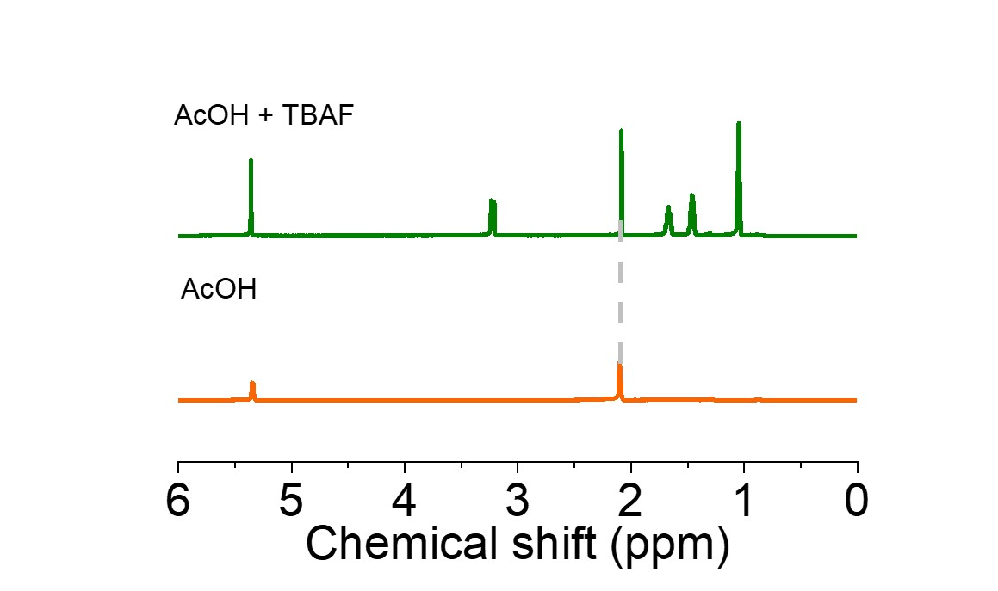
Figure S19. Overlaid ¹H NMR spectra of AcOH in the presence and absence of TBAF.

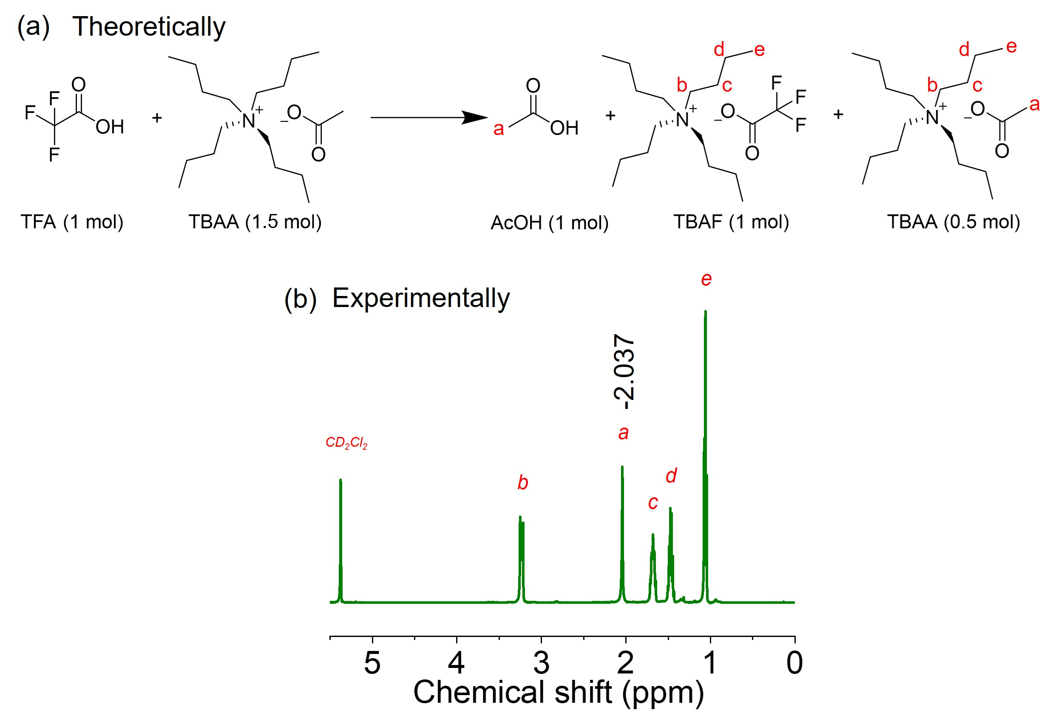
Figure S20. (a) Reaction route of TFA and TBAA at [TFA]₀/[TBAA] = 1: 1.5. (b) ¹H NMR spectrum of the mixture of Hex-NH₂ and TFA in CD₂Cl₂ in the presence of TBAA. [I]₀/[TFA]₀/[TBAA]₀ = 1:10:15.

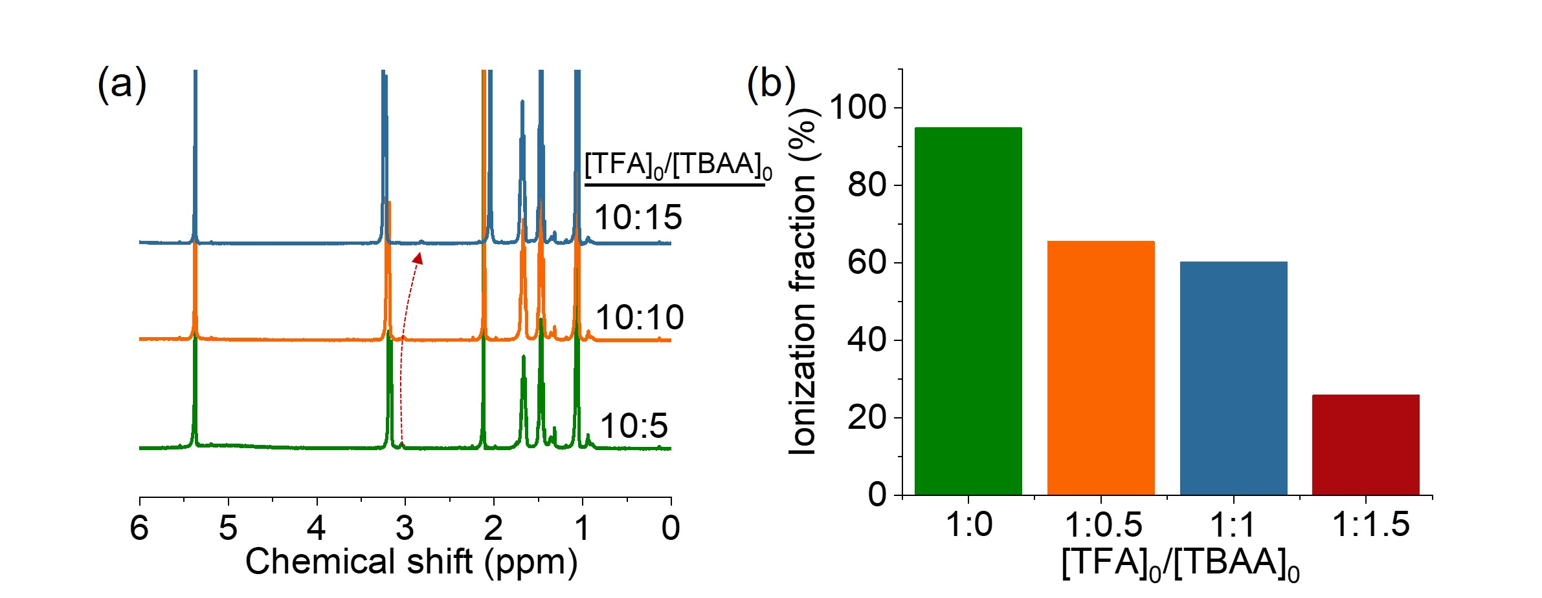
Figure S21. (A) Overlaid ¹H NMR spectra of mixture of Hex-NH₂ and TFA in the presence of TBAA. [Hex-NH₂]₀/[TFA]₀ = 1:10. (B)The ionization fraction of Hex-NH₂ with different [TBAA]₀ in the TFA/TBAA cooperative system. [Hex-NH₂]₀/[TFA]₀ = 1:10.

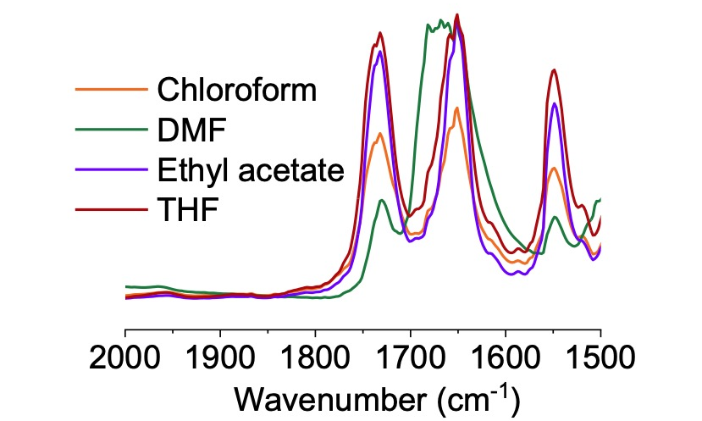
Figure S22. Overlaid FTIR spectra showing the polymerization of BLG-NCA initiated by Hex-NH₂ in different solvents within TFA/TBAA cooperative system. Reaction times were 10 min in chloroform, THF, DMF, and ethyl acetate, respectively. [M]₀/[I]₀/[TFA]₀/[TBAA]₀ = 100:1:10:15, [M]₀ = 0.3 M.

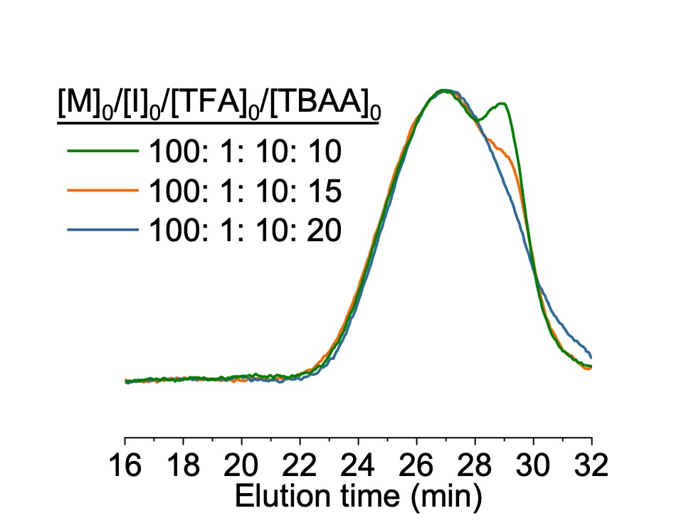
Figure S23. Normalized GPC-LS traces of obtained PBLG at various [TBAA]₀ in DMF. [M]₀/[I]₀/[TFA]₀=100:1:10, [M]₀=0.3 M.

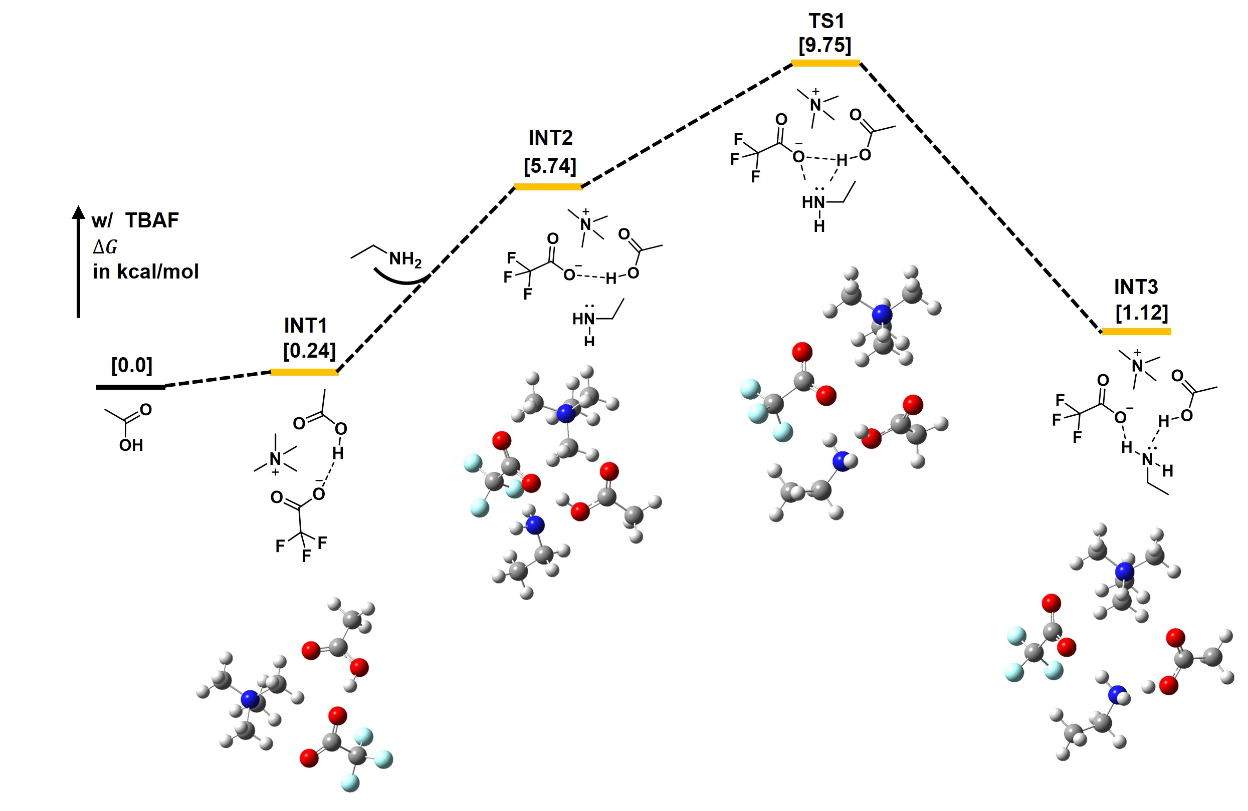
Figure S24. Calculated Gibbs free-energy profile of the model proton transfer shuttle process in the presence of TBAF. Ethylamine and tetramethylammonium acetate were used as a model monomer for simplification. Some crucial intermediates (INT) and transition states (TS) are illustrated by 3D models where some hydrogen atoms are neglected for clarity.

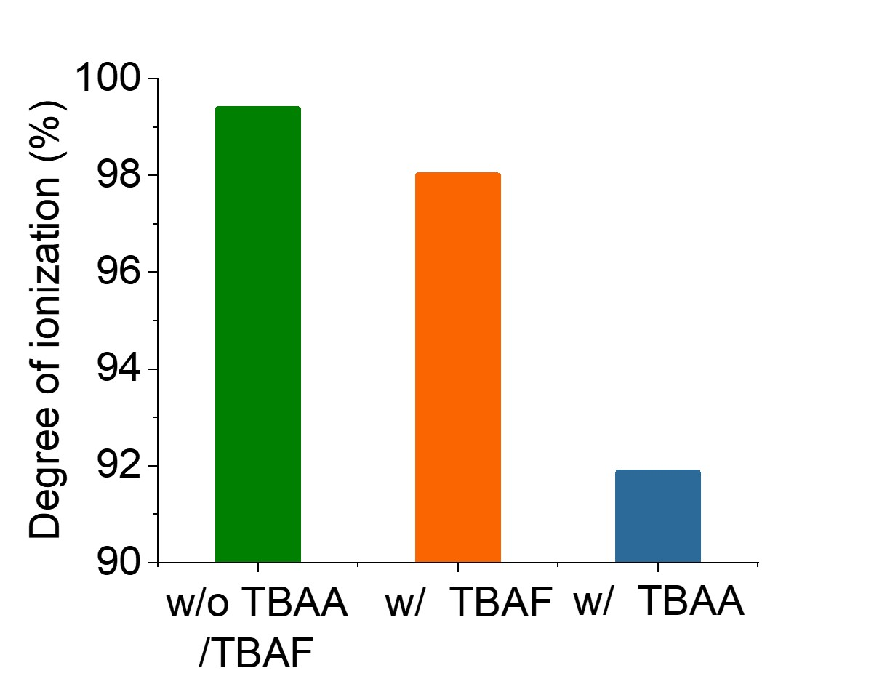
Figure S25. The degree of ionization of ethylamine in the absence and presence of TBAA or TBAF was calculated from DFT.

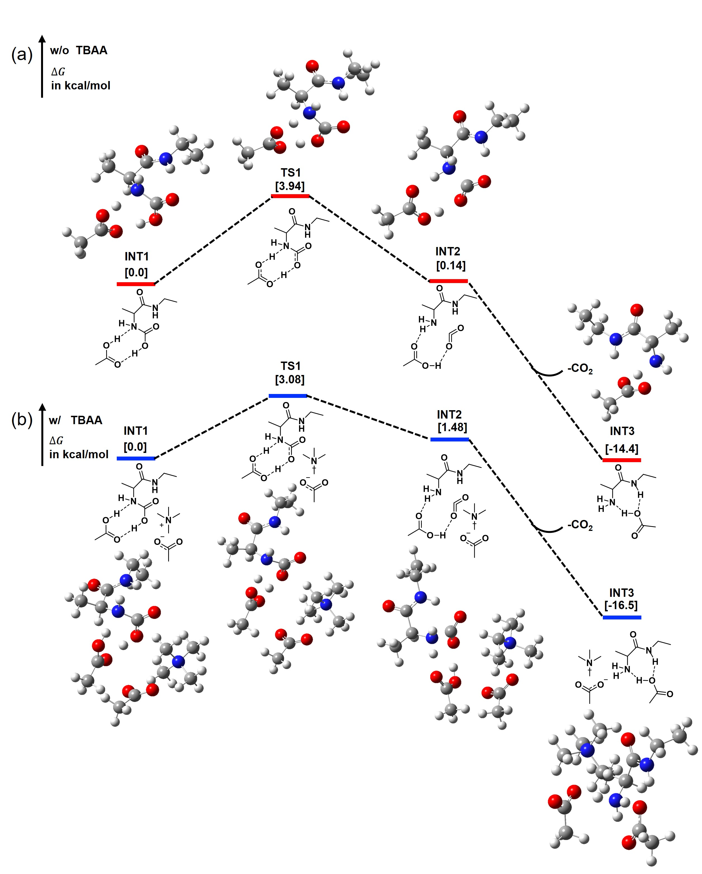
Figure S26. Calculated Gibbs free-energy profile of the model decarboxylation step with AcOH in the (a) absence or (b) presence of TBAA. _{L}-Alanine NCA was used as a model monomer for simplification. Some crucial intermediates (INT) and transition states (TS) are illustrated by 3D models where some hydrogen atoms are neglected for clarity.

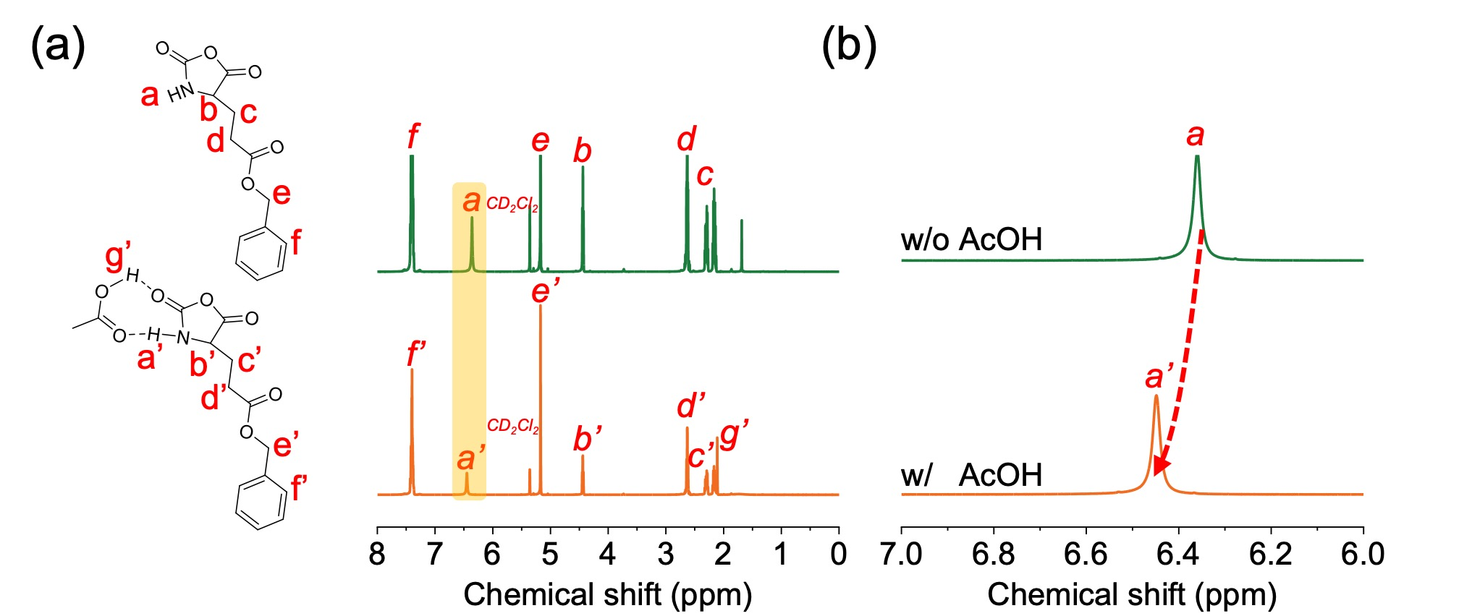
Figure S27. (a) Overlaid ¹H NMR spectra of BLG-NCA in the absence and presence of AcOH. [BLG-NCA]₀/[AcOH]₀ = 10:1. (b) The change in chemical shift of -NH- in BLG-NCA in the absence and presence of AcOH.

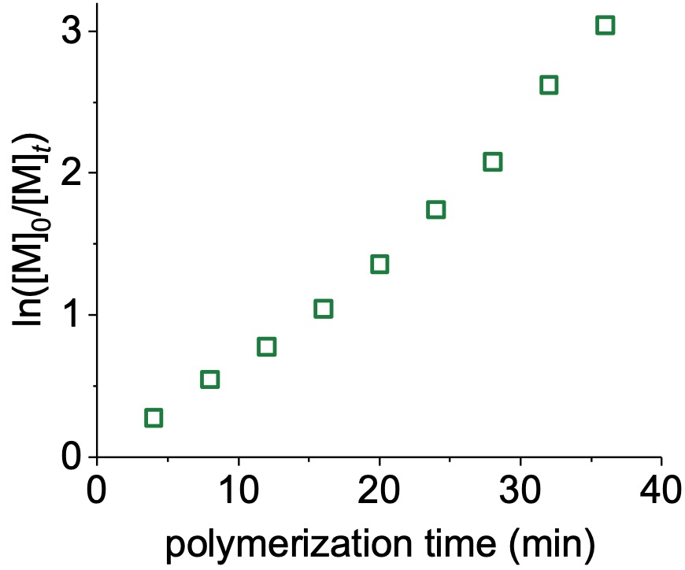
Figure S28. Semilogarithmic kinetic plot of polymerization of BLG-NCA in DCM initiated by Hex-NH₂ using AcOH as catalyst. [M]₀/[I]₀/[AcOH]₀ = 100:1:10, [M]₀ = 0.3 M.

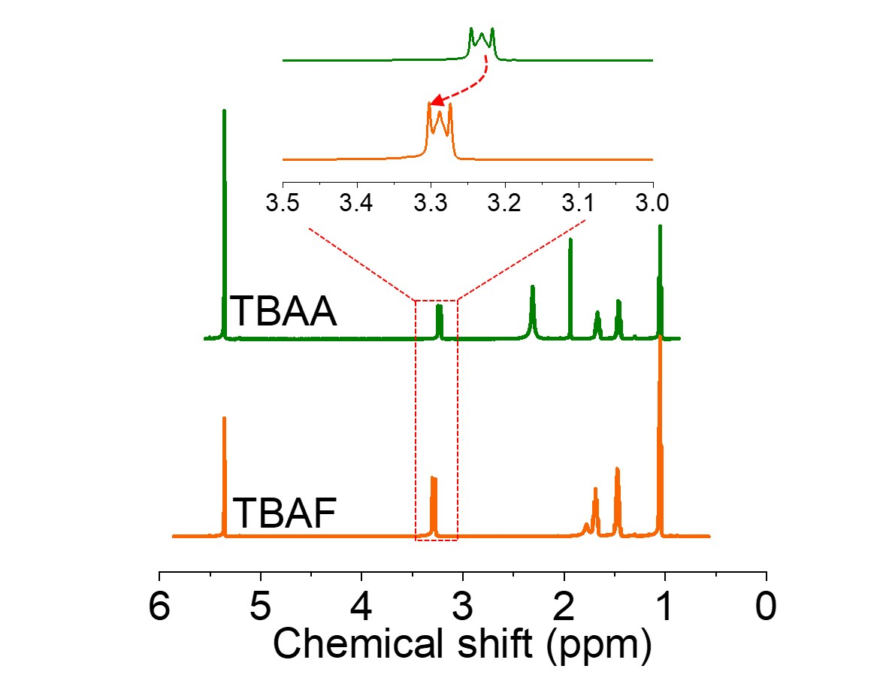
Figure S29. Overlaid ¹H NMR spectra of TBAA and TBAF in CD₂Cl₂.

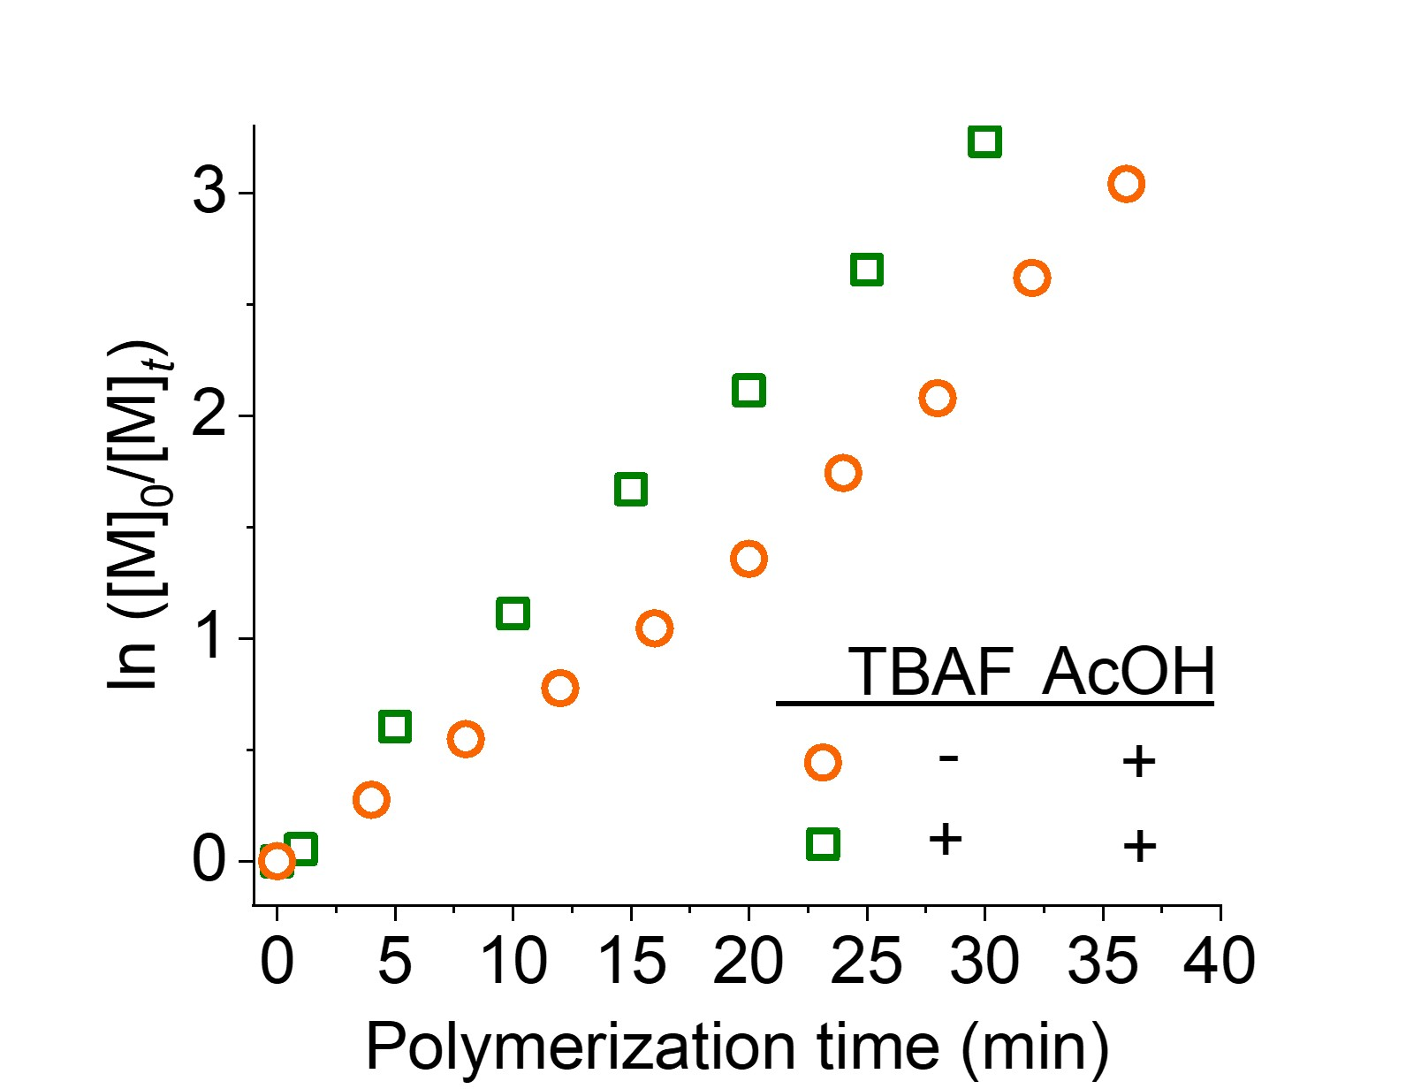
Figure S30. Semilogarithmic kinetic plot of polymerization of BLG-NCA by Hex-NH₂ in the presence and absence of TBAF. [M]₀/[I]₀/[AcOH]₀/[TBAF]₀ = 100/1/10/10, [M]₀ = 0.3 M.

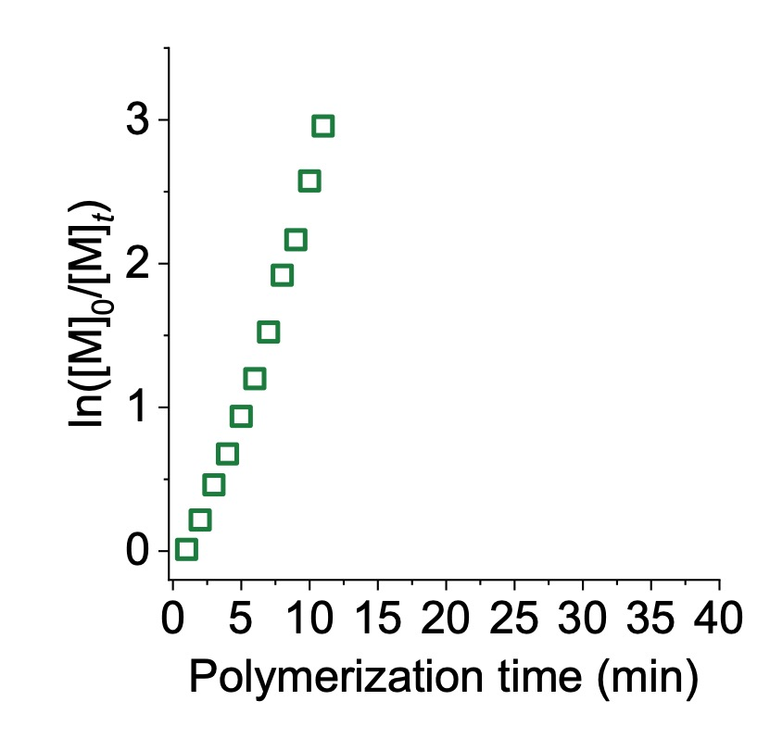
Figure S31. Semilogarithmic kinetic plot of polymerization of BLG-NCA in DCM in the presence of Hex-NH₂, AcOH, TBAF and TBAA. [M]₀/[I]₀/[AcOH]₀/[TBAF]₀/[TBAA]₀ = 100:1:10:10:5, [M]₀ = 0.3 M.

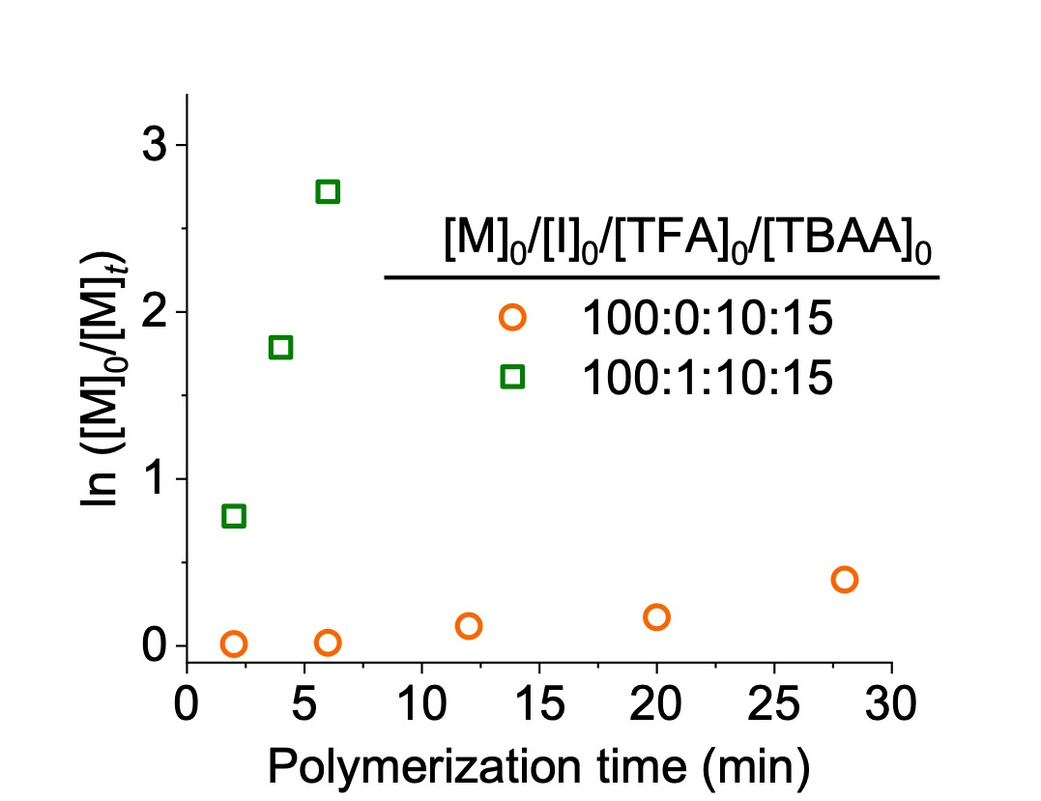
Figure S32. Semilogarithmic kinetic plot of polymerization of BLG-NCA in DCM with or without Hex-NH₂ in the presence of TFA and TBAA. [M]₀/[I]₀/[TFA]₀/[TBAA]₀ = 100:1:10:15, [M]₀ = 0.3 M.

Supplementary Tables
Table S1. Polymerization of BLG-NCA initiated by Hex-NH₂ at various [TFA]₀/[I]₀ ratios in the presence of TBAA.^{[a]}
Entry | [TFA]₀/[I]₀ | t (min)^{[b]} |  | M_{n, GPC} (kDa)^{[c]} |  | M_{n, theo.}  (kDa) |  | Đ^{[c]}
1 | 1 | 16 | 24.9 |  | 21.9 |  | 1.09
2 | 5 | 23 | 22.1 |  | 21.9 |  | 1.03
3 | 10 | 10 | 21.7 |  | 21.9 |  | 1.03
4 | 15 | 10 | 22.7 |  | 21.9 |  | 1.03
5 | 20 | 10 | 21.9 |  | 21.9 |  | 1.03
^{[a]}All polymerizations were conducted at room temperature in DCM using BLG-NCA as the monomer. [M]₀ = 0.3 M, [M]₀/[I]₀/[TBAA]₀ = 100:1:15. ^{[b]}Polymerization time reaching 95% monomer conversion. ^{[c]}Determined by GPC; dn/dc = 0.104.

Entry | [TBAA]₀/[TFA]₀ | t (min)^{[b]} |  | M_{n, GPC} (kDa)^{[c]} |  | M_{n, theo.}  (kDa) |  | Đ^{[c]}
1 | 2 | 10 | 21.9 |  | 21.9 |  | 1.09
2 | 1.5 | 10 | 21.7 |  | 21.9 |  | 1.03
3 | 1 | 100 | 21.6 |  | 21.9 |  | 1.02
Table S2. Polymerization of BLG-NCA initiated by Hex-NH₂ at various [TBAA]₀/[TFA]₀ ratios.^{[a]}
^{[a]}All polymerizations were conducted at room temperature in DCM using BLG-NCA as the monomer. [M]₀ = 0.3 M. [M]₀/[I]₀/[TFA]₀ = 100:1:10. ^{[b]}Polymerization time reaching 95% monomer conversion. ^{[c]}Determined by GPC; dn/dc = 0.104.

Table S3. Polymerization of BLG-NCA initiated by Hex-NH₂ at various [M]₀/[I]₀/[TBAA]₀ ratios.^{[a]}
Entry | [M]₀/[I]₀/[TBAA]₀ | t (min)^{[b]} |  | M_{n, GPC} (kDa)^{[c]} |  | M_{n, theo.}  (kDa) |  | Đ^{[c]}
1 | 100:1:15 | 5 | 21.9 |  | 21.9 |  | 1.84
2 | 100:0:15 | 5 | 49.2 |  | 21.9 |  | 1.42
^{[a]}All polymerizations were conducted at room temperature in DCM using BLG-NCA as the monomer. [M]₀ = 0.3 M. ^{[b]}Polymerization time reaching 95% monomer conversion. ^{[c]}Determined by GPC; dn/dc = 0.104.

Table S4. Polymerization of BLG-NCA initiated by Hex-NH₂ in the presence of acid with different pKa.^{[a]}
Entry | Acid | pKa | t  (min)^{[b]} |  | M_{n, GPC} (kDa)^{[c]} |  | M_{n, theo.} (kDa) |  | Đ^{[c]}
1 | TMA | 5.03 | 1.5 | 20.2 |  | 21.9 |  | 1.23
2 | PrA | 4.87 | 1.5 | 19.4 |  | 21.9 |  | 1.21
3 | IA | 4.84 | 1.5 | 18.9 |  | 21.9 |  | 1.21
4 | AcOH | 4.76 | 1.5 | 18.8 |  | 21.9 |  | 1.21
5 | CA | 4.51 | 1.5 | 19.9 |  | 21.9 |  | 1.16
6 | FA | 3.77 | 2 | 18.9 |  | 21.9 |  | 1.15
7 | MA | 3.53 | 2 | 18.8 |  | 21.9 |  | 1.16
8 | BrA | 2.90 | 5 | 18.5 |  | 21.9 |  | 1.12
9 | TFA | 0.52 | 8 | 21.6 |  | 21.9 |  | 1.05
10 | MSA | -1.2 | 10 | 22.7 |  | 21.9 |  | 1.03
^{[a]}All polymerizations were conducted at room temperature in DCM using BLG-NCA as the monomer. [M]₀ = 0.3 M, [M]₀/[I]₀/[Acid]₀/[TBAA]₀ = 100:1:10:15. ^{[b]}Polymerization time reaching 95% monomer conversion. ^{[c]}Determined by GPC; dn/dc = 0.104.

Table S5. MALDI-TOF characterization of PBLG obtained from polymerization in the presence of TFA/TBAA cooperative system.
n | [PBLG + Na]⁺
n | Calcd. | Found
32  33  34  35  36  37  38  39 | 7134.4 | 7134.9
32  33  34  35  36  37  38  39 | 7353.5 | 7353.8
32  33  34  35  36  37  38  39 | 7572.6 | 7573.6
32  33  34  35  36  37  38  39 | 7791.7 | 7792.5
32  33  34  35  36  37  38  39 | 8010.8 | 8011.4
32  33  34  35  36  37  38  39 | 8229.9 | 8228.5
32  33  34  35  36  37  38  39 | 8448.9 | 8448.2
32  33  34  35  36  37  38  39 | 8668.1 | 8668.9

Table S6. Polymerization of BLG-NCA initiated by Hex-NH₂ at various [M]₀ in the presence of TFA and TBAA.^{[a]}
Entry | [M]₀ | t (min)^{[b]} |  | M_{n, GPC} (kDa)^{[c]} |  | M_{n, theo.}  (kDa) |  | Đ^{[c]}
1 | 0.1 | 120 | 22.9 |  | 21.9 |  | 1.08
2 | 0.2 | 70 | 22.0 |  | 21.9 |  | 1.03
3 | 0.3 | 10 | 21.9 |  | 21.9 |  | 1.03
4 | 0.4 | 10 | 21.1 |  | 21.9 |  | 1.02
^{[a]}All polymerizations were conducted at room temperature in DCM using BLG-NCA as the monomer. [M]₀/[I]₀/[TFA]₀/[TBAA]₀ = 100:1:10:15. ^{[b]}Polymerization time reaching 95% monomer conversion. ^{[c]}Determined by GPC; dn/dc = 0.104.

Entry | Block of numbers | Monomer | t (min)^{[b]} |  | M_{n, GPC} (kDa)^{[c]} |  | M_{n, theo.} (kDa) |  | Đ^{[c]}
1 | 1st | BLG-NCA | 10 | 21.9 |  | 21.9 |  | 1.03
2 | 2st | ELG-NCA | 10 | 28.7 |  | 37.6 |  | 1.03
Table S7 Polymerization of di-block polypeptide initiated by Hex-NH₂ in the presence of TFA and TBAA.^{[a]}
^{[a]}All polymerizations were conducted at room temperature in DCM using BLG-NCA as the monomer. [BLG-NCA]₀/[ELG-NCA]₀/[I]₀/[TFA]₀/[TBAA]₀ = 100:100:1:10:15. ^{[b]}Polymerization time reaching 95% monomer conversion. ^{[c]}Determined by GPC; dn/dc = 0.104.

Table S8. Polymerization of BLG-NCA using different tertiary amines as proton shuttle catalyst.^{[a]}
Entry | Catalyst | t (min)^{[b]} | M_{n, GPC} (kDa)^{[c]} |  | M_{n, theo.}  (kDa) | Đ^{[c]}
1 | TEA | 60 | 27.1 | 21.9 |  | 1.16
2 | DIPEA | 60 | 67.4 | 21.9 |  | 1.61
3 | DMAP | 60 | 30.6 | 21.9 |  | 1.16
^{[a]}All polymerizations were conducted at room temperature in DCM using BLG-NCA as the monomer. [M]₀/[I]₀/[TFA]₀/[Tertiary amine]₀ = 100:1:10:15, [M]₀ = 0.3 M. ^{[b]}Polymerization time reaching 95% monomer conversion. ^{[c]}Determined by GPC; dn/dc = 0.104.

Table S9. Quantitative assessment of each species at various [M]₀/[I]₀/[TFA]₀/[TBAA]₀.
[M]₀/[I]₀/[TFA]₀/[TBAA]₀ | TFA (equiv) | AcOH (equiv) | TBAF (equiv) | TBAA (equiv)
100:1:10:5 | 5.00 | 5.00 | 5.00 | 0.00
100:1:10:10 | 0.20 | 9.80 | 9.80 | 0.20
100:1:10:15 | 0.02 | 9.98 | 9.98 | 5.02

Table S10. Polymerization of BLG-NCA in various solvents initiated by Hex-NH₂ in the presence of TFA and TBAA.^{[a]}
Entry | Solvent | t (min)^{[b]} |  | M_{n, GPC}  (kDa)^{[c]} | M_{n, theo.}  (kDa) |  | Đ^{[c]}
1 | Chloroform | 10 | 19.5 |  | 21.9 | 1.1
2 | DMF | 10 | 26.4 |  | 21.9 | 1.33
3 | Ethyl acetate | 10 | 22.3 |  | 21.9 | 1.45
4 | THF | 10 | 43.1 |  | 21.9 | 1.62
^{[a]}All polymerizations were conducted at room temperature in DCM using BLG-NCA as the monomer. [M]₀/[I]₀/[TFA]₀/[TBAA]₀ = 100:1:10:15, [M]₀ = 0.3 M. ^{[b]}Polymerization time reaching 95% monomer conversion. ^{[c]}Determined by GPC; dn/dc = 0.104.

Table S11. Polymerization of BLG-NCA initiated by Hex-NH₂ at various [TBAA]₀/[TFA]₀ ratios.^{[a]}
Entry | [TBAA]₀/[TFA]₀ | t (min)^{[b]} |  | M_{n, GPC} (kDa)^{[c]} |  | M_{n, theo.}  (kDa) |  | Đ^{[c]}
1 | 2 | 3 | 17.6 |  | 21.9 |  | 1.26
2 | 1.5 | 6 | 16.5 |  | 21.9 |  | 1.33
3 | 1 | 10 | 18.0 |  | 21.9 |  | 1.25
4 | 0.5 | > 720 | - |  | - |  | -
^{[a]}All polymerizations were conducted at room temperature in DMF using BLG-NCA as the monomer. [M]₀ = 0.3 M. [M]₀/[I]₀/[TFA]₀ = 100:1:10. ^{[b]}Polymerization time reaching 95% monomer conversion. ^{[c]}Determined by GPC; dn/dc = 0.104.

Table S12. The rate constant of the polymerization in Semilogarithmic kinetic plot of the polymerization of BLG-NCA
Entry | [M]₀/[I]₀/[TFA]₀/[TBAA]₀ | [M]₀ | K_{p}
Figure 1C-1 | 100:1:10:20 | 0.3 M | 0.7010
Figure 1C-2 | 100:1:10:15 | 0.3 M | 0.4800
Figure 1C-3 | 100:1:10:10 | 0.3 M | 0.0320
Figure 1C-4 | 100:1:10:5 | 0.3 M | 0.0004
Figure 1C-5 | 100:1:10:1 | 0.3 M | 0.0002
Figure 1D-1 | 100:1:1:15 | 0.3 M | 0.2242
Figure 1D-2 | 100:1:5:15 | 0.3 M | 0.1452
Figure 1D-3 | 100:1:10:15 | 0.3 M | 0.2640
Figure 1D-4 | 100:1:15:15 | 0.3 M | 0.3191
Figure 1E-1 | 100:0.5:10:15 | 0.3 M | 0.1969
Figure 1E-2 | 100:0.75:10:15 | 0.3 M | 0.3475
Figure 1E-3 | 100:1:10:15 | 0.3 M | 0.4858
Figure 1E-4 | 100:1.5:10:15 | 0.3 M | 0.7160
Figure 1E-5 | 100:2:10:15 | 0.3 M | 0.8934
Figure S5-1 | 100:1:10:15 | 0.1 M | 0.0206
Figure S5-2 | 100:1:10:15 | 0.2 M | 0.0494
Figure S5-3 | 100:1:10:15 | 0.3 M | 0.6547
Figure S5-4 | 100:1:10:15 | 0.4 M | 0.5109
Figure S7 | 100:0:0:15 | 0.3 M | 0.8371

Supporting References
1. Tian, Z.; Zhang, Z.; Wang, S.; Lu, H. A moisture-tolerant route to unprotected α/β-amino acid N-carboxyanhydrides and facile synthesis of hyperbranched polypeptides. Nat. Commun. 12, 5810 (2021).
2. Zhang, R.; Zheng, N.; Song, Z.; Yin, L.; Cheng, J. The effect of side-chain functionality and hydrophobicity on the gene delivery capabilities of cationic helical polypeptides. Biomaterials 35, 3443-3454 (2014).

