Supporting Information
Yu Liu,ª Jin Shi,ª Peng Wang,ª Zhiyong Liu,ª Tingting Cao,^{b} Dengwei Yu,ª Jingrui Shen,ª Lichen Yin,ª Jianjun Cheng,^{b,c,d,}* Haoyu Tang^{a,}*

ª Institute of Functional Nano & Soft Materials (FUNSOM), Collaborative Innovation Center of Suzhou Nano Science and Technology, Soochow University, Suzhou, Jiangsu 215123, China
^{b} Department of Materials Science and Engineering, Westlake University, Hangzhou, Zhejiang 310030, China.
^{c} Research Center for Industries of the Future, Westlake University, Hangzhou, Zhejiang 310030, China.
^{d} Institute of Advanced Technology, Westlake Institute for Advanced Study, Hangzhou, Zhejiang 310024, China.

*Corresponding to: Jianjun Cheng (chengjianjun@westlake.edu.cn) and Haoyu Tang (Email: hytang@suda.edu.cn )

Materials
N_{ε}-tert-butyloxycarbonyl-_{L}-lysine (BLL), n-butylamine, triphosgene, trifluoroacetic acid (TFA), cyanine5 (Cy5) NHS ester and rhodamine B isothiocyanate were purchased from Shanghai Aladdin Biochemical Technology Co., Ltd. Hyaluronic acid (HA), 1-(3-dimethylaminopropyl)-3-ethylcarbodiimide hydrochloride (EDC) and N-hydroxysuccinimide (NHS) were purchased from Anhui Zesheng Technology Co., Ltd. Tetrahydrofuran (THF), hexane and N,N-dimethylformamide (DMF) were purchased from Yonghua Chemical Co., Ltd. Diethyl ether, ethanol, NaHCO₃ and acetic acid were purchased from Chinasun Specialty Products Co., Ltd. Dimethyl sulfoxide (DMSO), HCl and H₂SO₄ were purchased from Shanghai Lingfeng Chemical Reagent Co., Ltd. Glutaraldehyde was purchased from Shanghai TCI Chemical Industry Co., Ltd. Paraformaldehyde was purchased from Shanghai Beyotime Biotechnology Co., Ltd. Deionized water was obtained from LA753 water purification system (ELGA Lab Water Co. Ltd.). Poly(dimethylsiloxane) (PDMS) slides were purchased from Hangzhou Guinie Advanced Materials Co., Ltd. (4-(1,2,2-triphenylvinyl)phenyl)methanamine (TPE-NH₂) was purchased from Shanghai Bepharm Science&Technology Co., Ltd. Carbonyl cyanide 3-chlorophenylhydrazone (CCCP, Cat. No. S85757) was obtained from Yuanye Biotechnology. Masson’s trichrome staining kit (Cat. No. G1340) was supplied by Solarbio Life Sciences. Bacterial RNA extraction kit (Cat. No. R6950) was purchased from Omega Bio-Tek. Hieff UNICON ColorGPS SYBR qPCR Master Mix (Cat. No. 11188ES08) was obtained from Yeasen Biotechnology. FITC-labeled Concanavalin A (FITC-Con A, Cat. No. MP6321) was purchased from MKBio Biotechnology. FilmTracer SYPRO Ruby Biofilm Matrix Stain (Cat. No. F10318) was obtained from Invitrogen, Thermo Fisher Scientific (China) Co., Ltd. One-step reverse transcription kit with DNase I (Cat. No. G8041) was supplied by Adamas Life. Gram-negative Escherichia coli (E. coli, ATCC 25922) and gram-positive Staphylococcus aureus (S. aureus, ATCC 6538) were provided by Nanjing Clinic Biological Technology Co., Ltd. Luria-Bertani (LB) broth, tryptone soy broth (TSB), LB agar, M9 minimal medium, bovine serum albumin (BSA) were purchased from Suzhou Great Pharmaceutical Technology Co., Ltd. Staphylococcal protein A (SPA) was purchased from Suzhou Keqing Biotechnology Co., Ltd. SYTO 9 green fluorescent dye and propidium iodide (PI) fluorescent dye were purchased from Thermo Fisher Scientific (China) Co., Ltd. NIH 3T3 (mouse embryonic fibroblast) cells and HaCat cells were purchased from the American Type Culture Collection (Rockville, MD) and were cultured in Dulbecco’s modified Eagle medium (DMEM) (Gibco, Grand Island, NY) containing 10% fetal bovine serum (FBS) at 37 °C in 5% CO₂ humidified air. 3-(4,5-dimethylthiazol-2-yl)-2,5-diphenyl tetrazolium bromide (MTT) was purchased from Sigma-Aldrich. Dichlorofluorescein diacetate (DCFH-DA) was purchased from Beijing Solarbio Science & Technology Co., Ltd. Crystal violet and phenol were purchased from Shanghai Macklin Biochemical Co., Ltd. Enzyme-linked immunosorbent assay (ELISA) kit for mouse TNF-α was purchased from Aimeng Youning (Shanghai, China). BCA protein quantification kit was purchased from Nanjing Vazyme Biotech Co., Ltd. Female BALB/c mice (8 weeks, 19-22 g) were purchased from Shanghai Slaccas Experimental Animal Co., Ltd. (Shanghai, China), and were housed in an SPF room, four to a cage, with access to water ad libitum, a 12:12 h light-dark cycle (7:00 am–7:00 pm), and a temperature of 25 ± 1 °C. The animal experimental protocols were reviewed and approved by the Institutional Animal Care and Use Committee, Soochow University. The approval number for the laboratory is SYXK (Su) 2017-0043.

Instrumentation
Nuclear magnetic resonance (NMR) spectroscopy. ¹H NMR spectra were recorded on an AVANCE NEO 400 spectrometer. Chemical shifts (δ) are reported in ppm and referenced to residual proton signals of the solvent.
Fourier transform-infrared (FTIR) spectroscopy. FTIR spectra were collected using a Bruker Hyperion FTIR spectrometer equipped with an attenuated total reflection (ATR) accessory. Measurements were performed in transmittance mode over 4000–600 cm⁻¹, with a resolution of 2 cm⁻¹ and 32 scans at 25 °C.
Gel permeation chromatography (GPC). Molecular weight distributions were analyzed using a GPC system consisting of an isocratic pump (1260 Infinity II, Agilent, USA), a multi-angle light scattering detector (DAWN, Wyatt Technology, USA), and a differential refractive index detector (Optilab, Wyatt Technology, USA). The MALS detector wavelength was set to 658 nm. Separation was performed on serially connected size-exclusion columns (KD-803, KD-804, KD-805, KD-806; 8 × 300 mm, Shodex, Japan) using DMF containing 0.1 M LiBr as the mobile phase at 1 mL/min at 60 °C.
Circular dichroism (CD). CD spectra were obtained on a JASCO J-700 spectrometer using a quartz cell with a path length of 0.1 cm. Spectra were recorded from 260 to 190 nm at a scan rate of 50 nm/min with a bandwidth of 1 nm. Polymer and SPA samples were prepared at 200 μg/mL in PBS.
Dynamic light scattering (DLS). DLS and zeta potential measurements were performed using a Zetasizer Nano ZS90 (Malvern Instruments, UK) at 25 °C with a He–Ne laser (λ = 633 nm) at a scattering angle of 90°. For size analysis, polymers were measured at 100 μg/mL in PBS, and bacterial suspensions at 1 × 10³ CFU/mL. For zeta potential measurements, polymers were tested at 100 μg/mL in PBS. Solution pH was adjusted with concentrated HCl or NaOH as needed. All measurements were performed in triplicate.
Transmission electron microscope (TEM). TEM images were acquired using a Tecnai G2 F20 microscope (FEI, USA) operating at 200 kV.
Scanning electron microscope (SEM). Sample and bacterial morphologies were examined using a Zeiss G500 SEM (Germany). Samples were sputter-coated with a gold–palladium alloy prior to imaging.
Ultraviolet-visible (UV-vis) spectrometer. The binding affinity of SPA and polymer was measured on a Thermo Fisher Genesys 150 UV–Vis spectrometer (USA) over 190–400 nm at 25 °C. Cuvette path length was 10 mm.
Confocal laser scanning microscope (CLSM). Biofilms on surfaces were imaged using a Zeiss LSM 800 CLSM (Germany). Samples were stained with SYTO 9 and PI (both 10 μM) for 20 min and visualized under a 10×/0.45 objective.
Fluorescence spectrometer. Fluorescence spectra were recorded using a FluoroLog 3 spectrometer (USA) from 400 to 800 nm with an excitation wavelength of 365 nm. Both excitation and emission slit widths were set to 5 nm.
Flow Cytometry. All samples were analyzed using a BD Accuri® C6 Plus flow cytometer (USA). Instrument gain and threshold were optimized using liquid broth as a control (FSC gain = 300, SSC threshold = 40,000). Samples were prepared to a final volume of 100 μL, with each condition in triplicate. A total of 10,000 events were collected per sample.

Preparation of HA-K
Synthesis of N_{ε}-tert-butyloxycarbonyl-_{L}-lysine N-carboxyhydrides (BLL-NCA)
N_{ε}-Boc-_{L}-Lysine (2.46 g, 10 mmol) was dissolved in anhydrous tetrahydrofuran (THF, 100 mL) in a round-bottom flask. To this solution, propylene oxide (6.99 mL, 100 mmol) and triphosgene (1.48 g, 5 mmol) were added. The reaction mixture was stirred at room temperature for 3 h. Subsequently, the solvent was removed under reduced pressure using a rotary evaporator to yield the crude product. The product was purified by recrystallization from a THF/hexane mixture, obtaining white crystals (2.39 g, 88.0% yield).
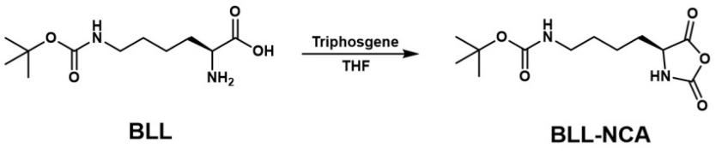
Synthesis of BK₁₀
BLL-NCA (272.3 mg, 1 mmol) was dissolved in dimethylformamide (DMF, 1 mL), and n-butylamine/DMF solution (0.1 M, 1 mL) was added. The reaction mixture was stirred at room temperature. The progress of the reaction was monitored in real-time by Fourier-transform infrared (FTIR) spectroscopy until the NCA monomer was completely consumed. The polymer was precipitated with diethyl ether, followed by centrifugation and vacuum drying to yield BK₁₀ (200.3 mg, 85.1% yield).
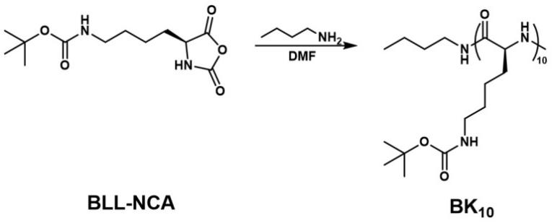
Synthesis of K₁₀
BK₁₀ (200 mg) was dissolved in trifluoroacetic acid (TFA, 2 mL). The reaction mixture was stirred at room temperature for 2 h, after which the product was precipitated with diethyl ether and collected by centrifugation. The resulting solid was dissolved in a 0.2 M NaHCO₃ solution and transferred to a dialysis bag (MWCO = 3500 Da), where it was dialyzed against deionized water for 3 days. The dialysate was freeze-dried to obtain K₁₀ (105.4 mg, 91.1% yield).
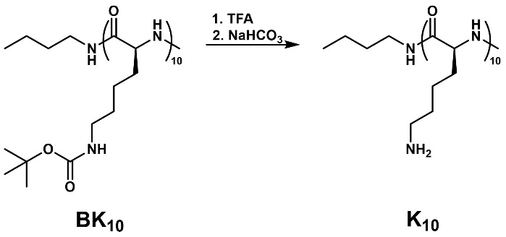
Synthesis of HA-BK
BK₁₀ (129.0 mg, 53.5 μmol) was dissolved in DMF (10 mL), and hyaluronic acid (HA, 136.9 mg, 1.8 μmol) was dissolved in aqueous HCl solution (pH 5, 10 mL). To the HA solution, EDC (102.7 mg, 0.6 mmol) and NHS (30.8 mg, 0.3 mmol) were added. After stirring for 30 min at room temperature, the BK₁₀ solution was added, and the reaction was allowed to proceed for 3 days. The reaction mixture was then transferred to a dialysis bag (MWCO = 3500 Da) and dialyzed against deionized water for 3 days. The crude product was freeze-dried and further purified by washing with DMF and precipitating with diethyl ether. The final product was obtained by centrifugation and vacuum drying (HA-BK, 150.5 mg, 61.2% yield). Here, x represents the number of disaccharide units composed of _{D}-glucuronic acid and N-acetylglucosamine, and y represents the number of polysaccharide units modified with BK₁₀ (x + y = 1, DS = 100y).
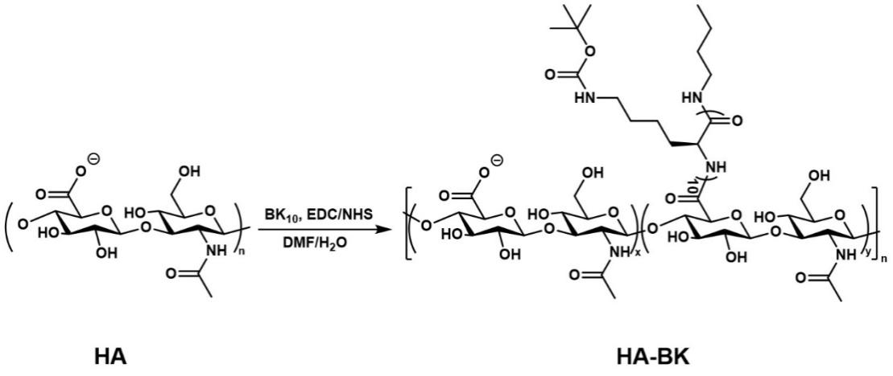
Synthesis of HA-K
HA-BK (150.5 mg) was dissolved in trifluoroacetic acid (TFA, 2 mL), and the reaction mixture was stirred at room temperature for 2 h. After completion, the product was precipitated with diethyl ether and collected by centrifugation. The solid was then dissolved in a 0.2 M NaHCO₃ solution and transferred to a dialysis bag (MWCO = 3500 Da). It was dialyzed against deionized water for 3 days and freeze-dried to yield HA-K (64.3 mg, 50.6% yield). Here, x is the number of disaccharide units composed of D-glucuronic acid and N-acetylglucosamine, and y is the number of units in the polysaccharide structure modified with K₁₀ (x + y = 1, DS = 100y).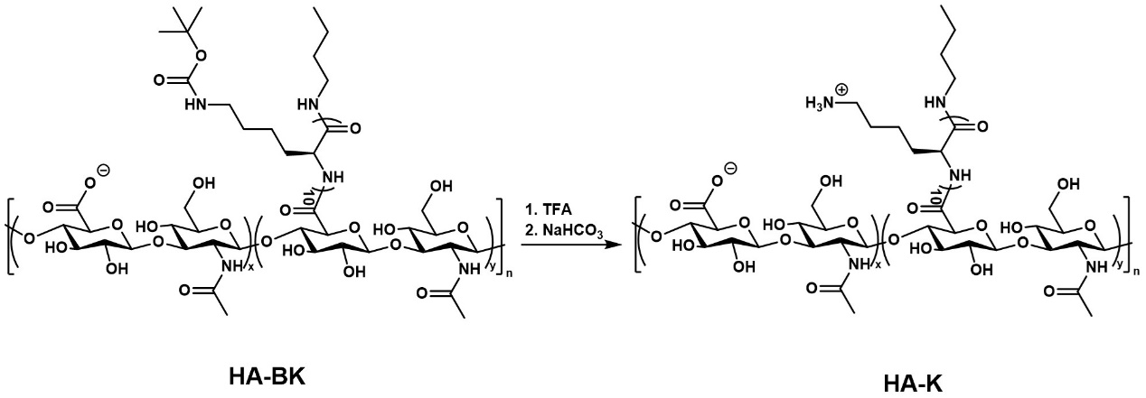

Modification of HA-K with rhodamine B
HA-K (10 mg, 0.12 μmol) was dissolved in deionized water (3 mL), and rhodamine B isothiocyanate (1.6 mg, 3 μmol) was added. The reaction was allowed to proceed at room temperature for 24 h. Following completion, the reaction mixture was transferred into a dialysis bag (MWCO = 3500 Da) and dialyzed against deionized water for 3 days. The dialyzed solution was then freeze-dried to yield a purple-red solid, rhodamine B-labeled HA-K.

Modification of HA-K with Cy5
Cy5-NHS (10 mg/mL, 3 μmol) was dissolved in DMSO, and HA-K (5 mg, 0.06 μmol) was dissolved in deionized water (2 mL). Triethylamine (2 μL, 14 μmol) was added to the mixture, which was stirred at room temperature overnight in the dark. The product was dialyzed against deionized water (MWCO = 3500 Da) for 3 days, followed by freeze-drying to yield Cy5-labeled HA-K as a blue solid.

Modification of HA-K with TPE
HA-K (10 mg, 0.12 μmol) was dissolved in deionized water (3 mL), and EDC (3.2 mg, 12 μmol) and NHS (2.3 mg, 6 μmol) were added. After stirring at room temperature for 30 min, TPE-NH₂ (3.6 mg, 6 μmol) was added, and the reaction proceeded for 24 h at room temperature. After completion, the reaction mixture was transferred to a dialysis bag (MWCO = 3500 Da) and dialyzed against deionized water for 3 days. The dialyzed solution was freeze-dried to yield the final product, HA-K-TPE.

Polymeric morphology observation by TEM
To characterize the polymeric morphology, 10 μL of HA-K PEC (100 μg/mL) in deionized water was deposited onto a copper grid. A 230-mesh copper grid coated with a thin carbon film was used as the TEM support. The grid was air-dried at room temperature before imaging. The morphology of HA-K PEC was then observed using TEM.
Stability of HA-K PEC in serum or enzyme solutions
The HA-K PEC solution (100 μg/mL) was mixed with mouse serum (1:4, V/V) and incubated at 37 °C. At predetermined time points (0-48 h), aliquots were collected and measured by DLS.
A representative stability in the presence of enzyme was as follows. HA-K PEC (100 μg/mL) were incubated with enzyme (e.g., Proteinase K, 15 mg/mL) in phosphate buffer (pH 7.4) at 37 °C. At predetermined time points (0-48 h), aliquots were collected and measured by DLS.

Antibacterial assay
The minimal inhibitory concentration (MIC) of HA-K PEC was determined according to the Clinical and Laboratory Standards Institute (CLSI) broth microdilution protocol.^{[1]} S. aureus and E. coli were cultured in TSB and LB media, respectively, at 37 °C with shaking at 200 rpm until reaching the desired growth phase. Cultures were harvested by centrifugation and washed three times with PBS to remove residual media. The bacterial suspensions were then diluted with LB medium to 1 × 10⁶ CFU/mL. Aliquots of 100 μL were dispensed into 96-well microplates containing serial dilutions of HA-K PEC (0–400 μg/mL). Plates were incubated at 37 °C for 24 h under aerobic conditions, and bacterial growth was measured at OD₆₀₀ using a microplate reader. MIC was defined as the lowest HA-K PEC concentration resulting in ≥ 80% growth inhibition relative to the untreated control.
To determine the minimum bactericidal concentration (MBC), 100 μL of bacterial suspension from each MIC well was serially diluted in PBS, and 100 μL of the dilutions was plated onto LB agar plates. Plates were incubated at 37 °C for 16 h, and colony formation was recorded. The bacterial suspension without HA-K PEC served as a control. MBC was defined as the lowest polymer concentration that eliminated ≥ 99.9% of viable bacteria.
$$Bacterial viability \%=\frac{CFU of sample}{CFU of control}×100\%$$

Bacterial cell viability assay by staining with SYTO 9 and PI

For planktonic bacteria, bacterial suspensions (1 × 10⁸ CFU/mL) was co-incubated with HA-K PEC at 37 °C for 24 h. Afterwards, the mixture was stained with SYTO 9 (10 μM) and PI (10 μM) for 15 min. Samples were washed three times with PBS prior to flow cytometry and cell separation.

For bacteria within biofilm, biofilm was co-incubated with HA-K PEC at 37 °C for 24 h. Then, ultrasonication was used to detach the bacteria. The mixture was stained with SYTO 9 (10 μM) and PI (10 μM) for 15 min. Samples were washed three times with PBS prior to flow cytometry and cell separation.

In vitro biofilm inhibition assay
A 96-well plate was loaded with 100 μL of bacterial suspension (1 × 10⁸ CFU/mL), followed by 100 μL of HA-K PEC (100 μg/mL) in PBS. After incubation at 37 °C for 24 h, wells were washed three times with PBS. Biofilms were stained with 1% crystal violet for 15 min, washed to remove excess dye, and subsequently solubilized with 33% (v/v) acetic acid. Absorbance at OD₅₉₀ was measured with a microplate reader. The minimum biofilm inhibitory concentration (MBIC) was defined as the lowest polymer concentration that inhibited ≥ 90% of biofilm formation compared with the control.
$$Biofilm growth \%=\frac{OD of sample-OD of blank}{OD of control-OD of blank}×100\%$$

Drug resistance assay
The initial MBIC (MBIC₀) of HA-K PEC and vancomycin against S. aureus was determined. Bacterial suspensions treated with 0.5 × MBIC of each compound were used to prepare inocula (1 × 10⁸ CFU/mL) for subsequent passages. Suspensions were added to 96-well plates with varying concentrations of HA-K PEC or vancomycin, and MBIC was reassessed after 24 h at 37 °C. This procedure was repeated for 15 consecutive passages, with MBIC of each passage recorded as MBIC_{n}. Bacterial resistance was evaluated by calculating the ratio of MBIC_{n} to MBIC₀.

Binding constant of polymer to SPA assay
Absorption spectra of free SPA and HA-K PEC–SPA complexes were recorded in PBS from 190 to 400 nm at room temperature. SPA interaction studies were conducted using 100 μg/mL SPA with increasing concentrations of HA-K PEC (25–400 μg/mL). Binding constants (K_{b}) were calculated using the Benesi-Hildebrand equation:
$$\frac{A₀}{(A-A₀)}= \frac{ε_{f}}{{(ε}_{b}- {}_{f)}}+ \frac{ε_{f}}{{(ε}_{b}- {}_{f)} K_{b }[Analyte]}$$
A₀ denotes the absorbance of free SPA, whereas A denotes the absorbance of bound form of SPA with HA-K PEC. In this equation, ε_{f} and ε_{b} denote the molar extinction coefficients of SPA in free and fully bound form, respectively. The values of binding constant (K_{b}) were estimated using the ratio of intercept-to-slope of the (A- A₀)/A₀ and [compound] plot.

Binding efficiency of HA-K PEC to bacteria assay
Bacterial suspensions (1 × 10⁸ CFU/mL) were stained with SYTO 9 (10 μM) for 15 min, washed with PBS, and resuspended in Cy5-labeled HA-K PEC (50 μg/mL) for 30 min. Samples were washed three times with PBS prior to flow cytometry and cell separation.

Planktonic bacterial morphologies observation by SEM
Bacterial suspensions (1 mL, 1 × 10⁸ CFU/mL) were mixed with an equal volume of HA-K PEC (100 μg/mL) and incubated at 37 °C for 24 h. Samples were fixed with 2.5% glutaraldehyde overnight and dehydrated using a graded ethanol series (20%, 30%, 50%, 70%, 99%). After the final dehydration, 100 μL of the suspension was deposited onto a PDMS surface and air-dried in a fume hood. The surface was sputter-coated with gold prior to SEM observation.

Bacterial morphologies observation by TEM
Overnight bacterial cultures were diluted with PBS to 1 × 10⁸ CFU/mL and incubated with an equal volume of HA-K PEC (100 μg/mL) at 37 °C for 2 h. The mixture was then serially diluted 10⁴-fold, and 10 μL of the final dilution was placed onto a carbon-coated 230-mesh copper grid and air-dried. Bacterial suspensions without polymer treatment served as controls. Morphologies were observed using TEM.

In vitro biofilm eradication assay
A 96-well plate was inoculated with 100 μL of bacterial suspension (1 × 10⁸ CFU/mL) and incubated at 37 °C for 24 h to allow biofilm formation. Subsequently, HA-K PEC (50 μg/mL in PBS) was added and the plate was further incubated at 37 °C for 1, 3, or 5 d. After incubation, the supernatant was carefully removed and the remaining biofilm was stained with 1% crystal violet for 15 min. The plate was then washed three times with water to remove excess dye. The bound crystal violet was subsequently dissolved in 33% (v/v) acetic acid, and the absorbance at OD₅₉₀ was measured using a microplate reader. The minimum biofilm eradication concentration (MBEC) was defined as the lowest polymer concentration that resulted in at least a 90% reduction in biofilm biomass compared with the untreated control.
$$Biofilm survival \%=\frac{OD of sample-OD of blank}{OD of control-OD of blank}×100\%$$

Live/dead staining assay
A fluorescence-based live/dead staining assay was performed to further evaluate the bactericidal activity of HA-K PEC. Briefly, biofilms were treated for 24 h using the procedure described above and then stained with SYTO 9 (10 μM, excitation wavelength (E_{x}) = 483 nm/emission wavelength (E_{m}) = 500 nm) and propidium iodide (PI) (10 μM, E_{x} = 535 nm/E_{m} = 617 nm) under dark conditions for 15 min. The stained biofilms were observed using confocal laser scanning microscopy (CLSM) to visualize live (green fluorescence) and dead (red fluorescence) bacteria.

Biofilm penetration assay
Biofilms of different maturation stages (1-day-old, 3-day-old, and 5-day-old) were gently washed with PBS and then incubated with rhodamine B-labeled HA-K PEC (50 μg/mL) at 37 °C for different time periods (0, 2, 4, and 8 h). After incubation, excess PEC was removed by washing with PBS. The biofilms were then stained with SYTO 9 (10 μM) for 20 min to label live bacteria, followed by PBS washing to remove unbound dye molecules. The stained biofilms were imaged using CLSM (SYTO 9: E_{x} = 483 nm, E_{m} = 500 nm; rhodamine B: E_{x} = 543 nm, E_{m} = 565 nm).
A layer-by-layer tomographic scanning along the vertical Z-axis of the biofilm was used to spatial quantitative analysis the penetration property of HA-K PEC. A fixed step thickness was used to collect continuous longitudinal sections. Each Z-axis slice collected along the thickness direction of the biofilm was numbered as Layer in scanning order. The horizontal axis of Layer 1 corresponds to the bottom layer of the biofilm that is closely attached to the glass slide substrate. An increase in the value of Layer represents an extension towards the surface layer of the biofilm. Layer 8 is the outermost layer of the biofilm set for scanning in this group. The average intensity (a.u.) of green and red fluorescence signals within each slice is extracted by image quantification software to characterize the distribution and abundance of target substances at different longitudinal depths of the biofilm.

Extraction of EPS
EPS was extracted from biofilms using a formaldehyde–NaOH method. Briefly, a 12-well plate was inoculated with 1 mL of S. aureus suspension (1 × 10⁸ CFU/mL) and incubated at 37 °C to allow biofilm formation. After 72 h of incubation, the culture medium was removed. The biofilm was then dispersed in 1 mL of PBS by sonication. The resulting suspension was centrifuged (4 °C, 3000 g, 15 min) to collect bacterial cells. The pellet was resuspended in 1 mL of 4% paraformaldehyde solution and incubated at 4 °C for 1 h to fix the cells. After fixation, the sample was centrifuged (4 °C, 5000 g, 15 min), and the resulting pellet was resuspended in 0.5 M NaOH. The suspension was incubated at room temperature for 3 h to extract EPS. Subsequently, the EPS extract was separated by centrifugation (4 °C, 20000 g, 45 min). The supernatant was collected and transferred into dialysis tubing (MWCO = 3500 Da) and dialyzed against deionized water for 72 h. The dialyzed solution was finally lyophilized to obtain purified EPS.

Measurement of the content of protein and exopolysaccharide in biofilms
A 96-well plate was loaded with 100 μL of the bacterial suspension (1 × 10⁸ CFU/mL) and was then incubated at 37 °C for 24 h to allow for biofilm formation. Then, HA-K PEC (50 μg/mL in PBS) was added and incubated at 37 °C for 1, 3 and 5 d. After discarding the supernatants, the protein content in biofilm was measured using a BCA protein assay kit according to the manufacturer's instructions. The absorbance of each sample at OD₅₆₂ was measured by a microplate reader.
The effect of the HA-K PEC on the content of exopolysaccharides in biofilms was measured by the phenol-sulfuric acid method. A 96-well plate was loaded with 100 μL of the bacterial suspension (1 × 10⁸ CFU/mL) and was then incubated at 37 °C for 24 h to allow for biofilm formation. Then, HA-K PEC (50 μg/mL in PBS) was added and incubated at 37 °C for 1, 3 and 5 d. After discarding the supernatants, the biofilm at the bottom of the 96-well plate was dispersed into 150 µL of PBS by sonication for 20 min and the supernatant was obtained by centrifugation (5000 g, 5 min). The supernatant (100 µL) was mixed with an equal volume of phenol solution (50 mg/mL), then 500 µL of 95% sulfuric acid solution was added and incubated for 30 min at 25 °C. The absorbance of each sample at OD₅₉₅ was measured by a microplate reader.

EPS specific fluorescence staining
A representative procedure is as follows. Biofilms were treated with HA-K PEC for 24 h. Then biofilms were stained with SYTOX Green (1 μM, E_{x} = 502 nm, E_{m} = 525 nm) and SYPRO RUBY (1 μM, E_{x} = 280 nm, E_{m} = 450 nm) under dark conditions for 15 min. The content and distribution of eDNA and protein in stained biofilms were observed under CLSM. The experimental images were analyzed with ImageJ.

Fluorescence spectrum of HA-K-TPE assay
To evaluate the interaction between HA-K-TPE and EPS, 1 mL of HA-K-TPE solution (100 μg/mL in PBS) was incubated with 1 mL of EPS solution (100 μg/mL in PBS) at 37 °C for 2 h. After incubation, an aliquot of the mixture was transferred into a quartz cuvette. The fluorescence emission spectrum was recorded using a fluorescence spectrophotometer with an excitation wavelength of 365 nm, and the emission spectrum was scanned from 400 to 800 nm. HA-K-TPE solution without EPS treatment was used as the control.

Membrane permeability assay
Bacteria (S. aureus or E. coli) were grown and harvested, washed, and re-suspended in 5 mM glucose and 5 mM HEPES buffer (1:1) (pH 7.2). The bacterial suspension (150 μL) was added to wells of a black 96-well plate. Then PI (10 μM, 50 μL) was added to the wells containing bacterial suspension and pre-incubated for about 5 min for S. aureus or E. coli. After the incubation, fluorescence was measured for next 8 min at every 2 min interval using a fluorescent microplate reader (excitation 535 nm, emission 617 nm). 20 μL of HA-K PEC (50–400 μg/mL, prepared in HEPES-glucose buffer) was added, and changes in fluorescence were monitored. Bacteria treated with vancomycin and polymyxin B as controls, respectively.
To assess the effect on biofilm bacteria, bacterial suspension (100 μL, 1 × 10⁸ CFU/mL) was added to a 96-well plate and incubated at 37 °C for 24 h to allow biofilm formation. The supernatant was then carefully aspirated, and the biofilm was gently washed once with PBS. Then, 100 μL of HA-K PEC (100–800 μg/mL) in HEPES-glucose buffer and 100 μL of M9 medium were added to the biofilm. After incubation at 37 °C for 24 h, the supernatant was removed and the biofilm was washed with PBS. Then, PI (10 μM, 200 μL) was added to the biofilm. After incubation in the dark for 5 min, the fluorescence intensity (excitation/emission = 535/617 nm) was measured using a microplate reader. Bacteria treated with HEPES-glucose buffer alone was used as the control.

Biofilm bacterial ROS expression assay
The effect of HA-K PEC on reactive oxygen species (ROS) production in biofilm bacteria was evaluated. Briefly, 100 μL of bacterial suspension (1 × 10⁸ CFU/mL) was added to a 96-well plate and incubated at 37 °C for 24 h to allow biofilm formation. Subsequently, 100 μL of HA-K PEC (100 μg/mL in PBS) and 100 μL of M9 medium were added to the wells. The plate was incubated at 37 °C for 24 h. After incubation, the supernatant was removed and the wells were washed three times with PBS. Then, 100 μL of DCFH-DA (10 μM) was added to each well and incubated at 37 °C in the dark for 30 min. The fluorescence intensity (excitation/emission = 485/528 nm) was measured using a microplate reader.
For the CCCP inhibition experiment, CCCP powder was dissolved in DMSO to prepare a 10 mM stock solution. S. aureus biofilms (1-day-maturity) were pre-incubated with culture medium containing CCCP at a final concentration of 10 μM for 30 min at 37 °C to fully inhibit bacterial respiratory chain activity. After pretreatment, the residual CCCP solution was discarded, and the biofilm samples were gently washed twice with sterile PBS to remove free CCCP. Then fresh medium with HA-K PEC (100 μL of HA-K PEC (100 μg/mL in PBS) was added to incubate the biofilms for 24 h. After incubation, the biofilms were stained with DCFH-DA fluorescent probe at a working concentration of 10 μM and incubated at 37 °C for 20 min in the dark, and the intracellular ROS levels of each group were quantitatively detected.

MTT assay
An MTT assay was performed to evaluate the viability of bacteria within the remaining biofilm. Briefly, 100 μL of bacterial suspension (1 × 10⁸ CFU/mL) was added to each well of a 96-well plate and incubated at 37 °C for 24 h to allow biofilm formation. Subsequently, HA-K PEC (50 μg/mL in PBS) was added and incubated at 37 °C for 1, 3, or 5 days. After incubation, the supernatant was carefully removed. Then, 100 μL of MTT solution (0.5 mg/mL in PBS) was added to each well containing biofilms and incubated in the dark at 37 °C for 30 min. The supernatant was subsequently removed, and the resulting formazan crystals were dissolved in DMSO. The absorbance at 595 nm was measured using a microplate reader.

Agar plate culture
The number of surviving bacteria within biofilms was determined by plate counting. A total of 100 μL of bacterial suspension (1 × 10⁸ CFU/mL) was added to each well of a 96-well plate and incubated at 37 °C for 24 h to allow biofilm formation. HA-K PEC (50 μg/mL in PBS) was then added and incubated at 37 °C for 1, 3, or 5 days. After removing the supernatant, 120 μL of PBS was added to each well. The plate was ultrasonicated for 3 min to detach the biofilms from the wells. The resulting bacterial suspensions were serially diluted. Subsequently, 100 μL of each dilution was spread onto LB agar plates and incubated at 37 °C for 16 h. Visible colonies were then observed and photographed.

Bacterial swarming and twitching motility assay
Swarming motility assays were performed using E. coli on LB agar plates in the presence or absence of polymers. The autoclaved agar solution was cooled to 60 °C, and an aqueous polymer solution (10 mg/mL) was added to obtain a final polymer concentration of 50 μg/mL. The mixture was poured into the wells of a 6-well plate and allowed to solidify in a sterile laminar flow hood for 1 h. Subsequently, 1 μL of mid-log phase E. coli culture (OD₆₀₀ = 0.5) grown in LB medium was inoculated onto the center of the agar surface. The plate was incubated at 37 °C for 16 h. The diameter of the resulting swarming zones was measured using ImageJ.
For twitching motility assays, 10 mL of LB agar containing polymer (50 μg/mL) was poured into each well of a 6-well plate. A mid-log phase E. coli culture (OD₆₀₀ = 0.5) was inoculated by stabbing through the agar to the plastic surface using a sterile needle. The plate was incubated at 37 °C for 20 h. After incubation, the agar was carefully removed using tweezers to expose the twitching zone at the agar-plastic interface. The twitching zone was stained with 0.1% crystal violet and the twitching diameter was quantified using ImageJ.

Biofilm bacterial morphologies observation by SEM
For scanning electron microscopy (SEM) observation, PDMS slides were placed in the wells of a 12-well plate. A total of 1 mL of bacterial suspension (1 × 10⁸ CFU/mL) was added to each well and incubated at 37 °C for 24 h to allow biofilm formation on the slides. The slides were then treated with 1 mL of HA-K PEC (50 μg/mL in PBS) for 24 h at 37 °C. After treatment, the slides were gently washed three times with PBS. Subsequent procedures for fixation, washing, dehydration, drying, and sputter coating were performed as described for planktonic bacterial samples.

Ethical statement
The animal experiments were approved by the Institutional Animal Care and Use Committee at Soochow University. The animal experimental protocols were performed by the NIH guidelines for the care and use of laboratory animals (NIH Publication No. 85-23 Rev. 1985).

In vivo biofilm inhibition assay
The in vivo biofilm inhibition assay was conducted as follows. Mice were anesthetized with 1% pentobarbital sodium. The dorsal skin was shaved, disinfected, and incised. PDMS slides (0.5 cm × 0.5 cm) were subcutaneously implanted, and the skin incisions were immediately sutured. Subsequently, 100 μL of S. aureus suspension (1 × 10⁸ CFU/mL) was injected at each implantation site. Mice were divided into two groups, namely the control group (treated with 100 μL PBS) and the treatment group that each mouse received a local injection of HA-K PEC (50 μg/mL in PBS, 100 μL). Groups of mice (n = 3 per group) were euthanized on days 3 and 7 post-treatment. The implants (i.e., implanted PDMS slides) and surrounding tissues were surgically excised. The explanted PDMS slides were used for SEM observation or they were gently rinsed with PBS and subjected to ultrasonication for 5 min to detach adherent bacteria. The resulting bacterial suspensions were serially diluted, and 100 μL of each dilution was plated on LB agar plates and incubated at 37 °C for 16 h. Colonies were then observed and photographed. The surrounding tissues were fixed in 4% paraformaldehyde, dehydrated in a graded series of ethanol solutions, embedded in paraffin, and cut into 5 μm-thick sections. Then, the tissues were stained with hematoxylin and eosin (H&E), and observed using high-resolution 3D cellular imaging system.

In vivo biofilm eradication assay
The in vivo biofilm eradication assay was performed as follows. Mice were anesthetized with 1% pentobarbital sodium. The dorsal skin was shaved, disinfected, and incised. PDMS slides (0.5 cm × 0.5 cm) containing pre-formed biofilms were subcutaneously implanted and the skin wounds were sutured. Mice were divided into two groups, namely the control group (treated with 100 μL PBS) and the treatment group that each mouse received a local injection of HA-K PEC (50 μg/mL in PBS, 100 μL). Groups of mice (n = 3 per group per time point) were euthanized on days 3 and 7 post-treatment. The implants and surrounding tissues were excised. The explanted PDMS slides were used for SEM observation or they were rinsed with PBS and transferred into tubes containing 1 mL PBS, followed by sonication for 5 min to disperse adherent bacteria. The bacterial suspensions were serially diluted, plated on LB agar plates, and incubated at 37 °C for 16 h before colony counting. The surrounding tissues were fixed in 4% paraformaldehyde, dehydrated in a graded series of ethanol solutions, embedded in paraffin, and cut into 5 μm-thick sections. Then, the tissues were stained with H&E, and observed using high-resolution 3D cellular imaging system.

Inflammatory factor assay
In the above animal model, mice (n = 3 per group per time point) were euthanized on days 3 and 7 post-treatment. Blood samples were collected and serum was isolated. The level of TNF-α in serum was measured using an enzyme-linked immunosorbent assay (ELISA) kit according to the manufacturer's instructions.

Biodistribution assay
For the biodistribution study in mice, Cy5-labeled HA-K PEC were i.v. injected to normal mice at 50 μg/mL. At 0.5, 2, 4, 6, 12, 24, and 48 h post injection, mice were sacrificed. The major organs including heart, liver, spleen, lung and kidney were harvested and imaged using a Maestro optical imaging system (λ_{ex} = 640 nm, λ_{em} = 670 nm) (IVIS, Cambridge Research and Instrumentation Inc.).

Polymer hemolysis assay
Erythrocytes were mixed with equal volumes of polymer solutions of different concentrations. After incubation at 37 °C for 2 h, the solution was centrifuged at 1000 rpm for 10 min, and the supernatant was added to a 96-well plate. The absorbance of each sample at OD₄₅₀ was measured by a microplate reader, which is the amount of hemoglobin released. The red blood cell suspension without polymer was used as the negative control, and the red blood cell suspension treated with PBS with a volume fraction of 1% Triton X-100 was used as the positive control. Three independent experiments were performed for each group.
$$Hemolysis \%=\frac{OD of sample-of negative control}{OD of positive control-OD of negative control}×100\%$$

Polymer cytotoxicity assay
Cells were seeded into a 96-well plate. After incubation at 37 °C overnight, the medium was replaced with fresh medium, and polymer solutions at different concentrations were added. After incubation at 37 °C for 24 h, MTT reagent (20 μL, 5 mg/mL) was added to each well. The plate was incubated at 37 °C for 4 h to allow formazan crystal formation. After incubation, the MTT-containing medium was carefully aspirated, ensuring that the formazan crystals remained intact at the bottom of the wells. DMSO (200 μL) was then added to each well to dissolve the crystals. The plate was placed on a shaker and shaken at 100 rpm for 15 min to ensure complete dissolution. The absorbance of each sample at OD₄₉₀ was measured by a microplate reader. The toxicity of the polymer to the cells was calculated by using the solution without polymer as a negative control group, at which time the cell viability was 100%. Three independent experiments were performed for each group.
$$Cell viability \%=\frac{OD of sample}{OD of control}×100\%$$

Biocompatibility of materials assay
To evaluate the in vivo biocompatibility of HA-K PEC, healthy BALB/c mice were randomly divided into 2 groups. The two groups were intravenously injected with 100 μL of PBS and HA-K PEC (100 mg/mL in PBS), respectively. Three days post-injection, blood was collected from the mice via cardiac puncture for complete blood count and blood biochemical analysis. The complete blood count was analyzed on a Cobas501 automatic hematology analyzer (Roche, Switzerland), and blood biochemistry was assessed using a BC-5380 automatic chemical analyzer (Mindray, China).
RNA extraction and cDNA synthesis
Total RNA was extracted using a commercial bacterial RNA extraction kit following the manufacturer's instructions. RNA quality and concentration were assessed prior to reverse transcription. cDNA was synthesized using a reverse transcription kit with genomic DNA removal step.

Quantitative reverse transcription polymerase chain reaction (qRT-PCR)
qRT-PCR was performed using SYBR Green chemistry on a real-time PCR system. Relative gene expression was calculated using the 2^^{-ΔΔCt} method with 16S rRNA as the internal control. All reactions were performed in triplicate.

Proteomic analysis
S. aureus (1 × 10⁸ CFU/mL) was treated with HA-K PEC (100 µg/mL) for 2 h, and the bacteria was collected by centrifugal. Then, the bacteria were treated for protein extraction and quantification, mass spectrometry detection, database search and data analysis, and an extracted protein was obtained.

Effect of HA-K PEC on bacteria bind to epithelial cells assay
S. aureus was incubated in TSB medium at 37 °C overnight. Bacterial suspension was diluted to 1 × 10⁸ CFU/mL in 0.1 M carbonate buffer. Then, Cy5-NHS ester was added to a final concentration of 100 μg/mL. After incubation in the dark at 37 °C for 60 min, the reaction was terminated by adding 0.1 M glycine. The precipitate was obtained by centrifugation (12000 g, 1 min) and washed three times with PBS to remove any unbound Cy5. Then, the precipitate was resuspended.
HaCaT cells were seeded in 6-well plates (3 × 10⁵ cells/well) and cultured overnight at 37 °C in a humidified atmosphere containing 5% CO₂. The next day, Cy5-labeled S. aureus were added to the cells in the presence or absence of HA-K PEC (100 μg/mL in PBS). After incubation at 37 °C for 60 min, the cells were washed once with PBS. Then, the cells were trypsinized and resuspended in PBS. The fluorescence intensity of Cy5 associated with the cells was analyzed by flow cytometry, the software FlowJo was used for data acquisition and analysis.
Supplementary Scheme, Figures, and Tables

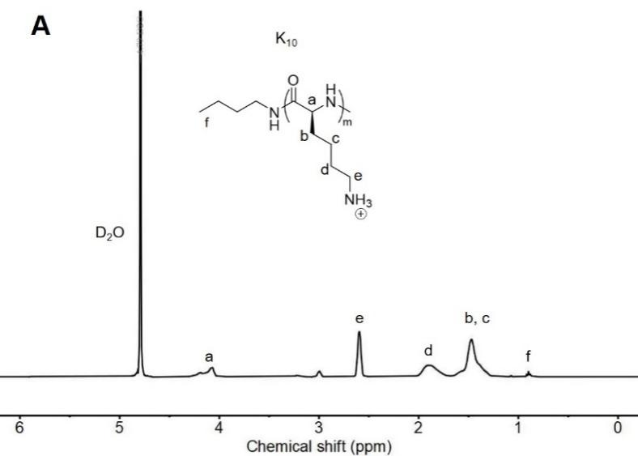

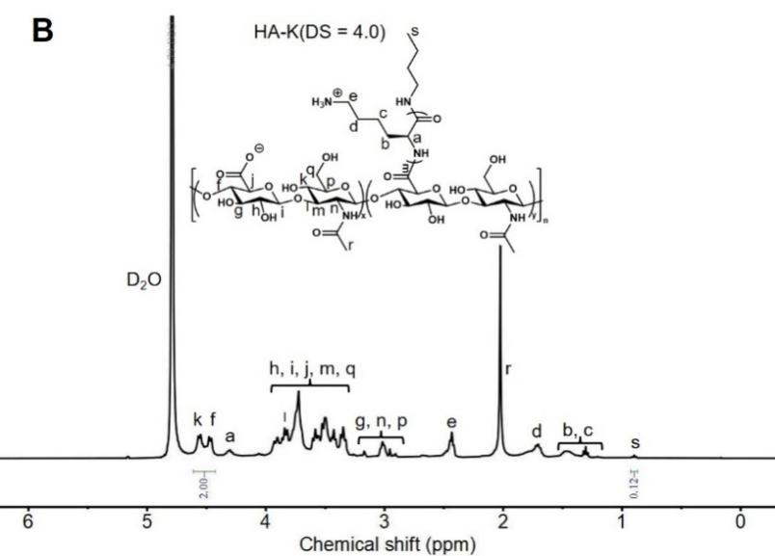

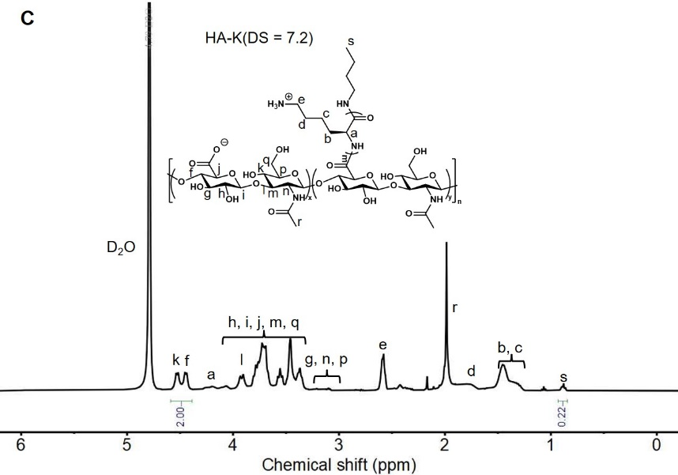
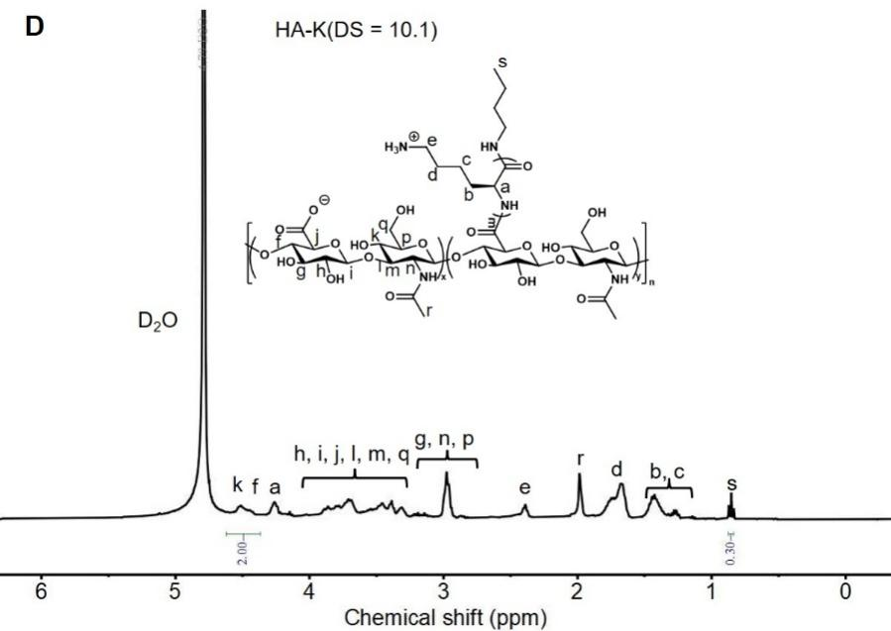
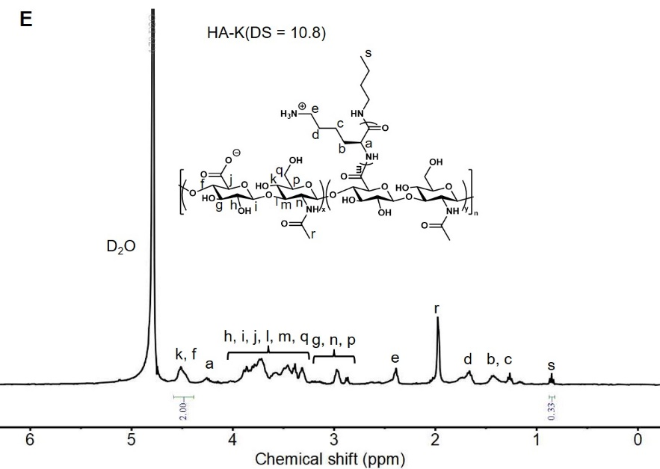
Figure S1. The ¹H NMR of (A) K₁₀, (B) HA-K (DS = 4.0), (C) HA-K (DS = 7.2), (D) HA-K (DS = 10.1) and (E) HA-K (DS = 10.8) (400 MHz, D₂O). The DS of HA-K can be calculated by the integral ratio of H_{f+k} to H_{s}.
Figure S2. GPC trace of BK₁₀.

Table S1. n-Butylamine initiated ROP of BLL-NCA.
Entry | Polymer | [M]₀/[I]₀^{[a]} | M_{n}*^{[b]}  (kDa) | M_{n}^{[c]}  (kDa) | Đ^{[d]}
1 | BK₁₀ | 10:1 | 2.4 | 2.6 | 1.08
[a] Initial monomer to initiator ratio.
[b] Theoretical number average molecular weight (M_{n}*).
[c] M_{n} determined by GPC.
[d] Dispersity determined by GPC.
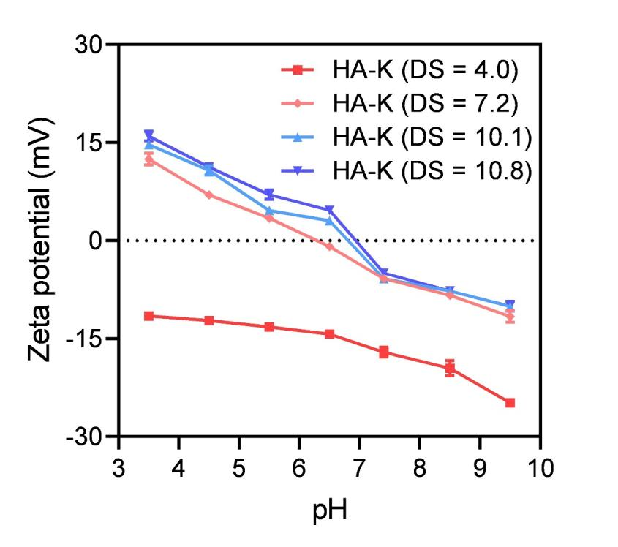
Figure S3. Zeta potentials of HA-K PEC with DS of 4.0, 7.2, 10.1 and 10.8 in aqueous solutions at pH 3.5–9.5 (100 μg/mL). Data are mean ± standard deviation (SD) (n = 3).

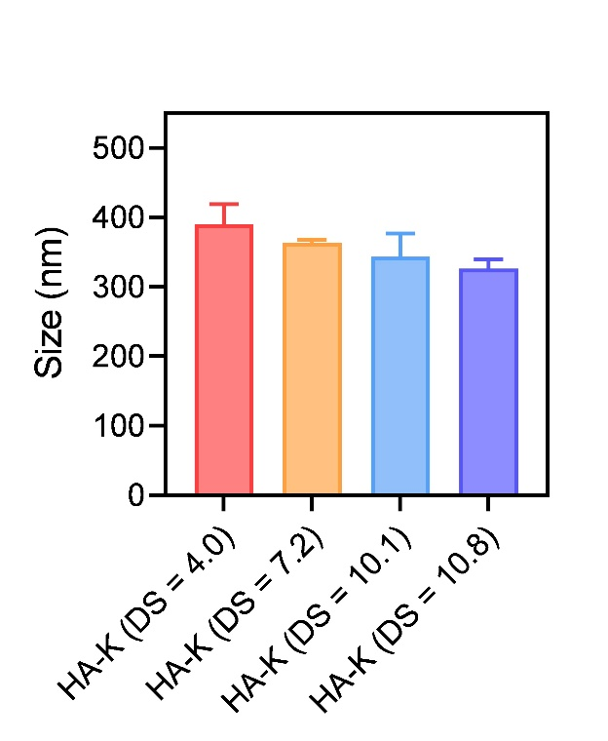
Figure S4. Sizes of HA-K PEC with DS of 4.0, 7.2, 10.1 and 10.8 in aqueous solutions at pH 7.4 (100 μg/mL). Data are mean ± standard deviation (SD) (n = 3).

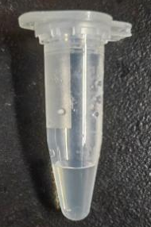
Figure S5. Image of HA-K PEC at 100 mg/mL in PBS.

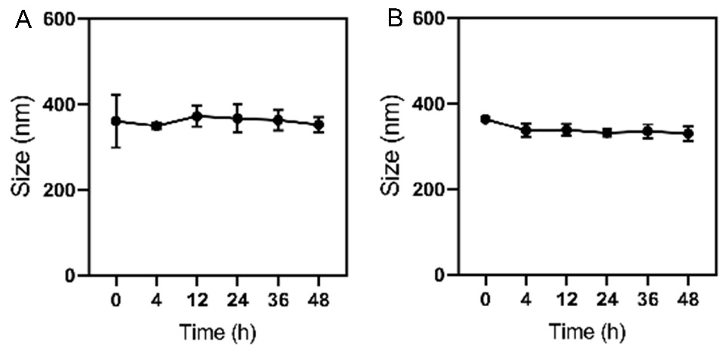
Figure S6. Hydrodynamic diameters (i.e., sizes) of HA-K PEC in (A) proteinase K aqueous solution and (B) serum at different times (0-48 h). Data are mean ± standard deviation (SD) (n = 3).
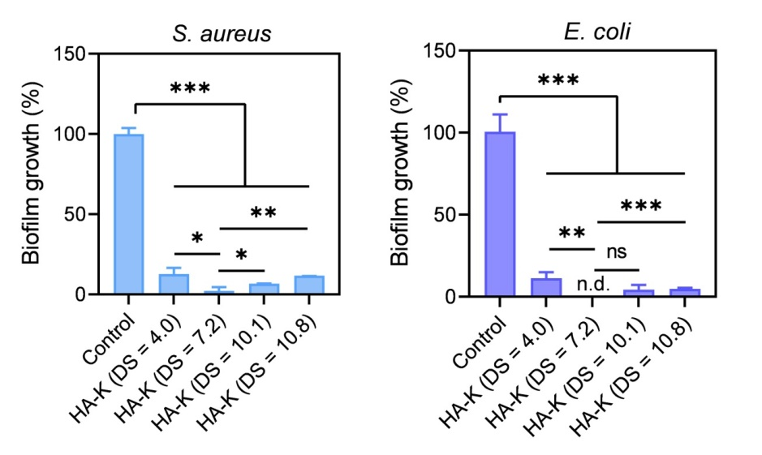
Figure S7. Evaluation of the performance of HA-K with DS of 4.0, 7.2, 10.1 and 10.8 in inhibiting biofilms formation. Biofilm biomass was measured by crystal violet staining at OD₅₉₀ after inhibiting the biofilm, which was treated with a concentration of 50 μg/mL of HA-K at DS values of 4.0, 7.2, 10.1, and 10.8 for 24 h. Data are mean ± standard deviation (SD) (n = 3) (*p< 0.05, **p < 0.01, ***p < 0.001 and ns indicates no statistical significance). n.d. signifies not detected.
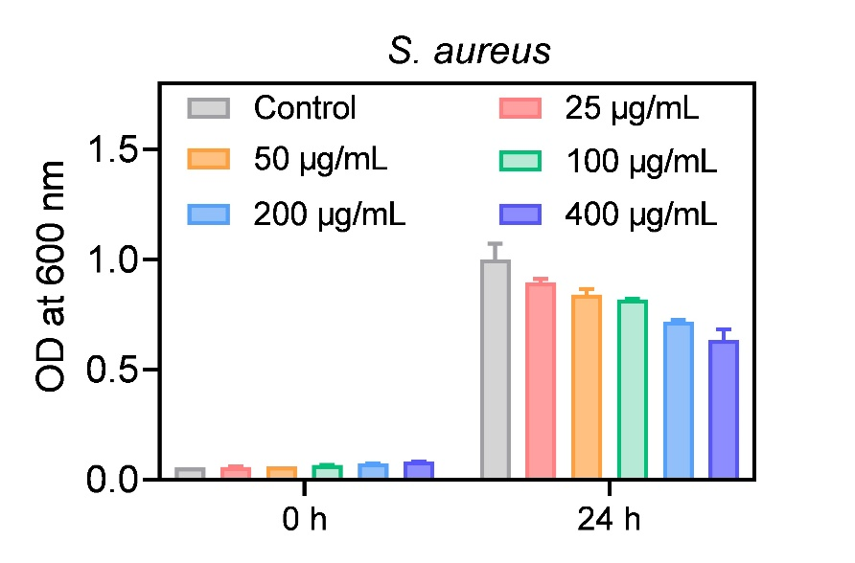
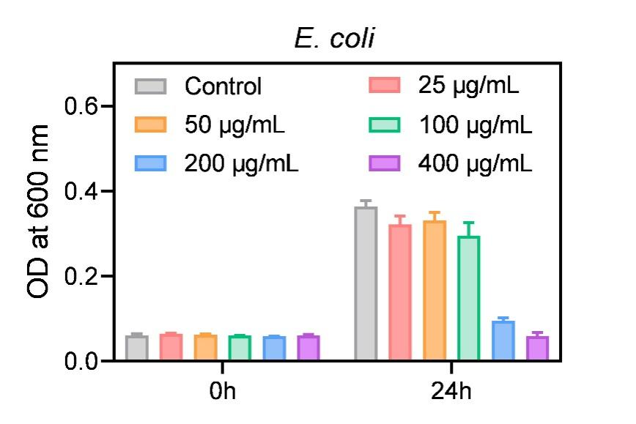
Figure S8. The assay of MIC of HA-K (DS = 7.2) PEC to S. aureus and E. coli. The concentration range of HA-K (DS = 7.2) PEC is 25–400 μg/mL. Data are mean ± standard deviation (SD) (n = 3).

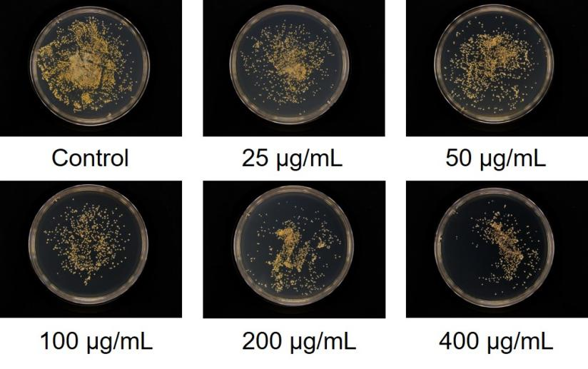
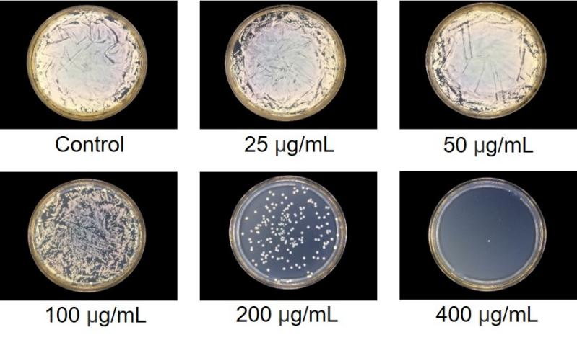
Figure S9. The assay of MBC of HA-K (DS = 7.2) PEC against S. aureus and E. coli. The concentration range of HA-K (DS = 7.2) PEC is 25–400 μg/mL.

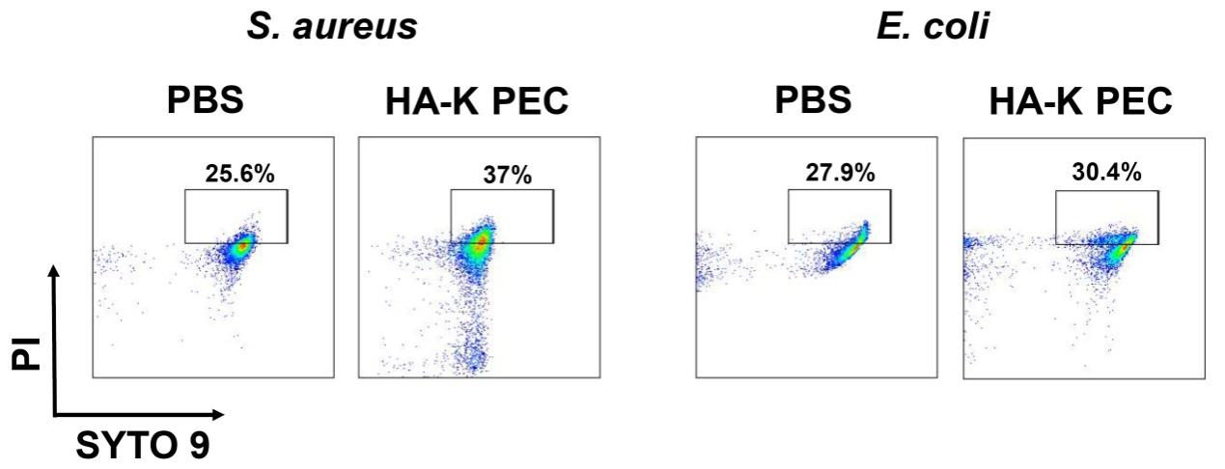
Figure S10. Live/dead bacterial cell viability analysis via flow cytometry. Planktonic bacteria were treated with PBS (control) or HA-K PEC.
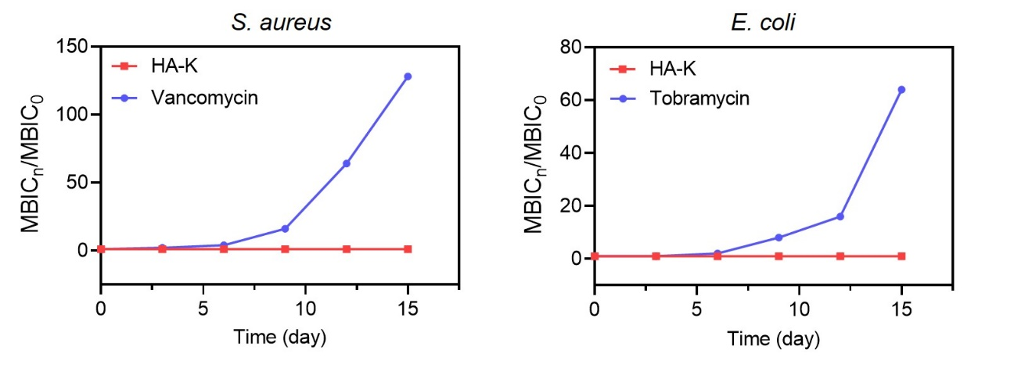
Figure S11. The assay of bacterial resistance of HA-K (DS = 7.2) PEC. The concentration of antimicrobial material was always maintained at 0.5 × MBIC.
Figure S12. qRT-PCR results of typical genes (mprF and clfB) involved in pathways related to antimicrobial peptide/cationic antimicrobial substance tolerance and adhesion-related pathways. The genes were extracted from S. aureus after incubation with 0.5 × MBIC HA-K PEC or 0.5 × MIC vancomycin for 1 day and 5 days. Data are mean ± standard deviation (SD) (n = 3) (*p < 0.05, **p < 0.01, ***p < 0.001). ns signifies not significant.

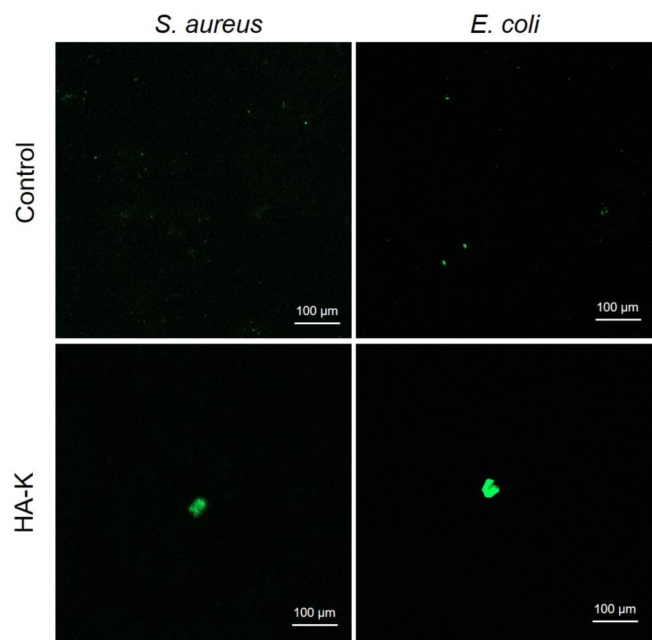
Figure S13. The aggregation behavior of bacteria after interaction with HA-K PEC observed by CLSM (scale bar = 100 μm).

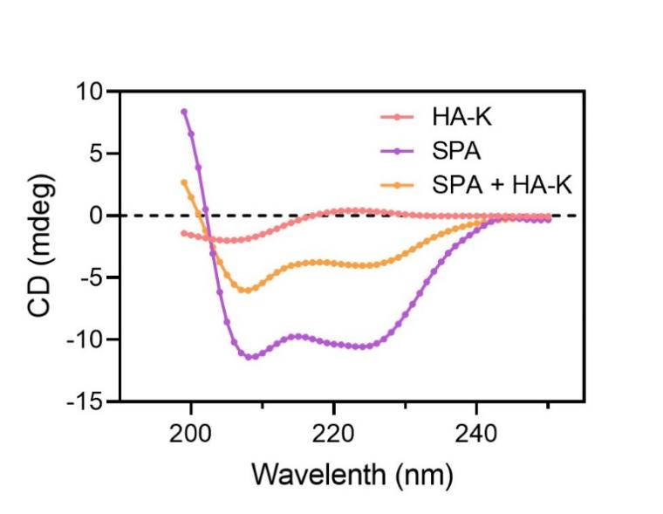
Figure S14. The CD spectra of SPA, HA-K PEC and their mixture in PBS (100 μg/mL).

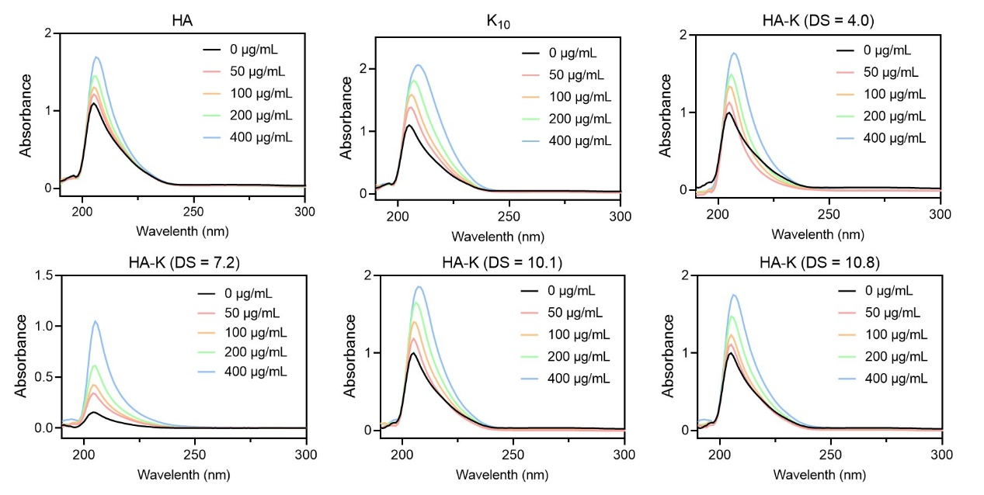
Figure S15. The absorption spectra of SPA in the absence and presence of HA, K₁₀, HA-K (DS = 4.0), HA-K (DS = 7.2), HA-K (DS = 10.1) and HA-K (DS = 10.8) at room temperature.

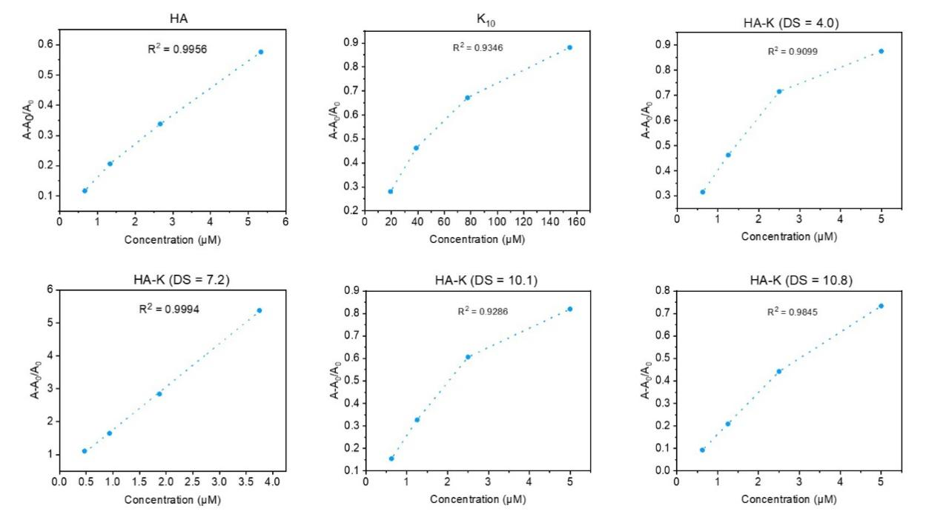
Figure S16. The dotted line plots of A-A₀/A₀ and polymer concentrations of HA, K₁₀, HA-K (DS = 4.0), HA-K (DS = 7.2), HA-K (DS = 10.1) and HA-K (DS = 10.8) at room temperature.

Table S2. Binding constants (K_{b}) of polymers to SPA.
Materials | HA | K₁₀ | HA-K  (DS = 4.0) | HA-K  (DS = 7.2) | HA-K  (DS = 10.1) | HA-K  (DS = 10.8)
K_{b} (M⁻¹) | 9.65 × 10⁴ | 4.19 × 10³ | 1.24 × 10⁵ | 1.31 × 10⁶ | 1.47 × 10⁵ | 1.45 × 10⁵

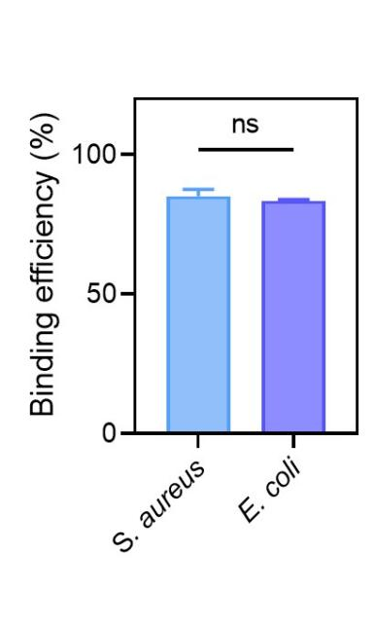
Figure S17. Binding efficiency of HA-K (DS = 7.2) toward to S. aureus and E. coli. Data are mean ± standard deviation (SD) (n = 3) (ns indicates no statistical significance).

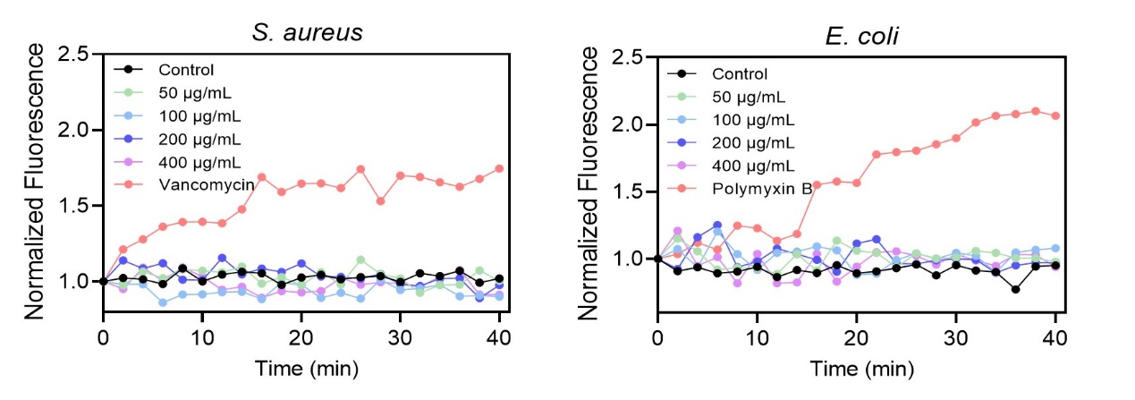
Figure S18. Membrane permeability of S. aureus and E. coli after interaction with HA-K (50–400 μg/mL) and antibiotics (at MIC).

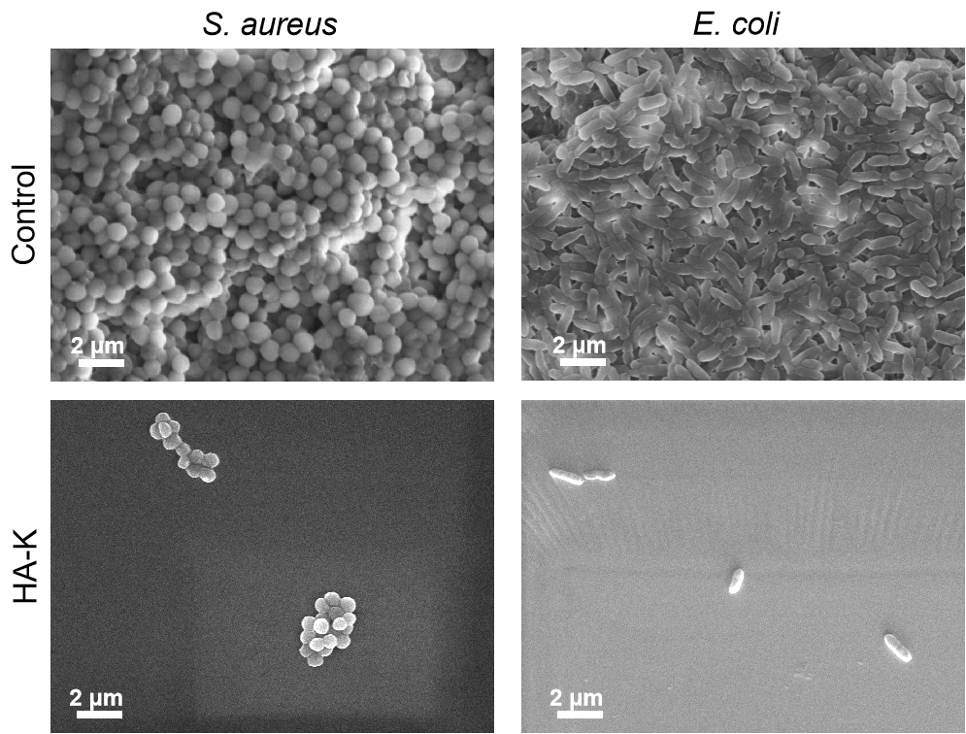
Figure S19. SEM images of S. aureus and E. coli biofilm growth untreated (control) or treated by HA-K PEC (Scale bar = 2 μm).

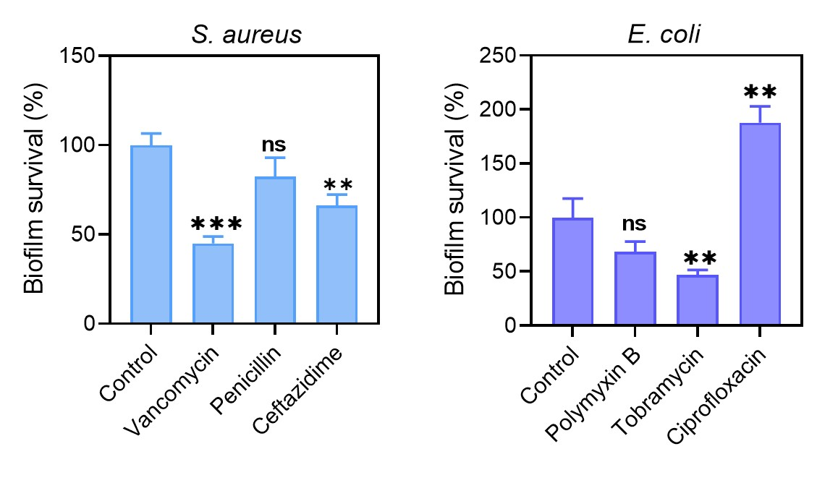
Figure S20. Evaluation of the performance of common antibiotics in eradicating biofilms formation. Biofilm biomass was measured by crystal violet staining at OD₅₉₀ after eradicating the biofilm, which was treated with a concentration of 50 μg/mL of vancomysin, penicillin, ceftazidime, polymyxin B, tobramysin and ciprofloxacin for 24 h. Data are mean ± standard deviation (SD) (n = 3) (**p < 0.01, ***p < 0.001 and ns indicates no statistical significance).
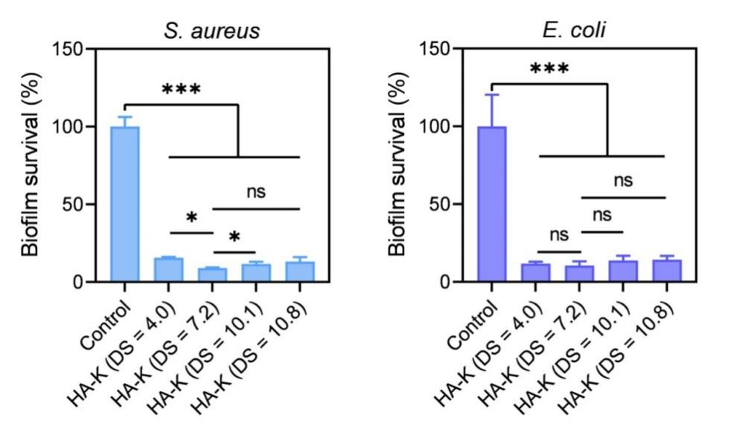
Figure S21. Evaluation of the performance of HA-K with DS of 4.0, 7.2, 10.1 and 10.8 in eradicating biofilms formation. Biofilm biomass was measured by crystal violet staining at OD₅₉₀ after eradicating the biofilm, which was treated with a concentration of 50 μg/mL of HA-K at DS values of 4.0, 7.2, 10.1, and 10.8 for 24 h. Data are mean ± standard deviation (SD) (n = 3) (*p< 0.05, ***p < 0.001 and ns indicates no statistical significance).

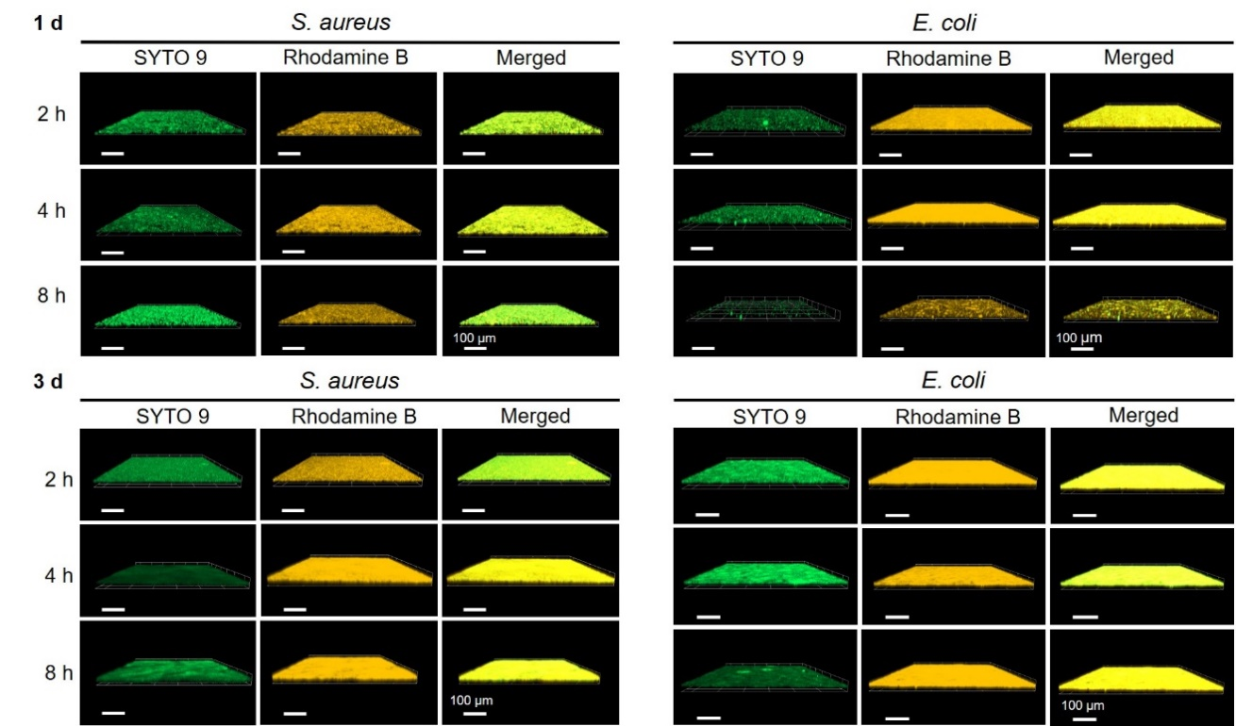
Figure S22. The assay of the biofilm penetration of HA-K (biofilms are 1-day-old and 3-day-old, respectively) (scale bar = 100 μm).
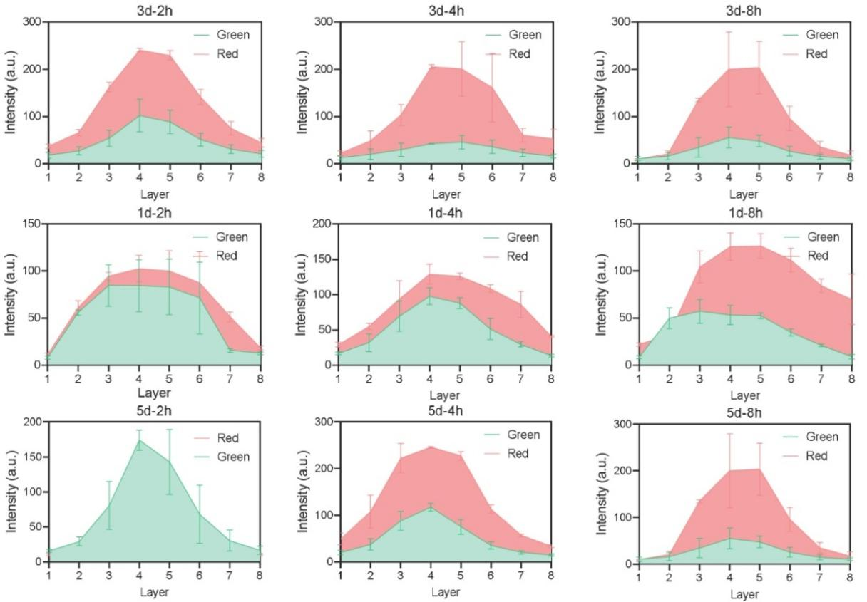
Figure S23. Layer-by-layer tomographic scanning along the vertical Z-axis of the S. aureus biofilms penetrated by Rhodamine B-labeled HA-K PEC. Data are mean ± standard deviation (SD) (n = 3).
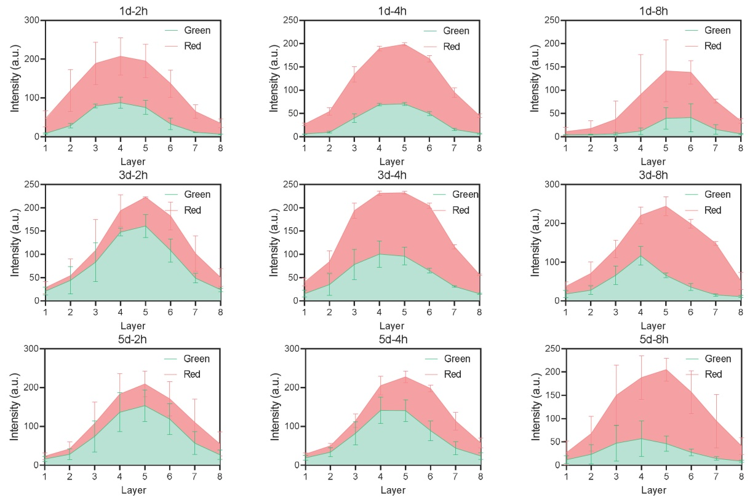
Figure S24. Layer-by-layer tomographic scanning along the vertical Z-axis of the E. coli biofilms penetrated by Rhodamine B-labeled HA-K PEC. Data are mean ± standard deviation (SD) (n = 3).
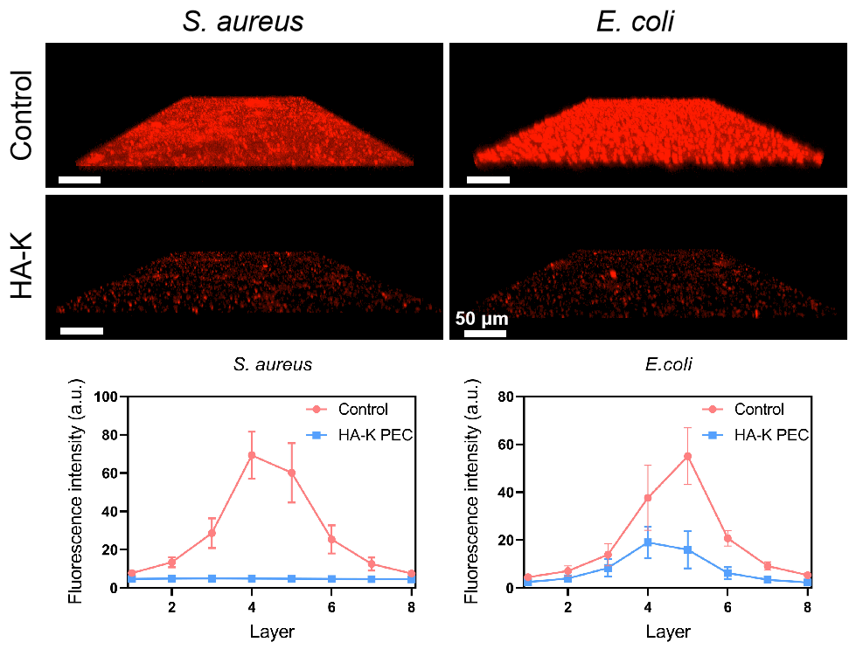
Figure S25. CLSM imaging and quantitative analysis of extracellular matrix proteins in bacterial biofilms. Data are mean ± standard deviation (SD) (n = 3).
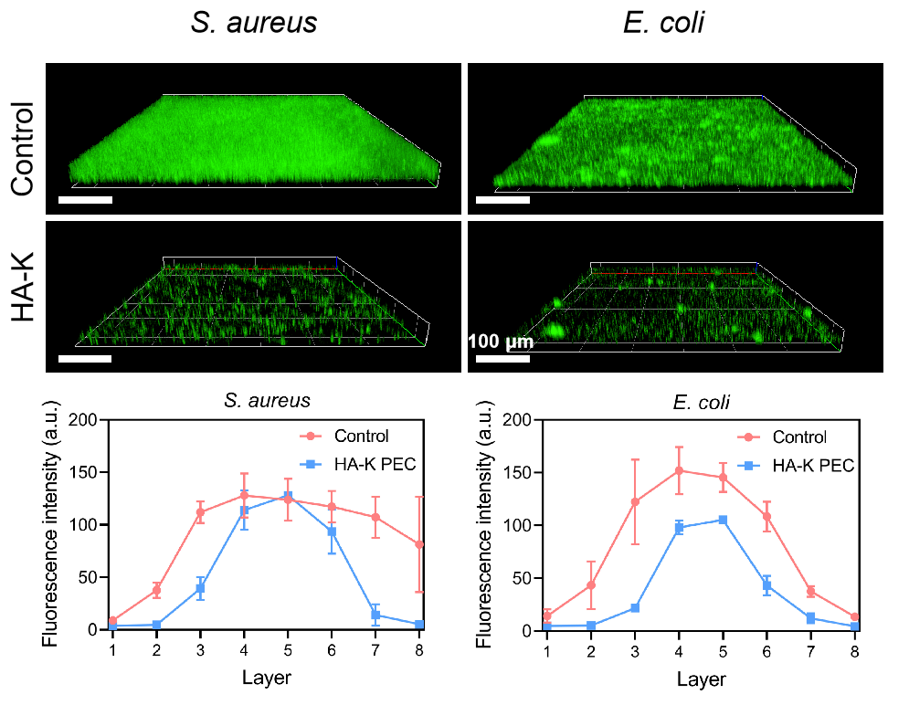
Figure S26. CLSM imaging and quantitative analysis of extracellular DNA (eDNA) in bacterial biofilms. Data are mean ± standard deviation (SD) (n = 3).
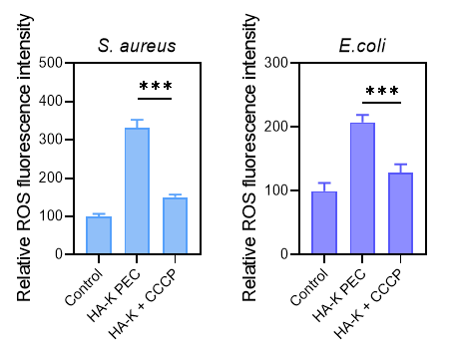
Figure S27. ROS production of bacterial biofilms untreated (control), treated by HA-K PEC, or HA-K PEC in the presence of CCCP. Data are mean ± standard deviation (SD) (n = 3) (***p < 0.001).

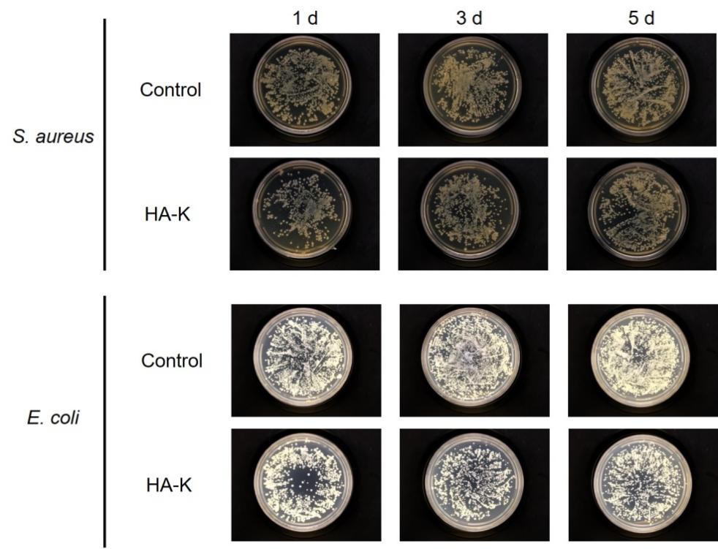
Figure S28. The assay of the survival bacteria of biofilm after the treatment with HA-K PEC.

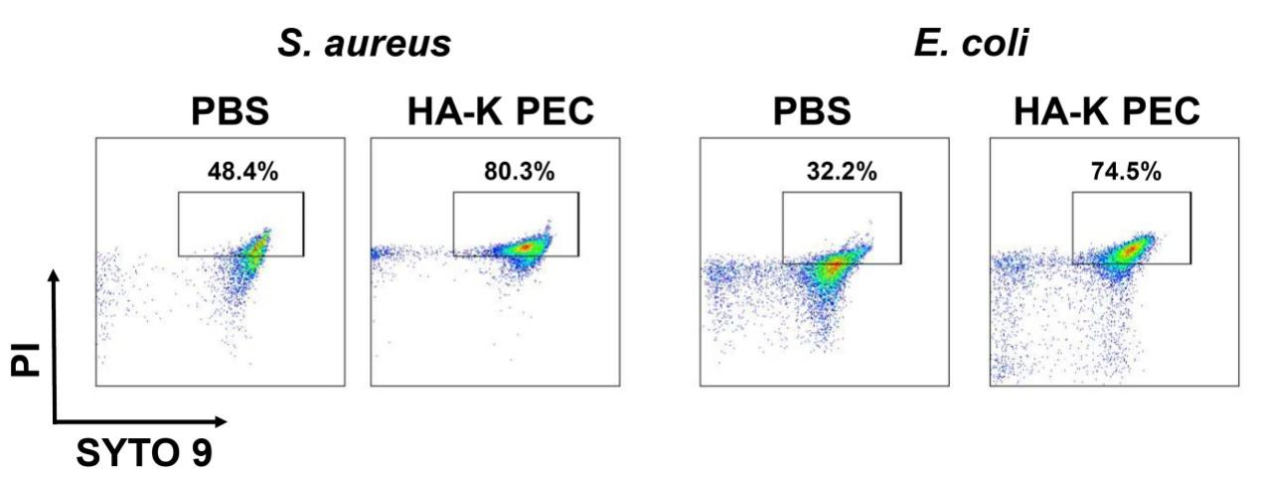
Figure S29. Live/dead bacterial cell viability analysis via flow cytometry. Bacteria in biofilms were treated with PBS (control) or HA-K PEC.
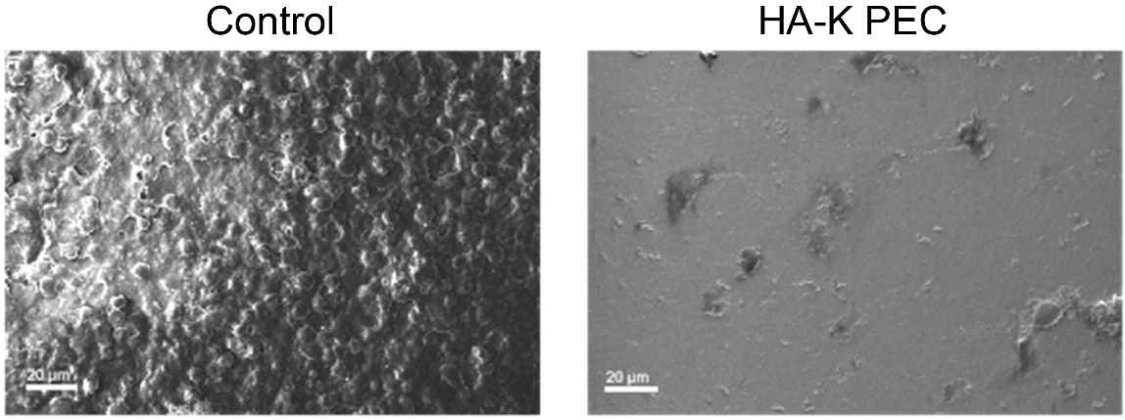
Figure S30. SEM images of planktonic S. aureus infected PDMS slides collected from untreated (control) or HA-K PEC treated mice after 7 days of implantation.
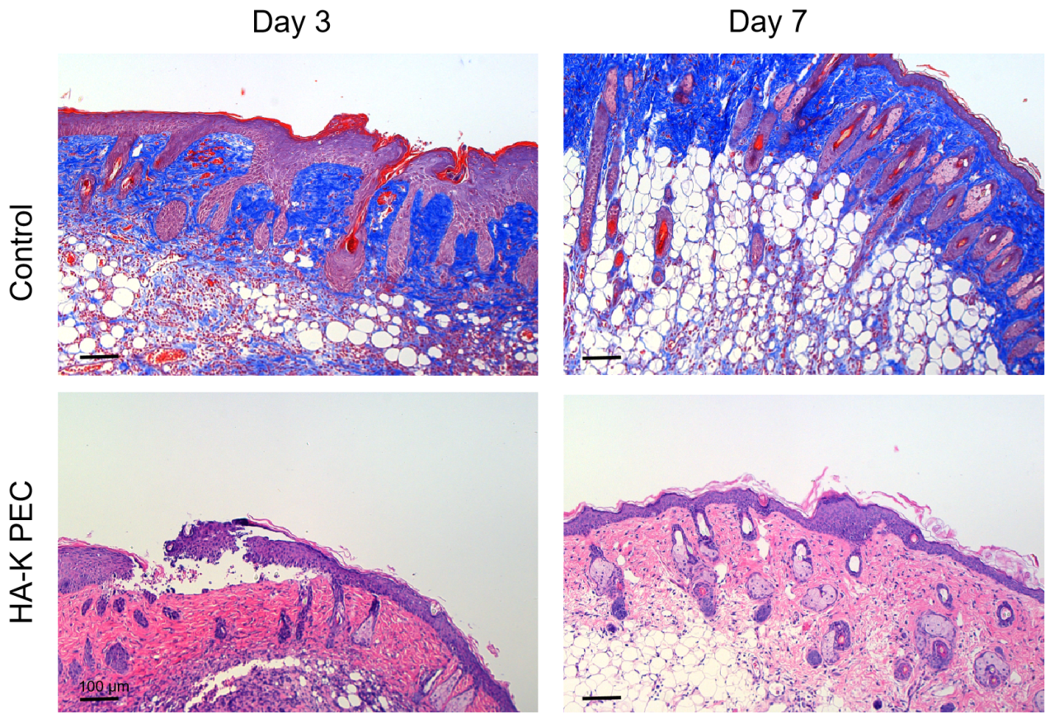
Figure S31. H&E staining images of planktonic S. aureus infected PDMS slide surrounding tissues after 3 and 7 days of implantation untreated (control) or treated by HA-K PEC. (Scale bar = 100 μm).

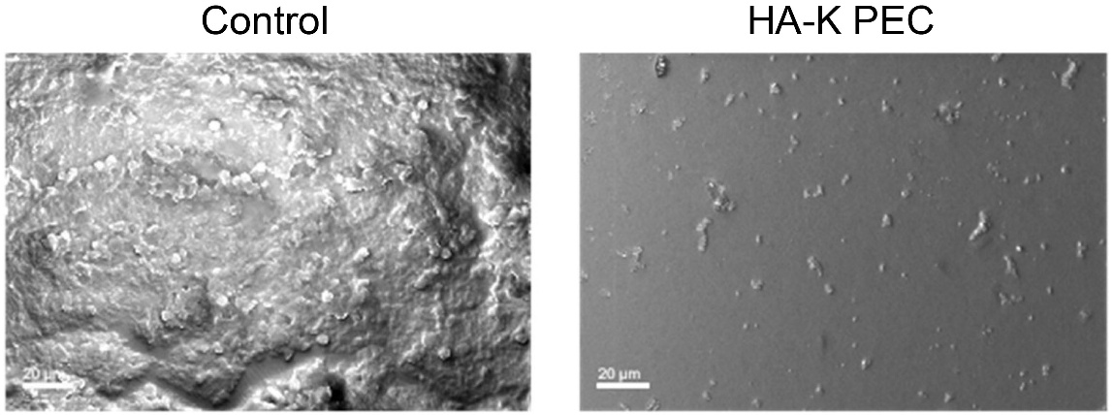
Figure S32. SEM images of S. aureus biofilm infected PDMS slides collected from untreated (control) or HA-K PEC treated mice after 7 days of implantation. (Scale bar = 20 μm).

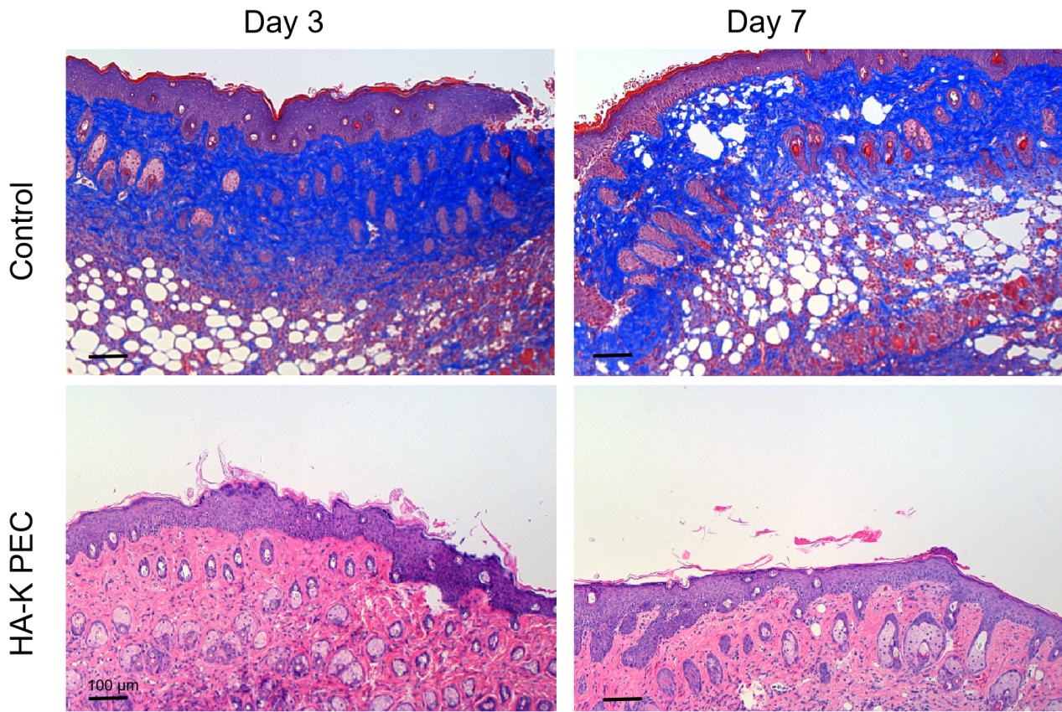
Figure S33. H&E staining images of S. aureus biofilm infected PDMS slide surrounding tissues after 3 and 7 days of implantation untreated (control) or treated by HA-K PEC. (Scale bar = 100 μm).

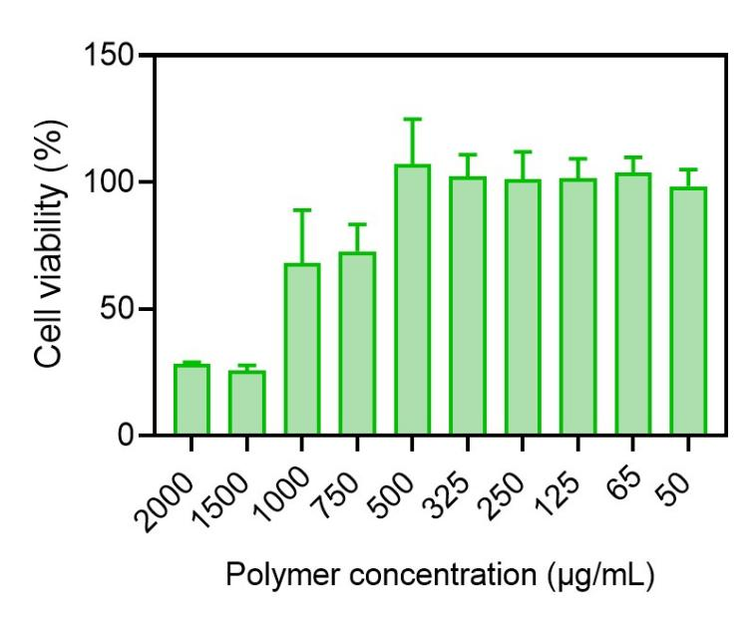
Figure S34. The cytotoxicity of HA-K PEC toward NIH 3T3 cells. Data are mean ± standard deviation (SD) (n = 3).
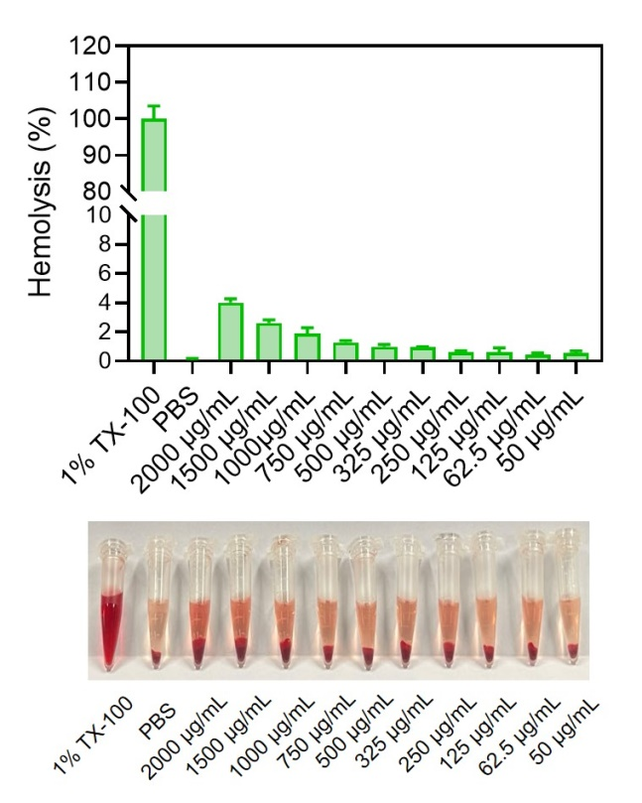
Figure S35. The assay of hemolysis of HA-K PEC. Data are mean ± standard deviation (SD) (n = 3).
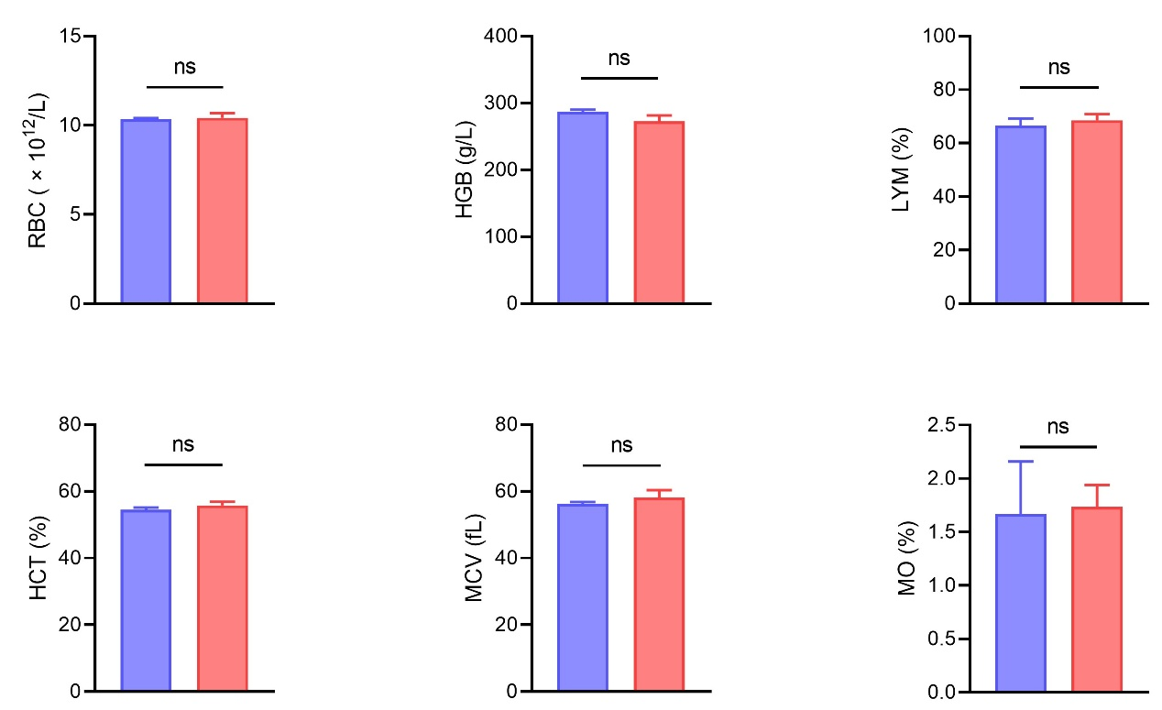
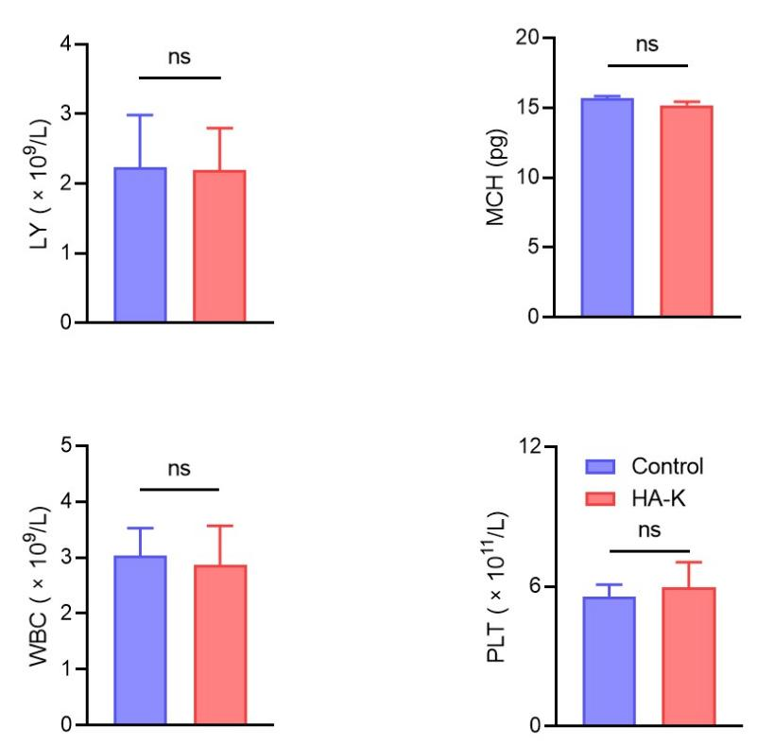

Figure S36. The evaluation of blood routine indicators with or without (as the control) the treatment of HA-K PEC. Data are mean ± standard deviation (SD) (n = 3) (ns indicates no statistical significance).
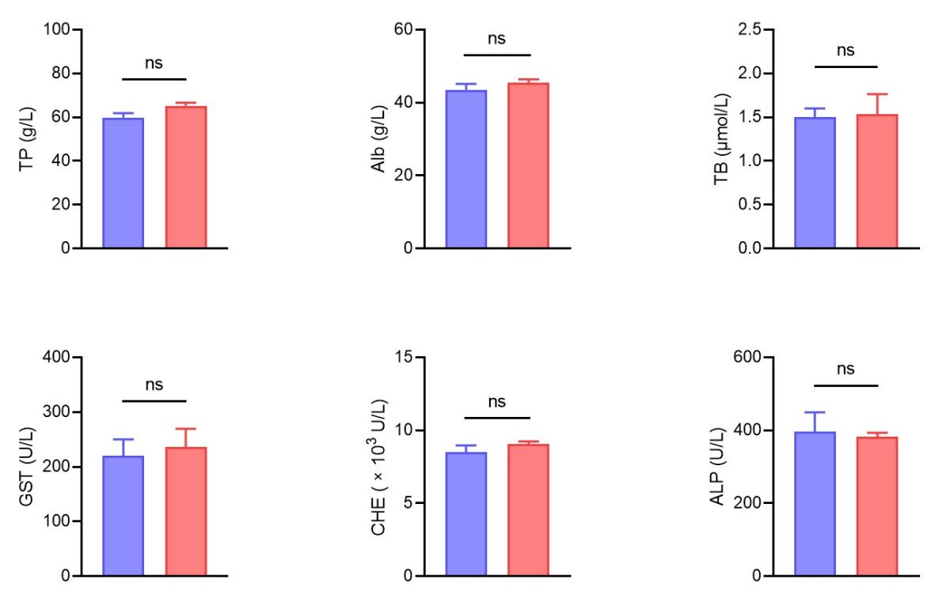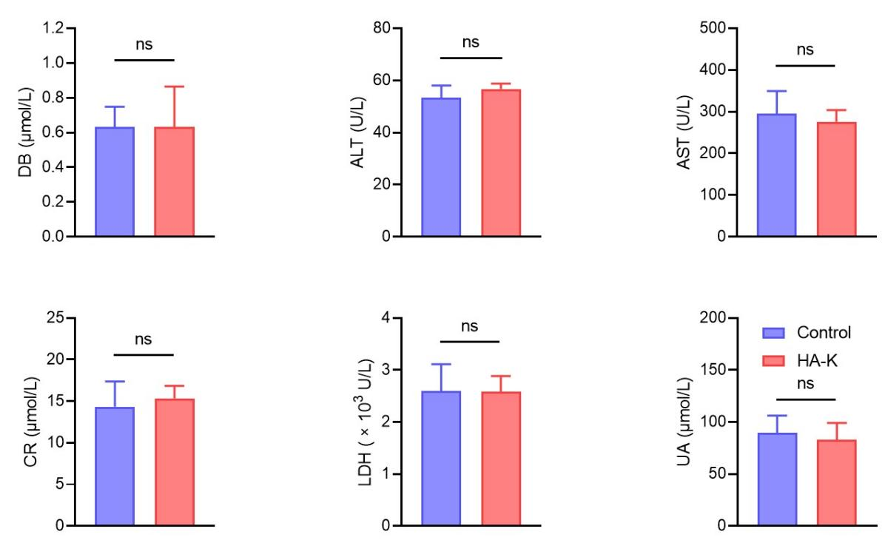

Figure S37. The evaluation of blood biochemistry after the treatment of HA-K PEC. PBS without HA-K PEC was used as the control. Data are mean ± standard deviation (SD) (n = 3) (ns indicates no statistical significance).

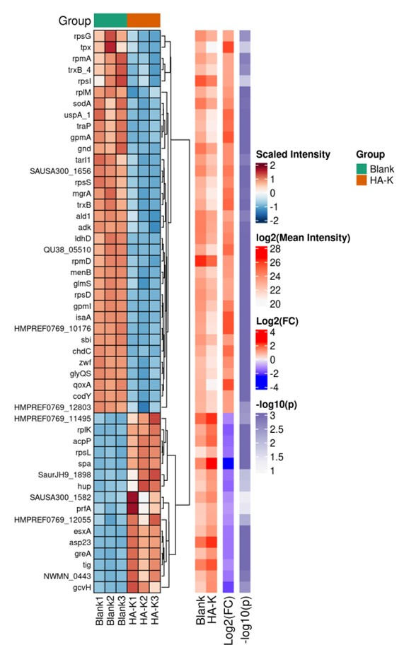
Figure S38. Hierarchical clustering heatmap of differentially expressed proteins between the control group and HA-K PEC treated group.
Figure S39. qRT-PCR results of typical genes (fabD and clfB) involved in fatty acids synthesis pathway and adhesion-related pathways. The genes were extracted from S. aureus treated with HA-K PEC (100 µg/mL) for 24 h. Data are mean ± standard deviation (SD) (n = 3) (*p < 0.05, ***p < 0.001).

Reference
[1] CLSI. Methods for Dilution Antimicrobial Susceptibility Tests for Bacteria That Grow Aerobically. 12th ed. CLSI standard M07. Clinical and Laboratory Standards Institute; 2024.

